**Meaningful Engagement of Indigenous Peoples and Local Communities in Marine Activities**

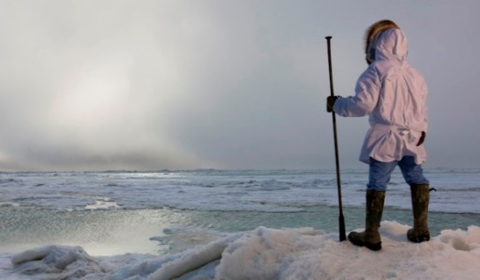

**A Reference Guide**

Based on the findings of the MEMA Part II Report. Protection of the Arctic Marine Environment (PAME ) Working Group.

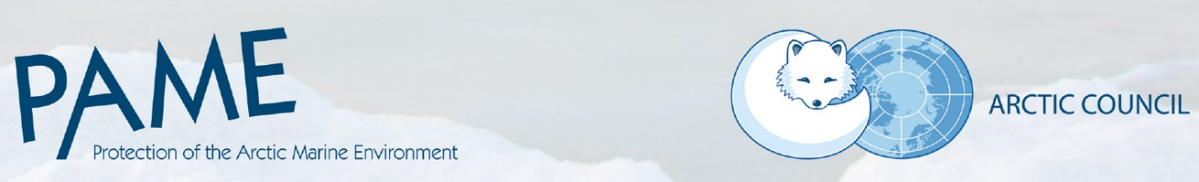**MEMA Reference Guide**

Introduction

This draft Reference Guide is designed to highlight good practices for meaningful engagement between proponents of actions or activities in the Arctic and Indigenous Peoples and local communities.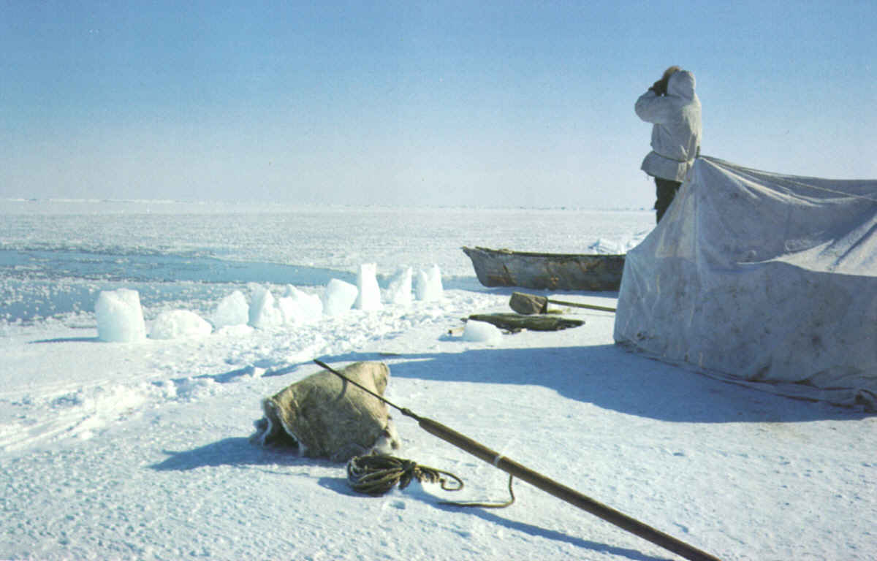 This It is based on the *Meaningful Engagement of Indigenous Peoples and Local Communities in Marine Activities (MEMA) Part II Report* prepared by the Protection of Arctic Marine Environment (PAME) Working Group.

This Reference Guide connects to the findings of the MEMA Part II Report and to the MEMA Database containing over 700 documents related to engagement practices around the Arctic. These sources can be used to further inform proponents and Indigenous Peoples and local communities of good practices and key lessons for meaningful engagement.

The term “meaningful engagement” has no single definition. Nor does it have a one-size-fits all approach for all activities. Meaningful engagement is understood to include a range of practices by government, industry and other proponents making decisions or seeking to operate in the Arctic.

Keeping in mind the adage of “written for everyone is written for no one,” there are, however, some good practices and key lessons that are applicable to all who enter into any Indigenous lands or local communities and whose entry could affect Indigenous Peoples.

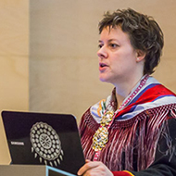Meaningful Engagement

Various factors are important to achieve meaningful engagement. These include:

• Indigenous Peoples and local communities being engaged,

• cultures being respected,

• consideration of a project’s timelines and size, and how it could impact communities,

• consideration of the location of communities, and

• consideration of the nature of a proposed activity.

Here are some factors that commonly lead to meaningful engagement:

• building trust,

• clearly outlining expectations,

• incorporating Indigenous knowledge and local knowledge, and

• ensuring ongoing communication between Indigenous Peoples/local communities and proponents.

The findings and key lessons from the analysis of hundreds of documents in the MEMA Part II Report are generalized. They are not specific to any activity or Indigenous Peoples. However, the body of the report analyzes specific activities and sources which can form the basis of more specific examples of good practices and key lessons.

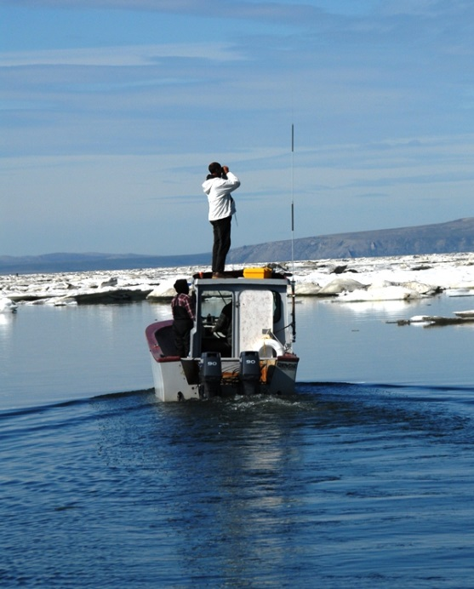**Good Practices and Key Lessons**

**Proponent**

Good Practices

1. Identify potentially affected people and organizations.
2. Consider cultural differences, community locations and resources available.
3. Conduct interactions in a transparent and culturally appropriate manner.
4. Determine how best to communicate with Indigenous Peoples and local communities.
5. Use multiple approaches and tools to engage,
6. Practice early and proactive engagement at all levels.

Key Lessons

General

1. Make Indigenous Peoples and local communities aware of any rights or opportunities to be meaningfully engaged.

Relationship Building

1. Understand communities and the culture, heritage and traditions of the people.
2. Develop capacity in communities by providing education, training, infrastructure and funding, when available.
3. Make an effort to incorporate and apply Indigenous knowledge and local knowledge through engagement approaches.

Process

1. Plan for engagement while being flexible with the process, since this can lead to more fruitful outcomes.

**Everyone**

Good Practices

1. Identify issues and factors where engagement is needed and engagement strategies could help.
2. Consider any existing and potential legal obligations relevant to engagement.
3. Build relationships based on trust and respect between project proponents and Indigenous Peoples and local communities;
4. Pinpoint the best times to begin engagement processes throughout an activity’s lifetime.
5. Develop an engagement plan or agreement with the community.
6. Report back on progress.
7. Set up supportive measures like recordkeeping, process reviews, conflict resolution mechanisms, as appropriate.

Key Lessons

General

1. There is no single approach to meaningful engagement; it depends on the context.
2. Consider outlining what all parties consider to be a meaningful role.

Relationship development

1. Keep relationship building and engagement ongoing to make the relationship meaningful.
2. Collaborate and coordinate among partners, including those who do not normally communicate directly with one another.
3. Develop a foundation of trust and provide clarity, certainty and reliability through constructive dialogue.
4. Include time for events and activities not directly related to issues being considered.

Process

1. Aim for an engagement process that balances interests and provides for positive outcomes for all partners.
2. Aim for representation of Indigenous Peoples and local community members on advisory councils and decision-making boards.

**Narrative Summary of Good Practices**

**Pre-engagement**

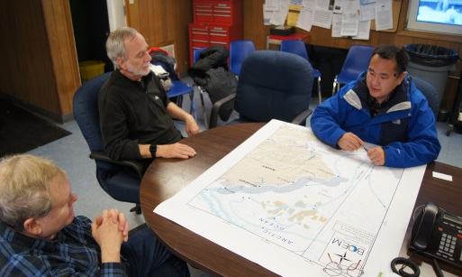An important part of plan development is pre-engagement with Indigenous Peoples and local communities who may be impacted by the proposed activity. Before planning an activity or entering local communities, it is important to educate yourself about the people and their communities.

This reference guide provides a list of webpages from Indigenous Permanent Participants that can help with “Arctic literacy.” It contains information and links to local government and/or tribal contacts, history of the peoples, culture(s?), cultural practices, subsistence activities, ways of life, socio-economics, population, geography of the region, weather, climate, etc.

**Saami Council**: [http://www.saamicouncil.net/en/about-saami-amazonShicouncil/](http://www.saamicouncil.net/en/about-saami-council/)

**Aleut International Association**: <https://aleut-international.org/>

**Russian Association of Indigenous Peoples of the North**: <http://www.raipon.info/>

**Inuit Circumpolar Council**: <https://www.inuitcircumpolar.com/>

**Arctic Athabaskan Council**: <http://www.arcticathabaskancouncil.com/aac/>

**Gwich’in Council International**: <https://gwichincouncil.com/>

A good practice is to understand a community’s culture and way of life before engagement. Such understanding stems from both qualitative and quantitative socio-economic data.

It is important to introduce yourself and include personal information including, what your education is, what your qualifications are, what your specialty is, and what it is that you do.

**Engagement**

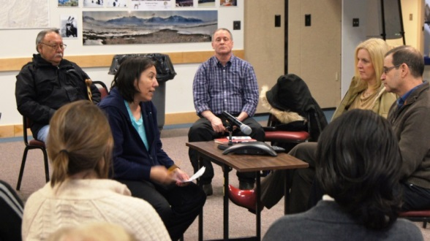**Beginning the process**

Beginning engagement as early as possible is valuable for establishing relationships, building trust and encouraging information sharing from the beginning. Early engagement will help to:

• identify and address the concerns of Indigenous Peoples and local communities;

• avoid or minimize any adverse impacts on Indigenous Peoples or local communities; and

• assess and implement mechanisms that seek to incorporate Indigenous and local knowledge.

A good practice throughout the life-cycle of an activity, plan or policy development is to be transparent and inclusive of Indigenous Peoples and local communities in the project development process. This may mean providing education, training, infrastructure and funding, when available, to facilitate engagement. Recognition of the contribution(s) of each other’s input into the activity is important to maintain trust and respect.

**Issues, factors, participants**

It is important that the proponent clearly identify activities, plans and policies that may affect Indigenous Peoples and local communities. This includes the project scope, timing and location of the proposed activity and how there may be an impact on Indigenous Peoples and local communities.

It is also important to include all relevant actors proposing an activity—government, industry, NGO or academic representatives—in the engagement process with Indigenous Peoples and local communities. An equitable balance of actors is critical to listen to everyone’s input.

An additional good practice is to understand who speaks for the community, which will differ depending on the context and which could involve informal leaders as well as official representatives. It is important to pay particular attention and respect to the knowledge and perspectives of elders.

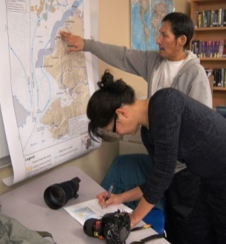**Legal and established practices**

It is important to identify whether there are legal requirements for engagement or any established approaches that are already in place. A good practice is to ask Indigenous Peoples and local communities whether they have preferred or established practices of engagement that may provide an approach that is already accepted.

**Participation in engagement**

It is important to consider potential influences or barriers to engaging Indigenous Peoples and local communities. These barriers could include seasons, remoteness of region, community capacity, language barriers, and hunting or other priority activities that may be impacted by the proposed activity. Barriers may change over the course of a project or process, so it is useful for engagement to be early and ongoing.

Early notification can help provide Indigenous Peoples and local communities with the information necessary to participate in meaningful engagement.

Consultation is a mechanism for engagement. It enables proponents to work directly with Indigenous Peoples and local communities. Consultation can include interviews, workshops and meetings in which group discussions can help potentially affected Indigenous Peoples and local communities understand what is being proposed or planned. They can assist in identifying and balancing competing claims, interests and motivations. However, consultation is a part of engagement. Engagement is a process that goes both ways and requires the co-development of activities.

**Communication**

Culturally appropriate engagement includes being considerate of cultural and linguistic differences among the actors involved in activities—in particular, in the validation and use of information and knowledge.

Being culturally aware includes understanding how (or that?) communities may communicate differently. This means recognizing language barriers by translating materials into the community’s language, using interpreters and ensuring materials are written in plain, non-technical language.

To aid with communication difficulties, a local facilitator, adviser or liaison can provide guidance and direction for getting to know communities and local organizations. They can also help identify potential participants and preferred means of engagement.

Developing an intercultural communication or an engagement plan between Indigenous Peoples and local communities and proponents can be set out from the start in engagement. A plan can outline:

• how to coordinate with members of a community or representatives;

• the roles for all those involved;

• expected strategies for engagement; and

• adaptable measures to ensure flexibility of the process.

A plan can also help to create accessible materials or forums for information sharing.

Social media can increasingly be used to generate awareness and interact with remote communities. More traditional communication methods are also valuable. Radio and VHF, television, newspapers and community bulletins may still be used where social media or Internet connection are unavailable or unreliable. A key aspect of a communications plan is providing final results. It is also important to communicate interim and final results to communities in a way that they find useful.

Communication is meant to be ongoing and involve a two-way approach. This enables

Indigenous Peoples and local communities to present their views, concerns and questions. It also opens up a dialogue between Indigenous Peoples and local communities and other affected people. It benefits from being ongoing over the course of an activity, project or plan, as it is a means of mutual information sharing between Indigenous Peoples and local communities and other parties.

**Forms of communication**

Written or Web-based

* Community newspapers
* Social media

• Handbooks

• Brochures

• Posters

• Websites

• Letters or emails

• Publication of notices

• Telephone calls

• Radio or TV presence

Face to face

• Workshops

• Visits to communities

• Meetings

• Presentations

• Public events

• Use of local advisers

• Communication centers set up in communities

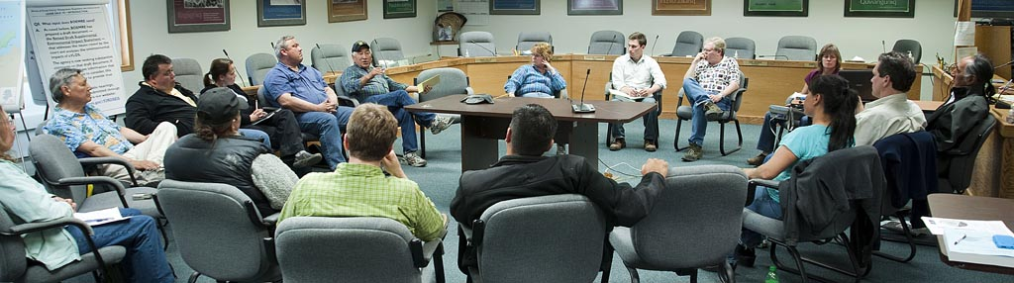

**Key stages of engagement**

**Timing--**When this occurs often depends on whether there are pre-approval requirements to be satisfied. The planning stage is the most frequent stage of engagement. The activity, plan or project will dictate the stages at which engagement is utilized.

**Proactivity--**Meaningful engagement does not begin when a problem occurs. It is an ongoing process that builds a foundation on which problems can be solved or managed. One way to be proactive is to engage with people in their community and near the site where the activity is planned. A key element to the pre-consultation phase is involving Indigenous Peoples and local communities in decisions about how engagement will occur and determining which issues will be on the agenda.

**Duration--**Engaging Indigenous Peoples and local communities in all parts of an activity, from strategic planning processes that scope the project to operational decisions on how it is implemented.

**Planning--**Developing a formal engagement or consultation plan can help manage engagement and ensure it is prioritized. A plan creates clear and realistic expectations of the engagement process and the responsibilities of all parties. Establishing one concise plan is preferable to multiple, long and complicated documents.

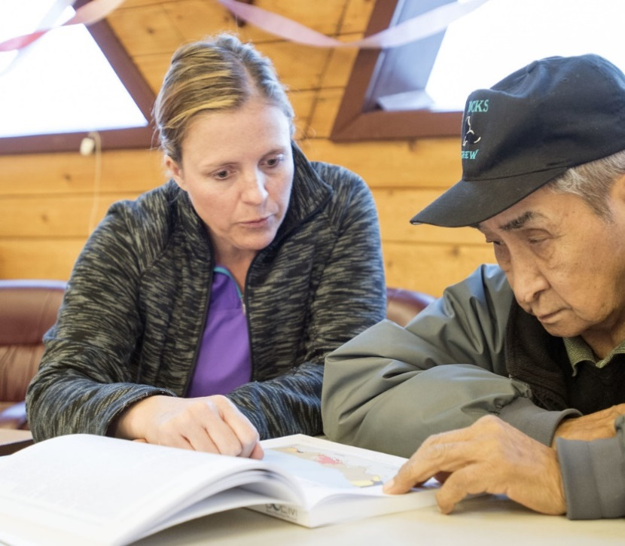**Follow-up--**Providing opportunities to address questions, concerns and issues raised over the course of the engagement process shows Indigenous Peoples and local communities where their input is being included when they are not at the decision-making table. This also continues the dialogue established between all parties. In addition, conducting a final review at the end of a project, plan or other activity enhances the engagement process.

**Reporting--**Reporting back to the community on the results of the engagement and how feedback was incorporated into a project or activity. This is another practice that helps ensure engagement is viewed as meaningful. This involves taking measures and providing resources to ensure information contained in a report is accessible and directly addresses the concerns that the community raised. This could mean providing translation, providing advisers and legal help, and making copies of reports and summaries available to people. Reporting back in a useful way that will help the community utilize the products should be considered.

**Supportive measures**

**Recordkeeping**

It is important to document and record consultation and engagement activities, meetings, discussions, issues, commitments and outcomes. It is also helpful to have all parties agree to methods of documentation and recordkeeping early in the process. Having a records management system in place will enable access to information throughout engagement.

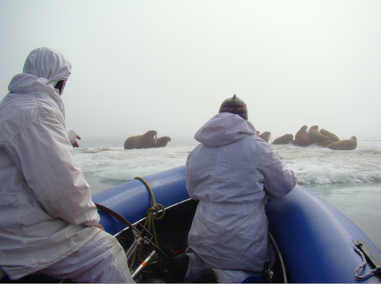

**Review of processes**

Regular reviews of engagement processes in which feedback from Indigenous Peoples and local communities is received can improve relationships and the overall process. This will allow for adjustments as necessary. Identification of accountability measures, which review procedures of engagement, are considered important for meaningful engagement.

**Conflict Resolution Mechanism**

Despite efforts for all parties to be in agreement on issues, conflict can arise. A process (plan) to resolve differences could be helpful to outline steps to be taken in the event that it is needed. In addition, plans of cooperation could assist in keeping a focus on balanced interests.

**MEMA Database Resources for Existing Information on Engagement**

The MEMA Database contains over 700 documents that relate to engagement Indigenous Peoples and local communities in marine activities. These include: legislation, regulations, rules, treaties, policy statements, guidance, and recommendations. Subject activities or actions can be searched independently as illustrated below.

**For shipping**

<https://pame.is/mema/view1list.php?cmd=search&t=view1&psearch=Shipping&psearchtype=>

**For tourism**

<https://pame.is/mema/view1list.php?cmd=search&t=view1&psearch=tourism&psearchtype=>

**For resource development**

<https://pame.is/mema/view1list.php?cmd=search&t=view1&psearch=resource+development&psearchtype=>

**For marine management**

<https://pame.is/mema/view1list.php?cmd=search&t=view1&psearch=management&psearchtype=>

**For research**

<https://pame.is/mema/view1list.php?cmd=search&t=view1&psearch=research&psearchtype=>

**For emergency preparedness, prevention and response**

<https://pame.is/mema/view1list.php?cmd=search&t=view1&psearch=emergency+response&psearchtype=>

The MEMA Database can also be queried according to the source of the documents, including governments, the Arctic Council, and academic/NGOs.

**For the Arctic Council**

<https://pame.is/mema/view1list.php?cmd=search&t=view1&psearch=Arctic+Council&psearchtype=%3D>

**For the United States**

<https://pame.is/mema/view1list.php?cmd=search&t=view1&psearch=United+States&psearchtype=AND>

**For Canada**

<https://pame.is/mema/view1list.php?cmd=search&t=view1&psearch=Canada&psearchtype=AND>

**For Norway**

<https://pame.is/mema/view1list.php?cmd=search&t=view1&psearch=Norway&psearchtype=AND>

**For Russia**

<https://pame.is/mema/view1list.php?cmd=search&t=view1&psearch=Russia&psearchtype=AND>

**For Greenland**

<https://pame.is/mema/view1list.php?cmd=search&t=view1&psearch=Greenland&psearchtype=AND>

**For academic/NGO**

<https://pame.is/mema/view1list.php?cmd=search&t=view1&psearch=academic&psearchtype=AND>