Desktop Study on Marine Litter including Micro-plastics in the Arctic
Final draft (07 Jan 2019): TRACK CHANGES

Table of Contents
Table of Contents 1
Glossary 2
Background 2
Section I: Rationale, Objectives and Geographic Scope 4
I.1 Rationale 4
I.2 Objectives 5
I.3 Definitions and geographic scope 6
Section II: Applicable Governance Frameworks 10
II.1 Arctic Council Efforts to address Marine Litter 10
II.2 International Instruments, Strategies, and Programmes 11
II.3 Regional Programmes 12
Section III: Literature Review 13
III.1 Sources and Drivers 13
Sea-based sources 16
Land-based sources 21
III.2. Pathways and Distribution 25
Pathways 25
Distribution 30
III.3. Interactions with biota and impacts 39
Interactions with biota, biological and ecological impacts 39
Socioeconomic impacts 56
III.4. Monitoring and Response 58
Monitoring 58
Ongoing Efforts to Address Marine Litter in the Arctic 61
III.5. Knowledge gaps 64
Section IV: Conclusion and Recommendation on next steps 68
Annexes 71
Annex I: Governance Frameworks 71
Annex II: Literature review tables 71
List of References 72

Glossary
[Note: to be added]

Background
Marine litter, particularly when made of plastic, is amongst the most pervasive problems affecting the marine environment globally (UNEP, 2009; UNGA, 2012; UNEP, 2016). The United Nations Environment Programme defines marine litter as ‘any persistent, manufactured or processed solid material discarded, disposed of or abandoned in the marine and coastal environment’ (UNEP, 2009).
The presence of litter in the oceans is ubiquitous, and it has been recorded from coastal shallow waters to the seafloor of deepest oceanic trenches and basins. Litter can be deliberately discarded or abandoned in the sea; brought indirectly to the sea by rivers, sewage outfalls, storm water or wind; or accidentally lost. Gear or parts of it can be lost at sea because of wear and tear linked to normal operations, due to negligent practices and/or bad weather. The universal challenge of addressing and managing marine litter is a useful illustration of the global and transboundary nature of many environmental problems.
On a global scale, plastics account for 72 percent (in number of debris or particles) of all marine litter (Bergmann et al., 2017a), though variations are large with plastic making up between 60 and 90% depending on the region (UNEP, 2016). The remaining percentage includes paper, wood, textiles, metal, glass, ceramics, rubber and any other material that does not degrade within days or months. Most of the scientific attention placed on marine litter over the last years has been devoted to plastic items, particles and their fragments (Ryan, 2015a) due to the fact that plastic is durable, i.e. degrades very slowly, light (has a density similar to water, allowing it to be transported for long distances), animals interact with it in multiple ways, and it can contain or accumulate toxic substances. Of the various types of marine litter, plastic marine litter and microplastics gather most of the focus of this document due to the large dominance of plastic debris, fragments and particles in the literature reviewed. The search targeted literature related to the sources, pathways, distribution and interactions with biota of marine litter or debris and microplastics in the Arctic. There remain a number of knowledge and data gaps on marine litter and microplastics, including accurate quantification of the percentage of plastic litter versus other types of marine litter in this region.
It is estimated that more than 150 million tonnes of plastics have accumulated in the world's oceans since the onset of industrial production (UNEP and GRID-Arendal, 2016). Marine plastic litter consists of macro-plastic items (greater than 5mm in size) or microplastics (≤ 5mm in size) including plastic fragments and plastics manufactured to be that size (i.e. pellets or microbeads).
The largest share of marine litter, including microplastics, is often attributed to the contribution from land-based sources associated with deficient waste management systems in intensively populated coastal regions, leading to an estimated 4.6 to 12.7 million tonnes of plastic litter being added yearly to our oceans (Jambeck et al., 2015). While there is an increasing number of models attempting to gauge the contribution of plastic litter from land (Jambeck et al., 2015), including the contribution transported via rivers (Lebreton et al., 2017; Schmidt et al., 2017), there is no recent global estimate of the contribution from activities at sea (i.e. fishing, shipping, aquaculture, etc.), and therefore it is impossible to accurately rank land-based vs. sea-based contributions. In any case, regional differences in relative contribution, e.g., in the Northeast Atlantic, where shipping and fishing activities have been determined to be the most significant sources of litter (Galgani et al., 2010; van Sebille et al., 2016; Buhl-Mortensen and Buhl-Mortensen, 2017), already indicate that the input associated with both land-based and sea-based activities deserves attention.
Even though the Arctic coastal region is sparsely populated and has limited terrestrial transport and industrial infrastructure, maritime activity in certain areas of the Arctic Ocean is intensive due to the numerous rich fishing grounds and growing shipping routes, providing for cost-effective transportation of goods into the Arctic and of resources out of the Arctic, especially for northern Norway and northwest Russia (Arctic Council, 2009). In addition, as for any other part of the world’s ocean, marine litter, includingmicroplastics, in the Arctic are not only a result of the pressure resulting from activities within the Arctic seas or its coastal areas, but also linked to input arriving from inland areas through rivers, air currents and from distant oceanic areas through global oceanic circulation. The proportion between locally-originated litter and microplastics and those of distant origin is at present not known but their combined input brings marine litter and microplastics to the Arctic and threatens marine and coastal ecosystems and its services.

[Paragraph on the history of the development of the PAME marine litter project that has led to the development of the desktop study]

Section I: Rationale, Objectives and Geographic Scope
[This section may need expanding as it is very short in comparison now with section II]

I.1 Rationale
The Arctic Council of Ministers adopted the Regional Programme of Action for the Protection of the Arctic Marine Environment from Land-based Activities (Arctic RPA) in 1998 (PAME, 1998) and updated it in 2009 (PAME, 2009). The Arctic RPA is a dynamic programme of action that uses a step-wise approach for its implementation and recognizes the continually evolving situation in the Arctic environment and the need for an integrated approach. It is the regional extension of the Global Programme of Action (GPA) for the Protection of the Marine Environment from Land-Based Activities, and as such provides a framework for addressing the main pollution source categories and responding to the global concerns. The eight source categories covered by the Arctic RPA are persistent organic pollutants (POPs), heavy metals, physical alteration and destruction of habitats, radionuclides, petroleum hydrocarbons, sewage and nutrients, sediment and litter.
In the marine litter summary assessment made for the 2009 update of the Arctic RPA multiple source activities and mixed origin, both within and outside the Arctic, were highlighted. The impacts and links to demographic, urban and industrial development were also stated emphasizing the connection between marine litter and municipal and household solid waste management. In the framework of the Arctic RPA marine litter was ranked as low priority for action due to the assessment of no immediate regional threat associated to it (PAME, 2009).

In June 2014, governments attending the first UN Environment Assembly noted with concern “the serious impact which marine litter, including plastics stemming from land and sea-based sources, can have on the marine environment, marine ecosystem services, marine natural
resources, fisheries, tourism and the economy, as well as the potential risks to human health” and “encouraged Governments to take comprehensive action to address the marine plastic
debris and microplastic issue”. The resolution adopted also requested the United Nations Environment “Executive Director… to undertake a study on marine plastic debris and marine microplastics, building on existing work and taking into account the most up-to-date studies and data” and present it “for the consideration of the United Nations Environment Assembly at its second session” (UNEA Resolution 1/6, 2014).
At the second UN Environment Assembly in May 2016 atending governments noted “the increased knowledge regarding the levels, sources, negative effects of and possible measures to reduce marine plastic debris and microplastics in the marine environment, as summarized in, among other sources, the 2016 study… on marine plastic debris and microplastics, the preparation of which was mandated by the Environment Assembly in its resolution 1/6” and further recognized “that the presence of plastic litter and microplastics in the marine environment is a rapidly increasing serious issue of global concern that needs an urgent global response taking into account a product life-cycle approach, and acknowledging that the levels and sources of marine plastic litter and microplastics, and the resources available to tackle the issue, can vary between regions, and that measures need to be taken and adapted as appropriate to local, national and regional situations” (UNEA Resolution 2/11, 2016).
In February 2017, and taking into consideration discussions held in the previous PAME Working Group meeting held in Maine (USA) in September 2016 during which a representative of the Secretariat of the GPA (UN Environment) provided information on the above resolutions and other work carried out by UN Environment, PAME agreed to include the project plan for the “Desktop Study on Marine Litter including Microplastics in the Arctic” in the PAME 2017-2019 Work Plan. The project plan envisaged a stepwise approach including two phases: the first one devoted to scoping and outreach with this desktop study as one of its major deliverables, and, a the second one, conditional to the main findings and outcomes of the desktop study, devoted to the development of a framework for an Arctic Regional Action Plan on Marine Litter.

I.2 Objectives
The main objective agreed at the onset of the Desktop Study on Marine Litter including Microplastics in the Arctic project is:
- To evaluate the scope of marine litter including microplastics in the Arctic, and its effects on the Arctic marine environment;
The Desktop Study will support the achievement of higher level goals such as:
- Increase knowledge and awareness of marine litter in the Arctic;

    - Enhance cooperation by the eight Arctic Council member governments to reduce negative impacts of marine litter to the Arctic marine environment; and,
- Contribute to the prevention and/or reduction of marine litter pollution in the Arctic and its impact on marine organisms, habitats, public health and safety; and reduce the socioeconomic costs it causes.

I.3 Definitions and geographic scope
[The annotated outline below assumes that as part of the text dealing with the scope of the Desktop Study, within Section I, there will be clarification of the terms marine litter, marine plastic litter, marine plastic debris, macroplastics, mesoplastics, microplastics and nanoplastics. That would ensure coherence of the content across the Desktop Study and how these terms are used and should be understood by the reader. Below the term marine litter is used pending further clarification as it is generic enough to include all forms and sizes of marine litter. Further, in every sub-section the report will summarzine plastic-specific information regarding macro, meso and microplastics. When the information is specific to a certain size group, it will be mentioned.]
Marine litter, also known as marine debris, has been defined as “any persistent, manufactured or processed solid material discarded, disposed of or abandoned in the marine and coastal environment” (UNEP 2009). It can be made of plastic, paper, machined wood, textiles, metal, glass, ceramics, rubber and any other man-made material that does not degrade within days or months.
The terms micro-litter and microplastics are descriptive terms providing for a practical convention to enable comparability of monitoring data. Microplastics are routinely defined as small particles or fragments of plastic measuring less than 5 mm in diameter (GESAMP 2015). The microplastic upper limit size is subject to discussions as the 5 mm threshold does not match the chemical or mathematical definition for the micro range that consider as microparticles those with sizes up to 100 or 500 micrometers, and therefore 10 times smaller than particles routinely referred as microplastics. Primary microplastics are plastic microparticles purposefully manufactured for industrial and domestic purposes while secondary microplastics are created by the weathering and fragmentation of larger plastic objects (UNEP, 2016).
The geographic scope of this desktop study is analogous to the one used in the Arctic Ocean Review Report (PAME, 2013). Accordingly the Arctic marine area for this desktop study is comprised of “the central Arctic Ocean, and in addition, the surrounding seas: the Bering Sea, the East Siberian Sea, the Chukchi Sea, the Beaufort Sea; the Northwestern Passages, Hudson Strait and Hudson Bay; the Baffin Bay, Davis Strait and Labrador Sea; the Greenland Sea, the waters around Iceland and the Faroe Islands, and northern parts of the Norwegian Sea; the Barents Sea, the Kara Sea, and the Laptev Sea.”.
The map of the Arctic Large Marine Ecosystems (LMEs) below (Figure I.1), as adopted by the Arctic Council at the Kiruna Ministerial Meeting in 2013, is used to illustrate the geographical coverage.
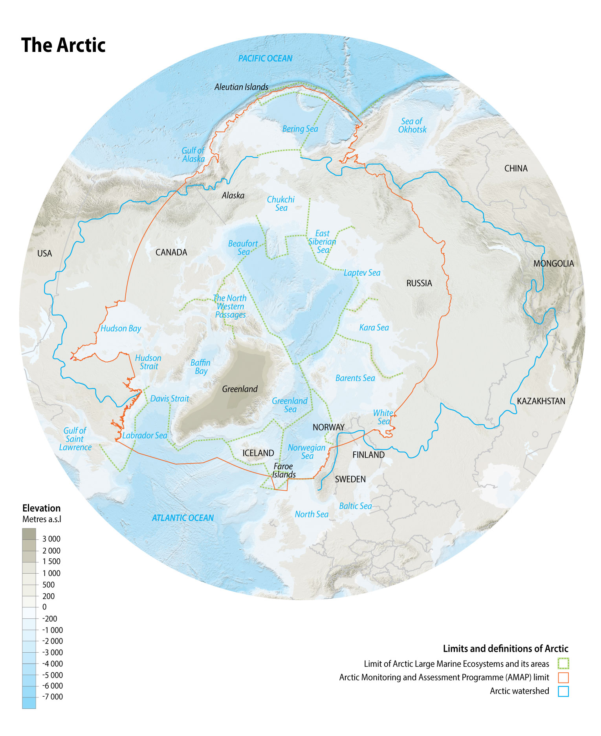

Figure I.1
Because of the interconnectivity of the world oceans, as well as the buoyancy of items such as some plastics, certain types of fishing gear, and processed wood, marine litter within the Arctic could originate from virtually anywhere in the ocean, and therefore, the whole world should be considered as a potential source for litter in the Arctic. Of course, areas in the immediate vicinity of the Arctic marine areas should be considered as most likely potential source areas, especially the North Atlantic and the North Pacific. In that respect information from coastal areas of the Norwegian Sea and the Gulf of Alaska has been included in the desktop study considering theregional circulation patterns. The northeasterly flowing Norwegian current sweeps the western Norwegian coast and transports water deeper into the Barents and Greenland Sea. The southwesterly flowing Alaskan Current flows along the southern shore of the Alaskan Peninsula reaching Unimak Pass where an important branch of this current penetrates and conditions the oceanography of the southeastern Bering Sea and slope waters. The input from these areas will be discussed in more detail within section III.2 on “Pathways and Distribution”.
The land-based boundary for the geographic scope of this study is the limit of the Arctic watershed, as marine litter found within the Arctic marine areas could theoretically originate from any point within that area (Figure I.1). In this respect, the Arctic watershed is defined as including the watersheds of the rivers flowing into the Arctic marine environment as defined above.

Section II: Applicable Governance Frameworks

II.1 Arctic Council Efforts to address Marine Litter
Since its inception, the Arctic Council has been involved in efforts to address the issue of marine litter, a matter of growing international concern. In 1998, the Arctic Council adopted the Regional Programme of Action for the Protection of the Arctic Marine Environment from Land-Based Activities (RPA). One objective of this RPA is to “take action individually and jointly, which will lead to the prevention, reduction, control and elimination of pollution in the Arctic marine environment and the protection of its marine habitat.” Subsequently, and shortly after the adoption of the Arctic Marine Strategic Plan in 2004, the Arctic Council Ministers requested PAME to review and update the RPA. PAME amended the RPA and released the updated version on 29 April 2009.
The Arctic Marine Strategic Plan 2015-2025 (AMSP), a framework to guide the Arctic Council’s actions to protect Arctic marine and coastal ecosystems, also addresses marine litter through various Strategic Actions. For example, the Strategic Plan calls for improving the understanding of cumulative impacts on marine ecosystems from human activity-induced stressors, including local and long range transported pollution from land and sea-based sources and marine litter (Strategic Action 7.1.3).
The 2017 Fairbanks Declaration of the the Arctic Council Ministerial (Fairbanks, Alaska) noted “with concern the increasing accumulation of marine debris in the Arctic, its effects on the environment and its impacts on Arctic communities, and decide[d] to assess the scope of the problem and contribute to its prevention and reduction, and also to continue efforts to address growing concerns relating to the increasing levels of microplastics in the Arctic and potential effects on ecosystems and human health”.

II.2 International Instruments, Strategies, and Programmes
There are a variety of international marine litter-related instruments, including general obligations to protect the marine envirionment, specific obligations to prevent pollution, and obligations to promote biodiversity. The United Nations Environment Programme (UNEP) has recently examined many of those instruments, summarized in the diagram below.
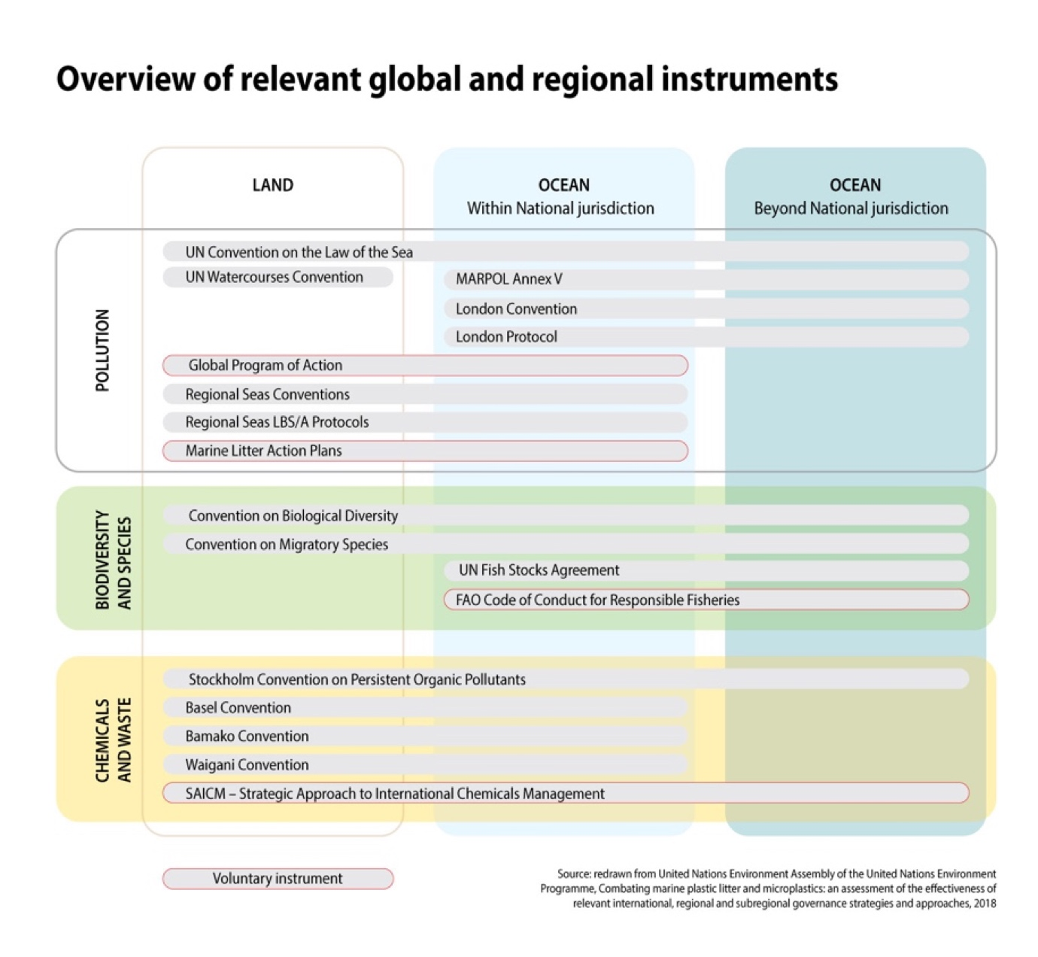
Figure II.1
In addition to international instruments, there are a few relevant UN processes. Most recently, in 2017, the UN Environment Assembly called for an Ad Hoc Open-ended Expert Group on Marine Litter and Microplastics. In addition, the UN 2030 Agenda on Sustainable Development includes 17 goals, each with specific targets. Goal 14 (Life Below Water) includes a target to, “by 2025, prevent and significantly reduce marine pollution of all kinds, particularly from land-based activities, including marine debris and nutrient pollution.” Finally, as far back as 1995, more than 100 countries and the European Union supported the non-binding Global Programme of Action for the Protection of the Marine Environment from Land-Based Activities (GPA), which addresses eight source categories of pollution, including marine litter, and encourages the development of regional and national programmes of action. Within the European Union, the Marine Strategy Framework Directive and the EU Plastics Strategy provide for a harmonised monitoring framework and the implementation of measures against marine litter at large scale.

II.3 Regional Programmes
The UN Environment Regional Seas Programme currently includes efforts of 143 countries participating through 18 Regional Seas Conventions and Action Plans to address the degradation of the world’s oceans by engaging neighboring countries to protect their common marine areas.
In general, the plans identify actions such as minimizing inputs from sea-based and land-based sources of marine litter; promoting actions to remove existing litter from the marine environment; supporting education and outreach efforts to increase public awareness, promote better commercial and recreational fishing practices, and promote collaboration among governments, private industry, and non-governmental organizations; and identifying ways to monitor and assess the marine environment and the efficacy of these actions to minimize impacts from marine litter. In addition, some of the plans contain specific actions to be accomplished within set timelines.

Section III: Literature Review

III.1 Sources and Drivers
[Introduction to potential sources of marine litter. Sources will be associated with different kinds of human activities carried out in the Arctic region, immediate vicinity and other identifiable regions of origin of the marine litter found within the Arctic marine areas. When specific information on sources is limited, information on the drivers could be used as proxy but we will request guidance on the need/will to include this after first draft has been delivered. Suitable proxies will be discussed and listed. Sources will be split between sea-based and land-based sources. Sources associated with coastal activities (i.e., coastal tourism and harbour activities) will be considered under land-based sources.]
Comment: Perhaps it’s better to start talking about litter overall and then move on to plastics
Marine litter and microplastics has become ubiquitous in the global ocean (UNEP, 2016). Man-made materials such as plastic, paper, machined wood, textiles, metal, glass, ceramics and rubber are used in pretty much all human activities ranging from extractive activities such as agriculture and fisheries, manufacturing activities, transportation, trade and commerce and service. The refuse, if mismanaged, or the accidental leakage of any of the above mentioned mand-made materials can reach the natural environment and eventually the marine environment leading to pollution as marine litter and microplastics.
Plastic is of specific interest because of its dominance compositionally speaking and because it is durable, i.e. degrades very slowly, light (has a density similar to water, allowing it to be transported for long distances), animals interact with it in multiple ways, and it can contain or accumulate toxic substances. Plastic is used in each and every link of the production chain and can be made into products or products components with infinite shapes and sizes.
Not every process or activity involving plastic will lead to leakage to the marine environment. Mostly processes run in the open environment (outdoors) are the ones that may ultimately lead to pollution if there is a release/leakage mechanism by which plastic raw materials, components, objects and/or their fragments leave the intended lifecycle consisting of production, supply chain, regular use and waste stream. Additionally, indoor processes may lead to pollution if there is a pathway (e.g. drain pipe or building openings) connecting the indoor space with the open environment. In order to implement measures to combat marine litter effectively, we need to understand not only the reasons why items or their fragments become litter, but also their mode of entry or pathway into the environment (Veiga et al., 2016).
When man-made objects are already within the marine environment at the time that they leave this intended cycle, the pathway of entry is either very short (i.e., a wave washing over the deck of a boat where objects are not secured or a wind gust taking a plastic bag left behind on a beach) or nil (i.e. fishing gear being disposed, lost or worn out in the ocean), and therefore lead to immediate litter. It is therefore logical to organize the analysis of the sources of marine litter as either sea-based (no pathway needed) or land-based sources (pathway needed). Within these two groups, the different sources are defined according to economic sector or human activity (OSPAR Commission, 2009; GESAMP, 2015, 2016; UNEP, 2016; UNEP and GRID-Arendal, 2016; OSPAR Commission, 2017).
While research on Arctic marine litter has led to numerous source attributions for debris washed offshore (Merrell, 1980, 1984; Johnson, 1990; Manville, 1990; Bergmann et al., 2017a; Nashoug, 2017; Polasek et al., 2017), there is not, to our knowledge, information available on the total input of litter into the Arctic. Although some of the debris collected during beach surveys can be easily singled out as unequivocally originating from certain sea-based sources (mostly fisheries), this is not the case for other litter that is unidentifiable or that can originate from more than one source either on land or at sea (OSPAR Commission, 2009). This hinders ranking sea-based contributions against land-based contributions or ranking amongst the different sea- or land-based activities. Cózar et al. (2017) used information on size of population living near the coast within the Arctic Circle and on the density of vessels normalized against the surface of the Arctic Ocean as proxies for the likely input of plastic litter from either land or sea. They concluded that, on the basis of the world ratios of vessels per coastal inhabitant, sea-based sources of plastic litter in the Arctic region must be particularly relevant in relation to the land-based sources. Similarly, Tekman et al. (2017) used the number of ships calling at Longyearbyen harbour (Svalbard, Norway) and the number of cruise passengers as a proxy of ship traffic and cruise tourisms in the area.
To complement the information obtained directly from beach surveys, proxies are used in the section below to determine the relative contribution of the different sources of marine litter and to provide information on the size and geographical distribution of the drivers or activities leading to the release of man-made materials into the environment (Fig III.1).
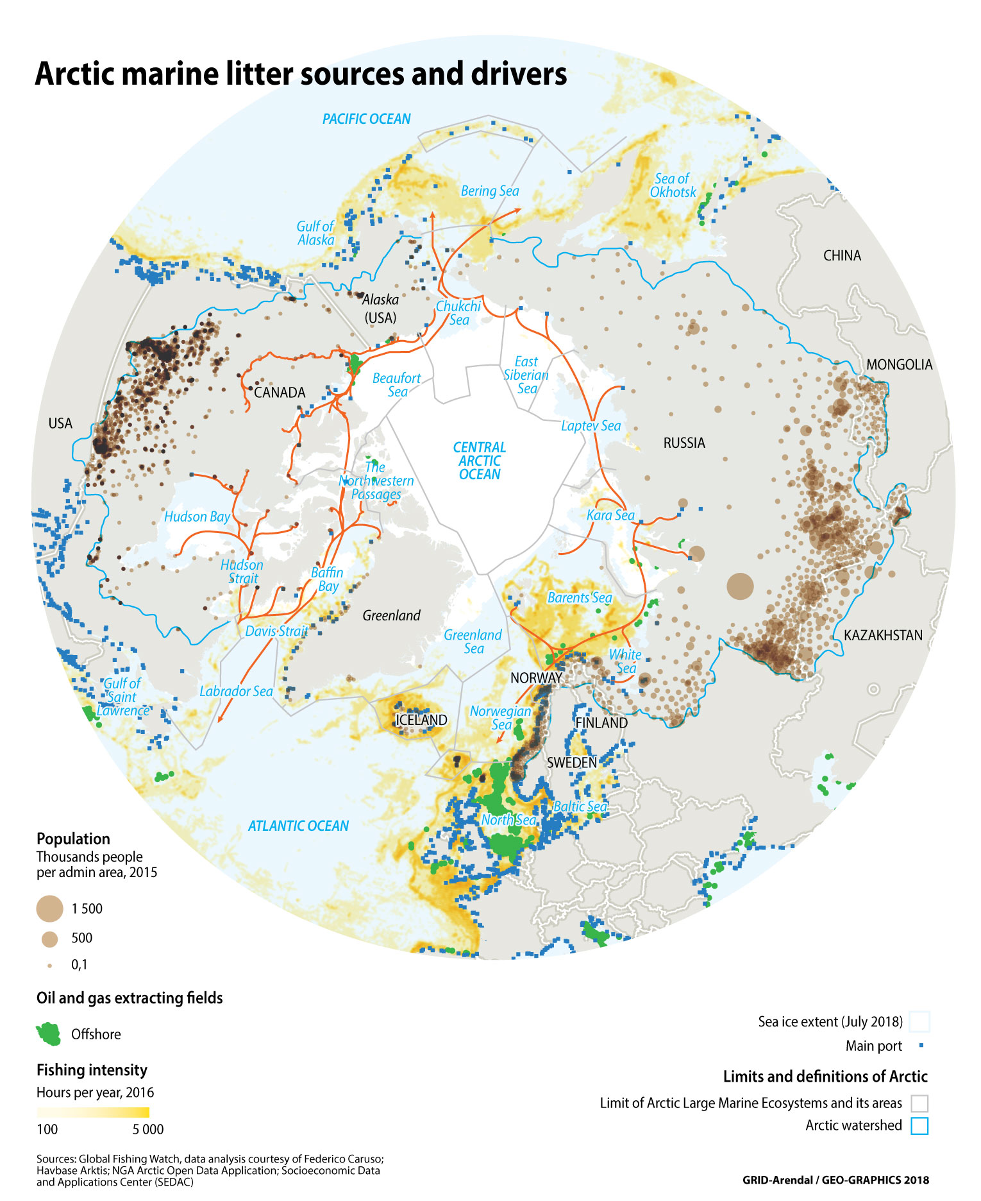
Figure III.1

Sea-based sources
[A priori this will include mainly fisheries (including commercial, subsistence, and recreational), aquaculture, shipping and cruise tourism and offshore resource exploration. Details will be provided on the specific types of activities within each sector that may lead to plastic pollution, whenever possible.]
The major sectors of maritime activity in the Arctic region are fisheries (including commercial, subsistence, and recreational), aquaculture, and shipping, including cruise tourism. One emerging sector of activity that may need consideration is offshore resource exploration and exploitation, including the use and potential discharge of plastic materials contained in offshore chemicals (Moskeland et al., 2018) .

Fisheries
Abandoned, lost or otherwise discarded fishing gear (ALDFG) is recognised as a major source of marine litter in the Arctic, more concretely in the Greenland, Norwegian, Barents and Bering Seas and the neighbouring areas of the North Atlantic and North Pacific Oceans (i.e. June, 1990; King, 2009; OSPAR Commission, 2009; Bergmann et al., 2017a; Buhl-Mortensen and Buhl-Mortensen, 2017; Nashoug, 2017; Weslawski and Kotwicki, 2018). Besides ALDFG, the use of fishing gear involves wear and tear that will lead to fragments or pieces of the gear being released in the ocean. For example, bottom fishing nets lose large quantities of attached dolly ropes aimed at protecting the net from abrasive ground contact (e.g. Murray and Cowie, 2011).
Classification of the objects collected during beach surveys in Svalbard established that between 44 and 100% of the mass of litter collected was contributed by fisheries-related items (Bergmann et al., 2017a). Fisheries-related objects are large and relatively dense and therefore their relative mass contribution will always be large in comparison to the number of objects collected. Based on research carried out in Svalbard, fisheries related objects are either large and dense or relatively small. Examples of smaller parts are net cuttings, strapping band and sheeting. Most probably also a large percentage of household litter items, but these are harder to link to a specific source. These smaller items make up a significant share of all litter in terms of the number of items. Examples of larger parts are ropes and (sections) of netting. The number of these items are much lower, but due to the large size and heavy weight of ropes and nets, the mass contribution of these two items is highest of all litter items. When survey data include this type of large fisheries objects the percentage of fisheries items by mass will be correspondingly high and so will be mass stocks when estimating these based on these percentages. Most fishing gear that ends up on beaches and can be analysed is made out of material that floats. This means that material that does not float, such as set nets or crab pots do not end up on beaches and remain in the sea. Almost all fishing gear ending up in beaches on the archipelago of Svalbard originates from bottom trawling (Strietman et al., unpubl. data): netting from cod and shrimp trawls; trawl bobbins and floats, including those that were attached to the nettings, ropes and rope pieces or bundles of packing bands that may have been used on fishing boats to seal cardboard or styrofoam boxes containing seafood or by other sea- and land-based industries. Trawling-related gear tends to predominate in beach surveys with 90% of all nets found on Svalbard beaches originating from bottom trawling in the Barents Sea (Strietman et al, unpubl. data). This is likely because two reasons. First bottom trawling is the main type of fisheries in the Barents Sea and the Svalbard Fisheries Protected Zone (Nashoug, 2017). Second the material used in these type of nettings floats and therefore ends up on beaches. Set nets and other non-floating fishing gear will sink when lost or discarded and not reach the shore (Strietman et al, unpubl. data). Fish crates that might also be used at sea or on land originated from Norway, Denmark, Spain, United Kingdom, Iceland and Faroe Islands providing an indication of the fleets active in the region (and contributing to litter), although crates also tend to circulate among vessels from different countries. Detailed observations of some of the objects for which origin can be determined (i.e., fishing nets or ropes) may sometimes also allow the identification of the release mechanism (Nashoug, 2017). The analysis of 100 fishing nets collected during clean-ups in Svalbard during the summer of 2017 and 2018 revealed that all of these fishing nets were sections of nets that had been replaced by new parts after they were damaged during fishing operations. Some of the nets pieces exceded 20 m² while most of them were more than 10 m². Based on judgement by Norwegian fisheries experts, at least 80-90% of these sections have been deliberately discarded after replacement with new sections of net (Nashoug, 2017; Strietman et al, unpubl. data). It is also worth noting, that at least 60-70% of all ropes collected on Svalbard shores are fisheries related but it is not possible to further specify the type of fisheries.
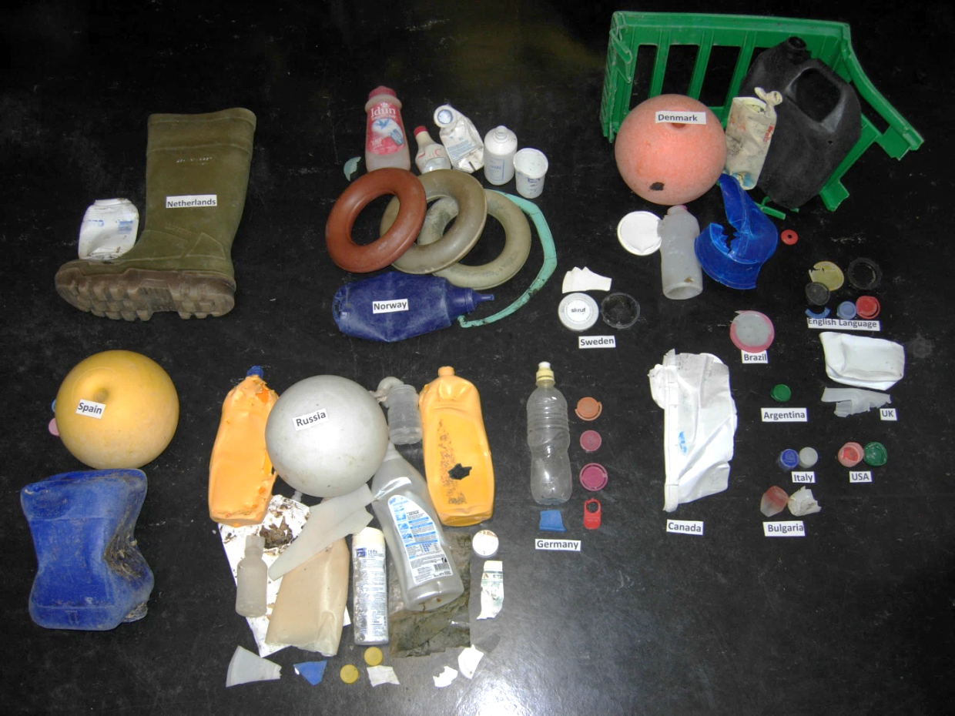
Figure III.2. Litter items with readable embossed text or labels collected from a beach of the Hinlopen Strait, Svalbard Archipelago (Credit: M. Bergmann, AWI).
A close inspection of litter beached on Svalbard showed that the majority of litter items with identifieable imprints originated from Norway and Russia (41%), other European countries (43%), or more distant sources including Canada, USA, Brazil, Argentina (9%) (Bergmann et al., unpubl. data, Figure III.2). Still, it is important to bear in mind that the identification of the country of production of an object does not mean that the actors involved in the release are also from the same country as the object could have been internationally traded. Similarly and also very important, the country of production of an object does not indicate where the object has been released, as it could have been transported for long distances before being released in the environment.
Litter from the fishing industry was also prevalent in the Bering Sea and Subarctic Northern Pacific, around the Aleutian Islands and Alaska Peninsula in the 1970s-80s (Johnson, 1990; June, 1990; Manville, 1990) and is still very present in more recent surveys where, besides the input linked to local fisheries, the influx of debris related to the 2011 tsunami in Japan is also detected (Polasek et al., 2017). Trawl net fragments (ropes, nets, floats, straps, etc.) were the primary type of litter, the number of which kept increasing from year to year, with the highest quantity of 216 fragments/km in Little Tanaga Island (Johnson, 1990). Beach litter studies carried out in Amchitka Island in 1972-74 (before the entry in force of MARPOL 73/78) allowed Merrell (1980) to estimate that a fleet of 1,457 vessels operating in the North Pacific and Bering Sea released 1,665 metric tons of litter into the ocean during 1972, so more than one metric ton per vessel per year. A correlation between the quantity of litter on AmchitkaIsland and the establishment of fisheries conservation zones and number of vessels in surrounding waters was noted by Merrell (1984) and illustrated how regulations, in this case fishing permits, can lead to a dramatic reduction of fisheries-related items. Countries of origin for litter found on Aleutian shores during the 70’s and 80’s were Japan, the former USSR, USA, China, Korea, with Japanese fishing nets being positively identified the most often (Merrell, 1980, 1984; Johnson, 1990; Manville, 1990). Identification of the fleet of origin of the fisheries-related items based on the different configurations and combinations of gear allowed conclusions to be drawn on the relationship between the decrease in the presence of litter and the establishment of fisheries area regulations restrinting fishing activity of certain fleets.
The central Bering Sea crab fishery was identified as a major contributor to litter washed onto the shores of the Pribilof Islands with up to 70% contribution from this activity and annual accumulation rates of up to several hundreds of kilograms per kilometer (King, 2009).
Comparison of the reports on the literature of the Arctic areas identified as most severely affected by litter related to fisheries with the areas with the highest fishing (and especially trawling) effort as depicted in Kroodsma et al. (2018) (Figure III.1) reveal a significant correlation. The wealth of information gathered in this study on fishing effort could be mapped at high resolution to ascertain the areas with highest likelihood for input of marine litter associated with the fisheries sector.

Aquaculture
Studies of marine litter in the Arctic do not provide information about the presence of debris associated specifically with aquaculture such as nets, ropes, floats, pipes and packaging material and containers. It is difficult to identify items that are specific to this activity unless they are recovered in close proximity to where aquaculture activities occur or have clear distinguishing markers. Overall, the importance of this sector, and therefore its potential contribution to marine litter, is relatively small compared to the fisheries sector but, on a local scale, it may still contribute significantly. In certain areas of the Norwegian coast aquaculture is estimated to be the source of approximately 30% of the total amount of marine litter detected (OSPAR Commission, 2009).
As for fisheries, detailed mapping of the areas where aquaculture is occurring would provide an indication of where the highest potential pressure associated with aquaculture may occur. Aquaculture in the Arctic has grown significantly in the last two decades. It is dominated by Norway (Nordland, Troms and Finnmark counties), which accounts for 93% of the total value of Arctic aquaculture, with a concentration on salmonid production. While Canada is the second largest producer amongst the Arctic nations, concentrating also on salmonids and shellfish, this is largely due to production in British Columbia, well south of the Arctic region, and only some operations in Newfoundland and Quebec. Iceland has an incipient but valuable production of arctic char (Hermansen and Troell, 2012; Troell et al., 2017).

Shipping
Under shipping sources, consideration is made regarding sources connected to all types of ships, except fisheries specific litter that is considered separately above. This category includes all kinds of materials and goods transporting ships, offshore industry ships and passenger ships including cruise tourism ships.
The potential contribution from shipping to marine litter pollution in the Arctic has been highlighted in several studies (Shaw, 1977; Bergmann and Klages, 2012; Bergmann et al., 2017a; Buhl-Mortensen and Buhl-Mortensen, 2017; Tekman et al., 2017), but as is the case for aquaculture, it is difficult to ascertain its relative contribution to marine litter based on source identification of the litter, as there is no unequivocal identification of objects or fragments contributed by ships on transit across Arctic waters. Common houselhold items (food, cleaning and personal hygiene products, etc.) are part of the waste generated onboard vessels. When this type of litter is found at sea, it is virtually impossible to determine whether the release occurred in a vessel or on land and even less which type of vessel.
Nashoug (2017) reported that a large amount and variety of household plastics (bottles and containers for beverages, ketchup, hygiene and laundry products, etc., see also Fig. III.2) of different nationalities was found on the beaches of Northwestern Svalbard. The remoteness of the locations where the products were found, far away from large population centers, makes the release from either fishing, merchant or cruise ships plausible. Also, large-sized food containers could indicate their release being connected to the galleys of larger vessels.
In addition to the discard or loss of solid domestic waste or other activity related waste, i.e. packaging or securing materials, the discharge of greywater, sewage and/or sludge could also contribute microplastics from cosmetics or microfibers from textiles– although the exact contribution is yet unknown. Furthermore, the discharge of processed (comminuted) food waste can also potentially lead to leakage of plastic debris and microplastics if waste separation is not adequately carried out.
The data contained in the Arctic Ship Traffic Database allows mapping of shipping routes to reflect the number of voyages and tonnage of the ships transiting the Arctic (Arctic Council, 2009) and provides a proxy for the areas that are potentially exposed to inputs from maritime traffic. The data in the database allow monthly and yearly analyses of shipping intensity, providing opportunities for assessments of seasonal and long-term variability in potential inputs.

Offshore resource exploration and exploitation
In addition, and although the limited knowledge about microplastic from oil and gas extraction activities is not fully conclusive (Moskeland et al., 2018), its contribution could be considered in future source assessments. Moskeland et al. (2018) identified through their study of the Norwegian continental shelf that highest microplastics concentrations are in general found at locations close to oil and gas installations. The mapping of the distribution of rigs and platforms in the Arctic also provides proxy data for the geographic distribution of the potential input related to this kind of activities.

Land-based sources
[Similar to sea-based sources, this will address activities on land that constitute the largest sources of land-based plastic pollution in Arctic marine environments. As for other regions, mismanaged domestic and industrial waste will likely dominate the land-based sources though documentation may be limited. Other potential sources that will be considered are transportation/logistics, mining and agriculture. Any other land-based sources that are identified in the Arctic region will be documented.]

Waste and wastewater management
At the global level, a major challenge to minimizing the input of litter and waste from land into the ocean is the lack of adequate waste management in coastal regions with a high and growing population density (Jambeck et al., 2015). As discussed above, due to overall low population densities in Arctic coastal areas, the localized pressure resulting from land-based inputs should be relatively low overall. Nevertheless, some specificities of the Arctic, such as population concentration along the coastline and river courses; settlements not covered by any waste collection schemes; remoteness, meaning lack of connection with network of large (regional or national) waste management systems; and lack of or deficient local waste management systems, may lead to locally high inputs linked to industrial or domestic waste management.
In small Arctic communities, solid waste collection and disposal is very basic. Recycling and baling facilities are rare and generally limited to larger communities. Collection in very small communities is typically by self-haul while larger communities often use community-haul systems (Warren et al., 2016). In some Arctic communities traditional waste management solutions are uncontrolled waste dumps, sometimes along the shoreline, and simple incinerators with no or limited flue gas treatment (Kirkelund et al., 2017). This has been documented to be the case for example in Greenland (Eisted and Christensen, 2011) and in Iqaluit in the Canadian Arctic (Samuelson, 1998). Inadequate or lacking wastewater treatment further contributes to the waste management problem as wastewater often contains traces of personal care products and many other contaminants originating from both households and industrial facilities (Gunnarsdóttir et al., 2013). Sewage and wastewater treatment differs geographically but overall deficient the Arctic, resulting in a continuous discharge of sewage and wastewater from households, hospitals and smaller industries directly to the coastal waters (Granberg et al., 2017). Magnusson et al. (2016) found that around 6 million microlitter particles (≥ 100 µm) were released per hour into the sea from from the Klettagarđar wastewater treatment plant receiving wastewater from the city of Reykjavik. At this plant only mechanical treatment, consisting only of a coarse grid that retains mainly larger debris, is applied to wastewater. In the same study, effluent water from six Nordic wastewater treatment plants were investigated and the efficiency of different treatment systems compared. Large quantities of microplastic fibers shed from washing synthetic textiles (de Falco et al., 2017), which are frequently worn in the cold polar regions, may reach the marine environment or be captured depending on the type of treatment applied. Sweden, for example, has developed technology to remove medicine via wastewater treatment, and thereby also microplastics are removed . This treatment is somewhat expensive and used in some regions.
There are very few studies looking specifically at the leakage and marine input of plastic debris linked to Arctic waste management systems, but ongoing work to quantify and characterize beach litter (Kirkfeldt, 2016; Strand and et al., in prep.) points towards potential input from inadequate waste management on the western shores of Greenland, where 90% of the Greenlandic population is concentrated. The composition of the waste accumulated in western Greenland survey sites resembles the composition of surveys carried out in the Skagerrak region, where the influence from higher population density along the coastline is reflected in the litter composition. In contrast, the composition of beach litter surveyed in Eastern Greenland, facing the intensively fished Barents sea and where there are fewer settlements, more closely resembles that of northern Norway and Svalbard where the imprint of fishing activities was compositionally registered (Strand, 2018).
In addition, a study looking into microplastics in the vicinity of Reykjavik, Iceland (Dippo, 2012), has reported exceptionally high concentrations of small plastic fragments and microplastics from a sandy beach near Reykjavik harbor. Though not specified in this report, the exceptionally high concentration of microplastics, including large amounts of plastic fibers and film, could be linked to this particular location, which is close to the harbor and a waste management facility. Therefore, even in areas of the Arctic with adequate waste collection and management systems, the proximity of waste management facilities to the shoreline should be taken into due consideration.
In order to gain further insight on the potential release of plastics associated with waste management, it could be useful to map the distribution of population density, as well as the location of urban settlements, as this information will provide an indication of potential localized points of release of plastic waste into the environment. This kind of information is readily available at a sufficient resolution. Of course, information on the quality of sewage treatment plants and waste management systems, i.e., coverage of waste and wastewater collection schemes, distribution of waste transfer and management facilities and dumpsites and their standards, would allow further inferences to be drawn on the potential and intensity of release. Jambeck et al. (2015) used national average values for waste mismanagement to estimate the contributions at the national level, but due to the singularities of the Arctic, it would be desirable to use higher-resolution information specific for the Arctic region or local assessments to better gauge the potential contribution from this source.

Transportation and logistics
In addition to releases linked to waste transportation, the distribution of goods, including plastic in any of its intermediate forms (pellets, powders etc.) before it is incorporated or turned into a product, can lead to man-made products leaving the intended cycle (UNEP, 2016; UNEP and GRID-Arendal, 2016). Most of the transfer of goods, including waste, will happen alongside the transport infrastructure network. Because of the lack of specific assessments on the release of litter during transportation, a map of the main transportation network, including roads and harbours, could improve the understanding of the areas where potential inputs can occur. Information on the density of the transportation network and the traffic on that network can provide a proxy for the potential intensity for release. The Arctic Ship Traffic Database contains information on ports in the Arctic that could be used to gauge the intensity of port activity to identify which of the port areas could potentially be receiving the largest inputs.

Extractive sector, construction and tourism
Finally, the extractive sector (including agriculture and mining), construction and tourism, also run all or part of their operations outdoors in the natural environment and may also be a source of litter release into the environment (UNEP, 2016; UNEP and GRID-Arendal, 2016). The distribution and intensity of the activity of these sectors in the Arctic watershed is highly variable and may overall not represent a large contribution, but again, there are no assessments or studies on the contributions from these sectors to litter in the Arctic region. The compilation of proxy indicators for the potential release from these activities - such as geographic distribution and material intensive they are (i.e., plasticulture, amount of plastic, machined wood and other materials used in Arctic construction, single-use plastic in outdoor tourism industry), and indications on the ratio of release into the environment - could allow a better assessment of their potential contribution to marine litter.

III.2. Pathways and Distribution
The description and understanding of the pathways of the entry of marine litter into Arctic waters is a crucial element in tracing the litter back to its sources. In addition, the knowledge and understanding of the distribution of marine litter within the Arctic is limited and therefore the consideration of potential pathways and documented (if any) entry or inflow of litter to the Arctic Ocean is a meaningful proxy to its distribution, pointing at likely areas for passage or (temporary) accumulation of debris and particles. Better understanding the fate of litter within the Arctic will allow consideration of measures for the removal and therefore reduction of potential impacts caused by its accumulation.

Pathways
A complete understanding of the input of litter, including microplastics into the Arctic marine environment needs consideration of the source sectors and the mechanisms of release as well as the pathways by which the debris reaches the marine environment (Fig. III.3). If the release occurs in the terrestrial environment, there has to be a pathway or combination of pathways connecting the point of release with the point of entry into the marine environment. Rivers and other waterways and wind or atmospheric circulation constitute such pathways.
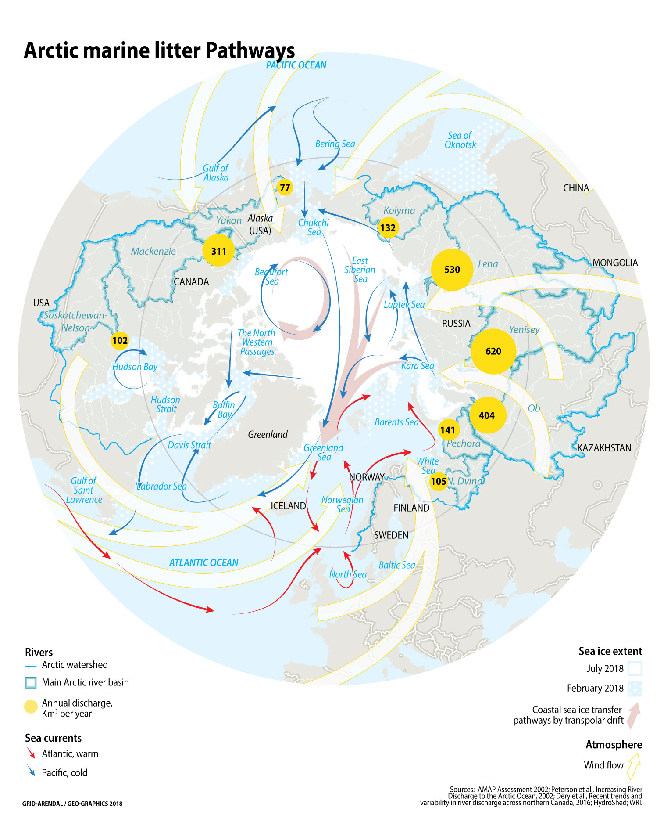
Figure III.3
When considering the presence of debris and microplastics in a part of the global ocean, in this case in the Arctic Ocean, there is a need to consider their transfer into the area considered through the regional circulation pathway.
The understanding of the input through these pathways is crucial in gauging the relative importance of local sea-based or coastal sources versus remote sources within the Arctic watershed or from other parts of the ocean.

Riverine transport
The Arctic watershed is vast and extends well beyond any of the boundaries traditionally used to define the Arctic region. The ten largest rivers in the Artic watershed are the Yenisey, Lena, Ob’, Mackenzie, Yukon, Kolyma, Nelson, Indigirka, Pechora and Dvina (AMAP, 1998). In terms of freshwater discharge, the Yenisey has the largest discharge with 673 km³/year, followed closely by the Lena with 581 km³/year. The watershed of the Ob’ encompasses the largest population of the ten rivers, with over 28 million people living in it, which is more than three times the population of the second most populated watershed, the Yenisey (8 million people) and more than 25 times the population within the Lena watershed (Shiklomanov et al., 2018). Siberian rivers discharging into the Kara, Laptev and East Siberian Seas have a huge combined drainage area of 9 million km² extending far south (Shiklomanov and Skakalsky, 1994) and encompassing many industrial and agricultural regions.
Massive river discharges make terrestrial influences particularly strong in the Arctic Ocean. While it holds less than 1% of the global ocean volume, the Arctic Ocean receives more than 10% of the global river discharge (Holmes et al., 2011). Waters of riverine origin can be traced throughout the Arctic Basin due to large outflows and the extensive ice cover, which minimizes mixing. Arctic rivers have an extreme seasonal pattern with a sudden flow peak during spring thaw, decrease over summer, and minimum flow values just before spring thaw again. This seasonal pattern affects the transfer of any suspended or floating materials, as well as litter, which would peak also during thaw. The transfer of floating litter would normally be hampered during winter when the river surface is frozen.
To date, there is no monitoring of the flux of litter, including microplastics, from rivers into the Arctic, and though it has been identified as a possible pathway (Kanhai et al., 2018), the contribution of riverine discharge to the input plastic and other materials in the Arctic is projected to be low due to the fact that these rivers flow through sparsely populated watersheds (Obbard et al., 2014). This assumption would benefit from verification in the light of the fact that the population in the Ob’, Yenisey and Lena watersheds, which extend beyond Arctic boundaries, is 38 million people, an order of magnitude larger than the population of the entire Arctic region. In addition, the wastewater generated by remote Arctic populations may be characterised by low population equivalents such that their effluents undergo only low or mostly no sewage treatment at all, potentially resulting in litter and microplastics direct leakage into water courses that transfer these to the Arctic Ocean. The leakage may even increase when areas with combined sewage and stormwater sewer systems are not capable of receiving large volumes of wastewater during severe rainfalls or thaw peaks and allow an overflow of untreated sewage and polluted stormwaters into receiving surface waters. During these occasions, even in areas where wastewater is treated to some extent, the overflow may not only contain microplastics, but even meso and macroplastics (Axelsson and van Sebille, 2017) and debris of other materials.
Lebreton et al. (2017) and Schmidt et al. (2017) modelled global plastic transfer from rivers into oceans based on waste management capacity, population density and hydrological information. Unfortunately, data on the watersheds and drainage network for areas north of 60º is not available in the global database used, and therefore this global model does not include modeled plastic input from Arctic rivers. The relative importance of marine litter input through Arctic rivers should be further considered in the light of the facts outlined above.

Atmospheric transport
At the global level, it is assumed that much less plastic debris is transported by wind than by rivers (UNEP and GRID-Arendal, 2016) though, in contrast with rivers, there is currently no global estimate of the input through this pathway. However, wind transport of plastic debris may be significant, particularly in arid and semi-arid areas with reduced surface runoff and dry and windy conditions. Wind may be an important localized pathway for lightweight debris, particularly from waste dumpsites located near or at the coast line, or beside watercourses. During intense storms such as blizzards or hurricanes, wind can mobilize debris that would not normally be available for transport and carry it directly into rivers and the ocean (Lebreton et al., 2012). The Arctic is characterized by windy shorelines, it is dry, with frozen ground, for a large part of the year, and there are multitude of small communities with open dumpsites near the ocean.
Though atmospheric circulation has been proven elsewhere to provide an efficient pathway for the transportation of microfibres and small plastic particles, such as tyre dust, (Cai et al., 2017; Dris et al., 2017), there are to date no published data on plastics and microplastics in air in the Arctic region (Halsband and Herzke, 2017). However, microplastics were detected in all of the snow samples taken from drifting sea ice in the Fram Strait and Svalbard, with up to 10,000 microplastic particles per liter snow, indicating atmospheric transport and fallout as a prime pathway (Bergmann et al., in prep.).

Oceanic transport
The movement of particles by ocean currents constitutes an additional source of marine litter, including microplastics, in the Arctic. The Arctic marine region is well connected to the global ocean through the southern edges of the Norwegian Sea and the Greenland Sea (Denmark Strait), where it meets the North Atlantic Ocean, and through the Bering Strait and the Bering Sea exchanging with the North Pacific Ocean. The influence of the Atlantic is much larger than that of the Pacific, as most of the water in the Arctic Ocean originates from the Atlantic Ocean (79%), while the inflow through the Bering Strait is lower (19%) (AMAP, 1998).
The exchange of water, and with it of any drifting plastic litter, from and to the North Atlantic Ocean has been addressed by the odelling work of van Sebille et al. (2012) that reflected the formation of an accumulation zone on each of the five subtropical basins and one previously unreported patch in the Barents Sea, which they linked to slow surface convergence due to deep-water formation. Recently, Cózar et al. (2017) postulated that both the surface circulation models and the field data reported in their study showed the poleward branch of the Thermohaline Circulation transferring floating debris from the North Atlantic to the Greenland and Barents Seas, where they would find a dead end of this plastic conveyor belt. Before these modelling and field work studies provided details on the accumulation of plastics in the Barents and Greenland Seas, Zarfl and Matthies (2010) had already estimated the flux of plastic (surface water flow times the plastic concentration in surface water mass), and that of the toxic substances associated with them, concluding that the fluxes associated with plastic drift are 5 to 6 orders of magnitude smaller than those from the same substances dissolved in the sea water or transported to the region through the atmosphere. Nevertheless, they pointed out that the significance of various pollutant transport routes does not depend only on absolute mass fluxes but also on bioaccumulation in marine food chains, as will be discussed later.
In addition to the input by drifting oceanic waters, Peeken et al. (2018) postulate, through their recent study of microplastics in sea ice cores, that sea ice drift is a pathway for the dispersion and transfer of microplastics from the areas of sea-ice formation in the Amerasian and Eurasian Basins, through the Transpolar Drift and ultimately towards the Fram Strait and the North Atlantic. This transfer mechanism is also shown to provide a dispersion pathway for the waters of the Siberian rivers towards the Barents and Nordic Seas (Pavlov, 2007).

Distribution
Litter, including microplastics, has been observed in all environmental compartments across the Arctic marine environment (Fig. III.4). Even in some locations distant from hubs of human activity, marine litter abundance is within the same order of magnitude to that of populated areas close to urban centers (Hallanger and Gabrielsen, 2018). It should be borne in mind that the distribution of documented observations of marine litter, including plastics and microplastics, is heavily dominated by higher accessibility and increased research activity in the Atlantic Arctic (Norwegian, Greenland and Barents Sea), as well as in the Bering Sea and the Gulf of Alaska and their coastal areas. Compositionally speaking, data regarding materials other than plastic is only available for beach and sea-floor surveys, as sea ice, surface waters, water column, and sediment studies have only focused on the concentration of plastic litter and microplastics.
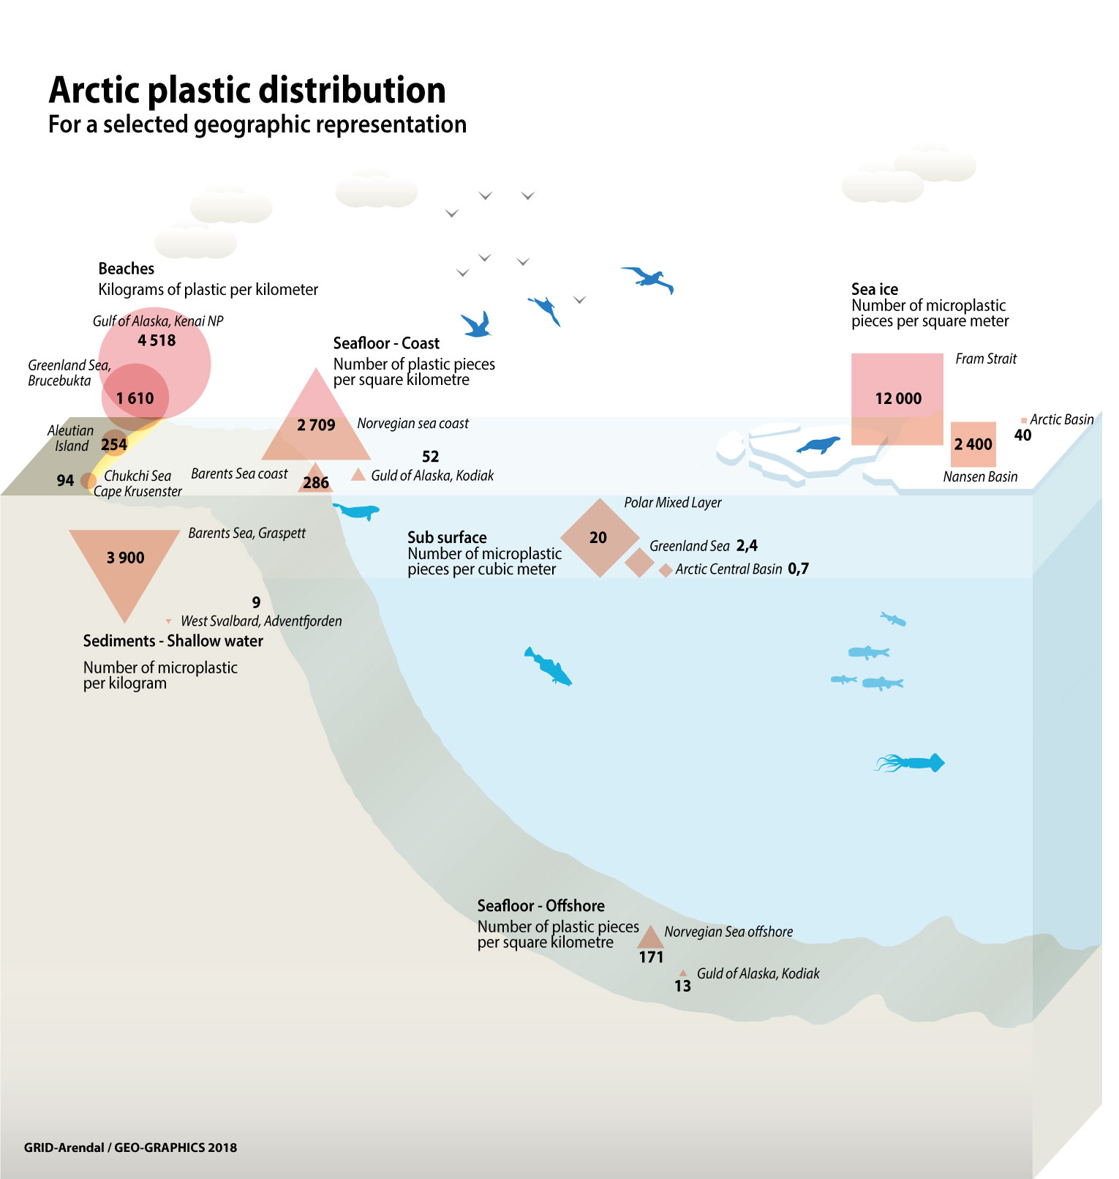
Figure III.4

Beaches and shorelines
Information on litter accumulated on the surface of beaches is mostly limited to objects easily observed by the naked eye when inspecting beaches, and therefore the information on beached plastics corresponds to meso and macrolitter (Table 2.1). Information concerning microplastics on beaches is gathered through the collection and analysis of sediment samples (beach sand) and is discussed in the Sediments subsection.
A wealth of information regarding marine litter accumulated on beaches of the Aleutian Islands was compiled during pioneering studies in the 1970s and 1980s. Hundreds of objects per kilometre were counted in several beaches in Amchitka, Attu, Agattu, Shemya, Buldir, Kiska, Little Kiska, and Adak Islands (i.e. Merrell, 1980; Merrell, 1984; Johnson, 1990; Manville, 1990). This was estimated to correspond to hundreds of kilograms per kilometre with most of it connected to intense fishing activity by Russian, Japanese and U.S. fishing fleets. More than 90% of the litter mass was associated with trawl nets or parts of them. A study recently published by Polasek et al. (2017) documented the presence of litter in three parks in the Gulf of Alaska (which is outside this Desktop Study area) and two in the Chuckchi Sea north of the Bering Strait. The density of debris in the Gulf of Alaska reached up to 4,196 kg/km but only 63 kg/km on the southeastern shores of Chukchi, lower than previously observed in the southern Bering Sea. While the shores of parks facing the Gulf of Alaska are directly exposed to inputs resulting from intense fishing and shipping activities in the Gulf of Alaska and northeastern Pacific, the shores of the southeastern Chukchi Sea receive fewer inputs due to much lower local fishing and shipping activity and likely to the limited input related to litter drifting from the Bering Sea northwards into the Arctic Ocean through the Bering Strait.
In the OSPAR region, beach litter is monitored at 17 sites within the Atlantic Arctic, with 36 surveys conducted in 2017. The amount of beach litter varied from a mean of 1,475 items per 100 m in the spring to 195 items per 100 m in the summer months. Plastic accounted for up to 94% of the material in the spring surveys (OSPAR. Pers. Comm.). The presence of beach litter has been documented on the shores of Svalbard facing the Arctic Ocean and the Fram Strait, with densities from 185 to 1,354 kg/km, with the exception of a site where density reached a maximum value of 7,331 kg/km due to the presence of a heavy fishing net in the area surveyed (Bergmann et al., 2017a). As on the shores of the Bering and Chukchi Seas and the Gulf of Alaska,, fisheries-related litter dominated the litter composition on Svalbard’s beaches, accounting for 48 to 100% of the mass. This dominance has also been reported in a study by Weslawski and Kotwicki (2018), carried out on the west coast of Prins Karl Forlandet (westernmost island of Svalbard archipelago). Surveys on the northwestern tip of Iceland revealed lower densities of litter, mostly plastic, with an average of 1,040 items/km corresponding to an average of 104 kg/km originating mostly from Icelandic fisheries (Kienitz, 2013). Surveying according to the OSPAR beach protocol has also been recently initiated at several locations on the eastern and western shores of Greenland (Strand and et al., in prep.). Initial results reveal similar median densities for the west coast, with 1,200 items/km, compared to much lower densities of 30 items/km in the East. Analysis of the type of objects collected reveals the dominance of local sources, i.e. mismanaged domestic waste or Barents/Greenland Sea fisheries over long-range transport, especially for west Greenland.

Sea ice
The widespread presence of marine plastic litter and microplastics in all compartments of the marine environment has spurred interest on veryfing this is also the case for the unique Artcic environment where sea ice constitutes and dditional compartment not present at lower latitudes. Observations of microplastic particles within sea ice in the Arctic are limited (Table 2.2) but enough to corroborate its presence. Obbard et al. (2014) documented concentrations ranging between 38 and 234 x 10³ n/m³ in sea ice cores collected in the central Arctic Ocean and Chuckchi Sea in 2005 and 2010. Recently published results from cores collected in the Fram Strait and the Central Arctic north of Svalbard (Peeken et al., 2018) revealed even higher concentrations of microplastics in sea ice, reaching maximum values of 1.2 ± 1.4 × 10⁷n/m³ in pack ice in the Fram Strait and minimum values of 1.1 ± 0.8 × 10⁶n/m³ just north of Svalbard. These concentrations are several orders of magnitude higher than those of Obbard et al. (2014), likely due to different methodologies used, and further confirm that sea ice is an important temporary sink of plastic litter. The second highest concentration was recorded in landfast ice, which was formed locally off east Greenland, highlighting a contamination of east Greenland surface waters at the time of ice formation. However, back-tracking ice drift trajectories from the location where the other ice cores were obtained showed that microplastics were likely entrained into the ice in the Kara and Laptev Seas and the Central Arctic Ocean and transported to the south with the Transpolar Drift. In addition, the differences in the amounts and composition of microplastic in different depths of the cores point to strong local differences in microplastics present in seawater during the process of ice formation.

Surface and sub-surface waters
Information on floating litter in surface waters is gathered through several methods. For the largest size fractions, visual observations from ships and even low-flying helicopter flights are available for the Barents Sea and Fram Strait (Bergmann et al., 2016) with an average of 0.001 items (all of them plastic) per kilometre. The smaller fractions are studied through the use of surface samplers, water pumps and stomach content analyses of the seabird Fulmarus glacialis or northern fulmar (i.e. OSPAR Commission, 2015; van Franeker and Law, 2015). For these size fractions only plastic is considered in the studies as the other materials either sink (glass, metal and ceramics), disintegrate (cardboard) or are difficult to distinguish from natural particles (machined wood). As for beached litter, information from several pioneering surveys carried out during the 1970’s and 1980’s in the Bering Sea, Gulf of Alaska and Subarctic North Pacific (Shaw, 1977; Day and Shaw, 1987; Day et al., 1990) revealed that the concentration of plastic in neuston surface waters samples (collected using slightly different net devices with mesh sizes of 0.333 - 0.5 mm and therefore sampling mostly microplastics (<5 mm) and mesoplastics) decreased from the Subarctic North Pacific towards to the Gulf of Alaska and the Bering Sea (Table 2.2). However, concentrations in the Bering Sea have increased from the mid 1970’s from tens of particles to thousands of particles per square kilometre (Table 2.2 and references therein). Still, concentrations in the Bering Sea in 2006 (0.017±0.010 - 0.072±0.041 n/m³, Doyle et al. (2011)) were one order of magnitude lower than concentrations in the Atlantic Arctic in 2014 (0.34±0.31 n/m³, Lusher et al., 2016). Cózar et al. (2017) recorded surface concentration of plastics in parts of the Norwegian and Barents Sea to have a median value of 0.063 n/m² in 2013. These concentrations are similar to median concentrations for subtropical accumulation zones associated with the subtropical oceanic gyres (0.044 n/m²) and one order of magnitude above the medians for non-accumulation open waters (0.0019 n/m²) (Cózar et al., 2017). Therefore, plastic abundance in certain areas of the Atlantic Arctic is comparable to the abundance in the subtropical oceanic gyres, although maximum values for subtropical oceanic gyres (1.3 n/m²) are one order of magnitude above maximum values recorded in the Barents Sea (0.32 n/m²; Cózar et al., 2017).
Studies of ingestion of surface plastic particles by northern fulmars show that levels of floating litter in the Atlantic Arctic and in the Gulf of Alaska are significantly lower than those in the North Sea and the Eastern North Pacific (Provencher et al., 2017). Despite this northwards decreasing trend, floating plastic is certainly present at high latitudes and much higher in the Atlantic sector of the Arctic than, for example in the Canadian Artic, with almost 90% of the individuals with ingested plastic in the Svalbard region compared to 40% in the Canadian Arctic (Trevail et al., 2015a; Provencher et al., 2017).
Scattered information from subsurface water samples (Lusher et al., 2015; Sundet et al., 2017) could not provide any insight on the vertical distribution of microplastics near the surface. The increase of plastic litter over time in the Bering Sea may be related to transportation of litter from other areas where concentration has been increasing due to increasing input (Day and Shaw, 1987). According to the data modelled by van Sebille et al. (2012) and measured by Cózar et al. (2017) plastics are likely concentrated in the Norwegian and Barents Seas surface waters as a result of the flow of water loaded with particles from the North Atlantic and the subsequent sinking and deep water formation in the Barents Sea. The recent study by Peeken et al. (2018) points to further pathways, i.e. southwards drift of particles from the Central Arctic to the Fram Strait with the Transpolar drift. High quantities of litter and microplastic in the Fram Strait are therefore potentially linked to (1) increasing local sources, (2) transport N->S (Transpolar Drift, engaging also pollutants from the Pacific and rivers) and (3) transport S->N (thermohaline circulation). Van Sebille et al. (2012) and Cózar et al. (2017) did not fully consider the transpolar drifts in their models and regarded the ice as a barrier more than a source.
The present and potential future increase of human activities in a warmer Arctic with longer ice-free seasons may favor the dispersion and increased concentration of plastic particles in Arctic surface waters (Cózar et al., 2017). Peeken et al. (2018) also highlight that the presence of microplastics in Arctic waters may increase with increased human activity and as a result of increased sea ice melt.

Water column
Data on the concentration of plastic within deeper parts of the water column that provide insight on the three-dimensional distribution of plastics in the Arctic, or even other parts of the ocean, is scarce (Table 2.2). Amelineau et al. (2016) gathered data on the concentration of microplastics across the top 50 metres of the water column near the eastern coast of Greenland and found concentrations within the same range and order of magnitude as those recorded in subsurface water samples in the Greenland and Norwegian Sea between Norway and Svalbard (Lusher et al., 2016). Morgana et al. (2018) reported values for the Northeastern Greenland Sea very similar to the values reported by the previous two studies in nearby regions confirming the ubiquitous presence in the Greenland Sea and Fram Strait.
Kanhai et al. (2018) showed the ranges for microplastic abundance (n/m³) across the different water masses in the Arctic Central Basin to be as follows: Polar Mixed Layer (0–375) > Deep and bottom waters (0–104) > Atlantic water (0–95) > Halocline waters i.e. Atlantic or Pacific (0–83). These values confirm that microplastics are present throughout the whole water column in the central Arctic Ocean, that they are being transported downwards out of the surface waters and that the water column constitutes one of the reservoirs of microplastics in the region. Using large volume pumps and Fourier-transform infrared spectroscopy imaging techniques, Tekman et al. (in prep.) detected higher mean microplastic concentrations at the sea surface (510 n/m³) and at 300 - 2500 m water depths (190 n/m³) in the eastern Fram Strait, indicating that higher abundance of microplastics and presence throughout the water column in this region of the Arctic marine environment. The fact that the density of most plastic polymers is close to the density of seawater (GESAMP, 2015) particle aggregate formation and ballasting processes (Kanhai et al., 2018) contributes to the efficient dispersal of microplastics through the water column.

Seafloor
Information on the presence of litter on the Arctic seafloor has been obtained in several studies through trawls or underwater photo and video transects (Table 2.3). As with surface water data, seafloor data is mostly restricted to the Atlantic Arctic, the Bering Sea and surrounding coastal areas. While surveys during the 1980s and 1990s in the Bering Sea and the Gulf of Alaska recorded concentrations of up to tens of objects per square kilometre, recent surveys in the Barents, Norwegian and Greenland Sea recorded concentrations of hundreds and up to thousands of items of litter per square kilometer.
Photo transects of litter on the seafloor of the Greenland Sea at the deep-sea observatory HAUSGARTEN (Bergmann and Klages, 2012; Tekman et al., 2017) have revealed a surprising increase in marine litter concentrations between 2002 and 2014, and especially at the northern station of the observatory, where concentrations of marine litter increased 23-fold from 346 objects per km² in 2004 to 8,082 objects per km² in 2014. Plastic was the dominant litter type, accounting for 47%, followed by glass (26%), rope (11%), metal (7%), fabric (6%), with paper/cardboard, pottery and timber making up the remaining 4%. Addition of more recent surveys revealed a 29-fold increase over time (2016: 10,358 ± 2,117 objects per km²) (Parga-Martinez et al. in prep.). Buhl-Mortensen and Buhl-Mortensen (2017) carried out an extensive study of marine litter on the seafloor of the Barents and Norwegian seas and reported background density values of 202 and 279 items/km², respectively. Fishing gear, largely dominated in coastal and offshore areas of the Norwegian and Barents Sea followed by other plastic items, rubber and ceramics and glass. The much higher values reported for HAUSGARTEN, a much more remote location than most of the sites covered in the study by Buhl-Mortensen and Buhl-Mortensen (2017), could be related to the different methodological approach but also to temporal differences. Alternatively, in addition to Atlantic inputs, HAUSGARTEN may receive litter transported from the Central Arctic to the south via the transpolar drift. The study carried out by Grøsvik et al. (2018) included data from bottom trawls and provided weight of litter by seafloor area, averaging 26 kg per km² with 66% of this corresponding to processed wood while plastic litter (2.9 kg per km²) accounted for more than 11% of the total mass but dominating the number of observations.
Through trawl sampling, and in some instances through photo/video transects, it is often possible to recognize objects or fragments of objects that allow tracing them to the potential sources. Except at HAUSGARTEN, all of the surveys above that targeted seafloor litter in the Arctic or nearby locations documented debris linked to fishing and/or shipping activities. At HAUSGARTEN, most of the items were plastic film fragments, which could not be clearly attributed to any particular source.
Due to the scarcity of information and lack of consistent monitoring programs across the Arctic, it is difficult to assess trends over time, but Bergmann and Klages (2012) and Tekman et al. (2017) indicate that the abundance of plastic in the Arctic seafloor is increasing, as is the proportion of smaller items.

Sediments
Marine litter sediment studies focus on plastic because of the implications mentioned in the Background section. In addition for fine grained sediments, glass, metal, ceramic, paper/cardboard and wood may be difficult to separate from the environmental matrix while plastic is identified much easily. The presence of plastics in marine sediments within the Arctic has only been documented in studies published during the last 5 years focusing on beaches, shallow-water and deep sea environments. Information is limited to Iceland, Svalbard/Greenland Sea and the Bering Sea and Gulf of Alaska (table 2.4).
Large plastic particles and microplastics were found in almost half of the beach sediments sampled near Reykjavik (Dippo, 2012) with no clear relationship to the distance from town detected. Therefore, it cannot be concluded that dispersion from point sources by ocean currents play a major role in the distribution of microplastics in Iceland. The sample with the highest particle load (> 150 n/l) could reflect the influence of the harbor and Reykjavik’s waste collection and treatment facility. For sites not influenced by these very local sources, the distribution, the presence of fisheries-related debris and the type of particles collected suggest that offshore fisheries and local meteorological and hydrographic conditions (winds and currents) are driving factors.
Plastic particles have also been identified in some of the beach sediment samples collected in several locations in Svalbard (Sundet et al., 2016; 2017). The sample containing the largest number of particles (111 n/l) was taken at the high-water mark or wrack line where plastic particles may be washed off during largest waves or the last high tide and accumulate temporarily. On the other side of the Arctic, another recent study (Whitmire and Van Bloem, 2017) identified between 40 and 130 pieces of plastic per kg of dry sediment collected at 6 different national park beaches bordering the eastern shores of the Bering Sea and the Gulf of Alaska .
Information on seafloor sediments is available for the Fram Strait including the western and north western shores of Svalbard (Woodall et al., 2014; Bergmann et al., 2017b) and the Barents Sea (Moskeland et al., 2018). Available information from these studies (Woodall et al., 2014; Sundet et al., 2016; Bergmann et al., 2017b; Sundet et al., 2017; Moskeland et al., 2018) suggests an increase in the concentration of microplastics with depth reaching several thousands of particles per litter or kilogram of sediment. This emerging trend would need to be confirmed through studies using a targeted approach and homogenous methodology. Both Woodall et al. (2014) and Bergmann et al. (2017b) postulate that the deep sea could be an area for preferential accumulation of small plastic particles constituting a large sink of the plastic that has accumulated in the ocean during the last decades. Bergmann et al. (2017b) also explores the linkages between the presence of the sea ice margin, including the role of the formation of algal aggregates during ice margin production blooms, and the highest concentration of plastics (6595 n / kg sediment) of all the studied sites. This possibility is further emphasized by the potential role of the transport of microplastics by sea ice drifting along the Transpolar Drift and reaching the Fram Strait, where it would melt releasing its pollution load (Peeken et al., 2018).
In 2018 and 2019, Chinese led surveys were carried out to monitor the presence of microplastic in bottom surface sediments from the northern Bering and Chukchi Seas (Jingli et al., 2018). Microplastics concentrations ranged from non detectable to 68.78 items/kg dry weight of sediment. The highest concentrations were detected in the Chukchi Sea with negative correlation between microplastic abundance and water depth was observed. Polypropylene (PP) accounted for the largest proportion (51.5%) of the identiﬁed microplastic particles, followed by polyethylene terephthalate (PET) (35.2%) and rayon (13.3%). Fibers constituted the most common shape of plastic particles. The range of polymer types, physical shapes and spatial distribution characteristics of the microplastics suggest that water masses from the Paciﬁc and local coastal inputs are possible sources for the microplastics found in the study area.

III.3. Interactions with biota and impacts
The impacts of marine litter, including microplastic, in the Arctic are, as in other areas, multiple and complex. Litter in the environment impacts biota, habitats and ecosystems. When marine litter is found in the same areas where human activities are carried out, it can also cause direct socio-economic and cultural impacts. In addition, impacts to the natural environment may also lead to further socio-economic and cultural impacts. The severity of the resulting socio-economic impacts will depend on which ecosystem service is affected and how fundamental the processes disrupted by the presence of litter and microplastics are for the functioning of the ecosystems. Some studies are already focussing on the impacts to the natural environment in the Arctic, while the resulting socio-economic impacts have, at most, been discussed qualitatively.

Interactions with biota, biological and ecological impacts
Documentation of interactions between marine organisms and plastic marine litter has increased drastically over the past years (Kühn et al., 2015; Lusher, 2015; Ryan, 2015a; Rochman et al., 2016; Werner et al., 2016; Provencher et al., 2017), covering impacts at the suborganism, organism, population, assemblage, habitat and ecosystem levels. Though impacts have often been demonstrated at the suborganismal levels, impacts from and beyond the population level are considered the most ecologically relevant. For example, for some marine mammals and seabirds, it has been proven that the addition of debris to their habitats causes contamination via ingestion or harm through entanglement, but there is little evidence for this contamination having an impact on their population (Rochman et al., 2016; Galloway et al., 2017). An extensive study on the impacts of marine litter (Werner et al., 2018) concludes that there are harmful effects of marine litter on individual organisms of many species and there is evidence, that marine litter negatively affects populations of some species. Yet, the monitoring of impacts on biota is challenging and linking evidence of the substantial numbers of individuals affected by marine litter and microplastics to negative effects on populations is difficult and not possible to date for most affected species. Similarly, within the Arctic region there are, so far, no studies demonstrating the interaction and impact beyond the organismal level. Small scale studies have nevertheless shown that plastic pollution can modify marine assemblages (Green et al., 2016), and there is growing evidence that marine litter, in combination with other anthropogenic stressors, represents a substantial challenge to marine biodiversity, ecosystems and its services. As with many other anthropogenic stressors, quantifying the ecological effects (i.e. at population level or higher) of marine litter in isolation is challenging but that that does not mean that there are no impacts.

The synthesis below is organized following the different kinds of direct interaction that plastic debris and microplastics have with organisms in the Arctic, i.e., ingestion, entanglement and rafting. In addition, it also considers the implications of the interactions in terms of constituting additional pathways for input and/or redistribution and providing for one last reservoir or matrix in which plastic litter accumulates in the Arctic marine environment besides those covered under “Pathways and Distribution”. A schematic synthesis of the different modes of interaction with biota is provided in figure III.5.
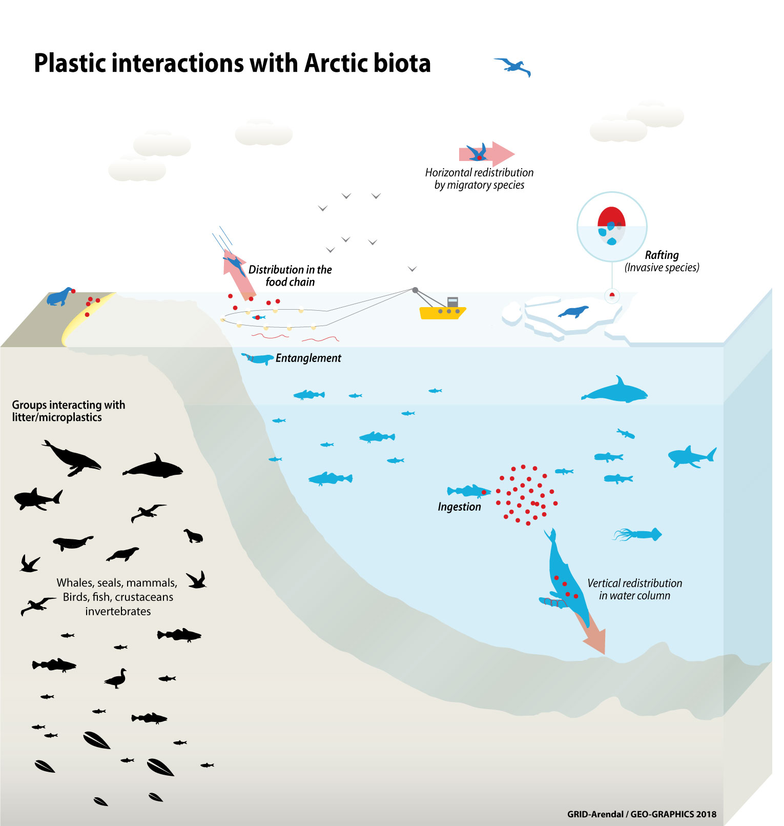Figure III.5

Ingestion
Studies on the ingestion of marine litter have, so far, almost exclusively documented the ingestion of plastic debris and microplastics. Plastic ingestion has been documented in multitude of studies across the Arctic and its vicinity since the 1970s (see table 3.1) with plastic has been found in the digestive system of seabirds (on which most studies are focused), marine mammals including cetaceans and seals, sharks, fishes and invertebrates.
Seabirds
Literature on the presence of plastic in seabirds is extensive for several regions of the Arctic and its vicinity. Observations have been collected in the Barents, Norwegian and Greenland Seas; Labrador Sea, Davis Strait, Baffin Bay and the Northwest Passage; the subarctic North Atlantic; the Gulf of Alaska and the Bering Sea; and the subarctic North Pacific (table 3.1). Research on seabirds, in particular northern fulmars (Fulmarus glacialis), prevails amongst other groups of organisms due to their widespread recognition as biological indicators of levels of pollution, distribution across the northern Hemisphere, allowing for standardized comparisons to be made (Trevail et al., 2015a; van Franeker and Law, 2015), and their high vulnerability to plastic ingestion due to their feeding habits (van Franeker et al., 2011). According to some studies the residence time of plastic in the gastro-intestinal tract of northern fulmars is short, with 75% of the plastic ingested being passed from the stomach to the gut within a month (van Franeker and Law, 2015). If this is so, plastic in the stomach contents of northern fulmars is a relatively robust indicator of local pollution levels. If sampling is carried out shortly after migration, the amount of plastic in the stomach contents may be an indicator of plastic pollution in their foraging areas along their migratory pathway, but this will not mask the trends in multiyear datasets of geographically distinct regions (van Franeker et al., 2011; Trevail et al., 2015b). Some caution should still be used when interpreting plastic ingestion data, as the inferrence of environmental conditions based on plastic stomach contents has been a subject of discussion, and accurate measures of ingested plastic retention times are needed to better understand temporal and spatial patterns in ingested plastic loads within marine organisms (Ryan, 2015b). In addition O'Hanlon et al., 2017 conclude in their review of the incidence of marine plastic debris on seabirds of the northeastern Atlantic that opportunistic sampling with limited or no coordination precludes the identification of temporal and spatial trends, and therefore, the apparent trends derived from our review should be considered cautiously.
The stomach contents of northern fulmars have been the focus of a special project for the monitoring and assessment of plastic particles in the North Atlantic developed within the OSPAR Ecological Quality Objectives (EcoQOs) (OSPAR Commission, 2008; van Franeker and The SNS Fulmar Study Group, 2013; OSPAR Commission, 2015) and have also been established as an OSPAR Common indicator. The methodology initially developed for monitoring the incidence of plastic pollution in the North Sea is now being used for the areas of the eastern North Atlantic, of the western North Atlantic and of the North Pacific where northern fulmar is found. This includes observations within the Arctic region, thus allowing relevant comparisons within and across Arctic regions. Some of the most recent examples of such extensive comparisons, including data from within and outside the Arctic region, are included in the works of Trevail et al., 2015a; van Franeker and Law, 2015; Avery-Gomm et al., 2017; Provencher et al., 2017; and van Franeker, 2017.
The latest comparison of standardized plastic content in northern fulmars (Avery-Gomm et al., 2017), which added data from the Labrador Sea to the existing dataset, further corroborates the northwards decreasing trend in plastic contents in the Eastern North Atlantic, Western North Atlantic and Eastern North Pacific (Kuhn and van Franeker, 2012). Therefore, northern fulmars foraging in the Arctic contain less plastic in comparison with those which breed and forage closer to highly developed and populated areas further south (e.g., comparative studies of Day et al., 1985; Provencher et al., 2014; Trevail et al., 2014; Amelineau et al., 2016; Avery-Gomm et al., 2017). Out of the three regions, the Arctic areas north of the Eastern North Atlantic (Barents and Greenland Seas) are characterised by much higher levels of plastic presence in northern fulmars than in areas at the same latitude or further south in the Eastern North Pacific (Gulf of Alaska) and the Eastern North Atlantic (Northwest Passage). Increased sea-based human activities (Kuhn and van Franeker, 2012), good connectivity through ocean circulation to areas further south in the Atlantic Ocean (Trevail et al., 2014; Trevail et al., 2015a; Cózar et al., 2017), release from melting sea ice (Obbard et al., 2014; Peeken et al., 2018) and overwintering in the North Atlantic during the non-breading season (van Franeker et al., 2011) have been suggested as reasons for high levels of plastics in marine birds of the Atlantic Arctic.
In addition, these standardized research efforts have allowed the assessment of temporal trends in the abundance of plastics in the surface of the North Atlantic over the last 30 years (Provencher et al., 2017). Despite a complex pattern with strong variability in the abundance and mass of total plastics, dominated by user plastics (fragments of plastics of multiple origins), a clear 75% reduction of industrial plastic particles (pre-production pellets) in the stomach content of northern fulmars in the North Sea has been recorded. This reduction has also been detected in floating particles in the North Atlantic gyre over time, proving that measures implemented to reduce the leakage of pellets to the ocean can lead to a reduction of plastic particles present in the marine environment (van Franeker and Law, 2015) and available for interaction with organisms. The reduction of industrial plastics has also been detected through similar studies of short-tailed shearwaters (Adrenna tenuirostris) in the Bering Sea (Vlietstra and Parga, 2002) pointing to the global nature of the reduction of industrial plastics in surface waters and therefore applicable to the whole of the Arctic. However, the most recent assessment of plastic particles in fulmar stomachs, conducted in 2017 as part of OSPAR’s Intermediate Assessment, indicates that levels of plastic ingestion by northern fulmars in the North Sea appear to have stabilised since the early 2000’s (OSPAR, 2017).
Recent literature reviews and studies of plastic and microplastic in the Atlantic sector of the Arctic (Provencher et al., 2014; Trevail et al., 2015a; Poon et al., 2017; Hallanger and Gabrielsen, 2018) collected information on the ingestion of plastic by three other seabird species, Brunnich’s guillemot or thick-billed murre (Uria lomvia), little auk or dovekie (Alle alle) and black-legged kittiwake (Rissa tridactyla) (table 3.1). Records for the common eider (Somateria mollissima) and the king eider (S. spectabilis) did not show eiders to be ingesting plastic. The systematic review of literature dating back to the 1980s and 1990s (i.e. Day et al., 1985; Robards et al., 1995), and devoted to seabirds elsewhere in the Arctic, including the Russian and Canadian High Arctic, the Bering Sea and Alaska (see table 3.1), provide records of plastic ingestion to varying degrees for the common eider and fifteen other species. Trevail et al. (2015b) also compiled records of plastic ingestion in seven sub-Arctic species, most of them included in table 3.1, indicating the widespread incidence of plastic ingestion in certain species. The vulnerability to plastic ingestion for the different Arctic seabird species will differ accordingly to their forgaging habitats, behaviours and diets.
Our review of records of plastic ingestion by seabirds (table 3.1) seems to indicate that since studies started documenting it, the frequency of occurrence of plastics in Arctic seabirds has stayed relatively stable, while the number of plastic items ingested per individual, as well the total weight, seem to be increasing over time. This is coherent with the single genus study carried out by Bond et al. (2013) that showed no significant trend over time in the frequency of plastic ingestion by common and thick-billed murres, while the number of pieces and mass by individual fluctuated from highest in the 1980s, lowest in the late 1990s, and intermediate in contemporary samples.
The occurrence of plastics in surface-feeding seabird species is two times higher than in pursuit-diving birds (Table 3.2), with the exception of values reported by Day et al. (1985), where frequency of plastic occurrence in pursuit-diving birds was 26% and 16% for surface-seizing birds, though this exception might be due to the sample size for these categories. However, the distribution of plastics among the surface feeders also differs. Northern fulmars, for instance, have a greater frequency of occurrence of plastics than kittiwakes (Table 3.2). As suggested by Avery-Gomm et al. (2013) and Poon et al. (2017) this might be explained by the breeding strategies of the two species: northern fulmars feed in areas further from their breeding ground and almost twice as large as feeding areas for kittiwakes, which allows them to reach areas with higher plastic concentration. The plastics tend to concentrate in areas of fronts and eddies, which are also areas where procellarids like northern fulmars tend to feed (van Franeker and Law, 2015), particularly in offshore and shelf edge habitats (review in Mallory et al. 2012). Provencher et al. (2014) also highlighted the influence of the foraging strategies (surface seizing vs. pursuit diving). In addition, fulmars are more omnivorous than kittiwakes, with the former consuming more large zooplankton, larval fish, and invertebrates (Mallory et al. 2012), while the latter consume primarily fish (Hatch et al., 2009). In addition, procellariids, including northern fulmars, do not regurgitate indigestible items like other seabirds do and so are vulnerable to the accumulation of debris (Mallory, 2006).
Studies of seabird diets have also helped document the transportation of plastics in the food chain. Hammer et al. (2016) examined plastic pellets found in great skuas and showed the higher prevalence of plastic pellets amongst the ingested remains of northern fulmars, indicating that plastics were transported from sea surface-feeders to predators.
The impacts associated with plastic ingestion by seabirds and other groups of organisms are potentially twofold: physical (e.g., internal injuries, ulceration and lodging in the digestive system causing obstructions, malfunctioning of the stomach and satiety feelings), and toxic due to the absorption of chemicals in instances when they are added to plastic during manufacturing and/or absorbed by it during its use and movement in the environment (Ask et al., 2016). The potential physical effects of plastic ingestion in Arctic seabirds have been discussed and inferred by analogy to demonstrated effects in seabirds from other latitudes since the 1980’s (Day et al., 1985), but few Arctic studies have addressed sublethal (e.g., body mass loss, reduced growth) and lethal effects. This is likely linked to the fact that it is often difficult to determine whether the plastic in dead stranded individuals (the large majority for northern fulmar studies) was actually the cause of death (Rochman et al., 2016). Vliestra and Parga (2002) found no relationship between plastic incidence and body mass in short-tailed shearwaters in the Bering Sea (collected as bycatch or shot) and concluded that body condition is little, if at all, compromised by plastic ingestion at least at the levels found during the study. However, Spear et al. (1995) documented a negative relationshiop between body weight of tropical Pacific seabirds and number of ingested plastic particles. While there is a lack of research directly connecting plastic ingestion to negative physical effects, some studies indicate that plastic may contribute to health degradation and, potentially, mortality. During a mass mortality of northern fulmars in the North Sea in 2004, several indicators suggested a background hormonal disturbance, potentially related to persistent high levels of chemicals, some of which may have derived from plastics, circulating in their bodies during a period of prolonged food shortage (van Franeker and The SNS Fulmar Study Group, 2011). While the North Sea population of northern fulmar has been growing for the last two centuries this trend has stopped or reversed since the 1990’s and reproductive success is at present poor (van Franeker and The SNS Fulmar Study Group, 2011, Werner et al., 2016). These authors point out that many factors are involved in population trends, but reduced adult survival and reduced reproductive output as a consequence of plastic ingestion are population effects that could play a role.
Further research on the interactions between plastics ingestion and impacts on seabird reproduction and population trends could help in discerning the cause relationship between the two. The studies by Trevail et al. (2014), Ask et al. (2016) and Herzke et al. (2016) specifically targeted the relationship between toxic substances and the abundance of plastic in northern fulmars from the Faroe Islands and Norway. After studying plastic in stomach contents and toxic chemicals (PCBs, PBDEs, PFAs, DDTs and other pesticides and OPFRs) in liver and muscle tissue from northern fulmars, they concluded that ingested plastic does not appear to be a significant route of exposure to the contaminants analysed therein. The dynamic bioaccumulation model included in the study by Herzke et al. (2016) suggested that plastics in the stomachs of northern fulmars are likely to act as a passive sampler of the persistent organic pollutants (POPs) that the northern fulmars receive through their diet, i.e. absorbing these substances while in the environment and providing information on environmental concentrations of these substances in the food ingested. However, previous reports indicated that some PBDE and PCB congeners predominantly associatied with plastic due to adsorption compared to overall diet could be transferred to seabird tissues (Yamashita et al., 2011; Tanaka et al., 2013). Except for DDTs and other pesticides, all of these substances are added to plastics during their manufacture. They are also present in the environment and absorbed onto plastic surfaces. Their association with plastic, however, does not seem to constitute a substantial addition to the chemical burden that northern fulmars experience through overall diet where these pollutants bioaccumulate (Ask et al., 2016).
Marine mammals
Data relative to the ingestion of plastic debris by marine mammals is mostly derived from dietary studies and anecdotal records of the presence of plastic in beached or stranded individuals (Table 3.3). Some records also mentioned the presence of wood but not specified if this was natural or machined wood.
Regarding cetaceans, ingested plastic debris have been recorded in individual sperm whales (Physeter microcephalus) and fin whales (Balaenoptera physalus), all of them caught in whaling operations off the eastern coast of Iceland. Martin and Clarke (1986) reported that less than 10% of the 221 sperm whales caught between 1977 and 1981 had non-food items (rocks, plastic and/or wood debris less than 0.2 m in length) in their stomachs. As for larger debris, five discarded fishing nets were recorded as part of the guts content in the examined individuals, the largest weighing 63 kg. This net was firmly stuck between the second and third stomach, causing a potentially lethal obstruction through starvation. The authors postulated that the smaller items could easily be expelled with the bones and squid beaks at periodic regurgitations. In 1982, a plastic bucket was found in the intestines of a sperm whale caught close to the Icelandic shore. This sperm whale was in poor condition, and the authors argue that the bucket could have contributed to its condition and a caused a lethal intestinal obstruction (Lambertsen and Kohn, 1987). Further, six out of 82 fin whales caught in summer 1985 had plastic material (plastic bags and small pieces of plastic sheeting) in their guts (Sadove and Morreale, 1990).
Anecdotal occurrences of plastic debris in the stomachs of bowhead whales (Balaena mysticetus) from Baffin Bay and the Beaufort Sea were also recorded in the 90’s (Lowry, 1993; Philo et al., 1993; also in Finley, 2001).
In recent years, the media has often linked incidence of lethal impacts to ingestion of marine debris by cetaceans, such as the sperm whale (Physeter macrocephalus) stranded on the Norwegian west coast near Bergen in February 2017. However, most of these incidents have not been the subject of published research studies, with some exceptions, was the case for the stranding of two other individuals of the same species on the coast of northern California (Jacobsen et al., 2010). In one whale, the emaciated body condition of the animal suggested starvation following gastric blockage, while for the other, gastric rupture following impaction with debris was presumed to be the cause of death.
Fish
There are very few studies that have documented the ingestion of plastic by fish in the Arctic. Plastic debris (fishing gear or line) has been found in stomach analyses of Greenland sharks (Somniosus microcephalus) from south Greenland with a frequency of 8.3% (Nielsen et al., 2013), and 3% from Svalbard (Leclerc et al., 2012). Low incidence (2.8% non-fibrous particles) was recently reported in juvenile polar cod (Boreogadus saida) caught in open coastal waters east of Svalbard and under the ice in the northern Svalbard shelf area, documenting for the first-time plastic ingestion by this ecologically important species in the Central Arctic Ocean (Kühn et al., 2018). A recent study by Morgana et al. (2018) investigated the presence of microplastics in two mid-trophic level Arctic fishes collected off Northeast Greenland, the pelagic polar cod (B. saida) and the demersal bigeye sculpin (Triglops nybelini). The study found different proportions of ingestion among the species, 18% for B. saida (n = 85), substantially higher incidence than for the juvenile individuals sampled in Svalbard by Kühn et al. (2018), and 34% for T. nybelini (n = 71). The significant difference in the occurrence of microplastics between the two species is likely a consequence of their feeding behavior and habitat, reflecting the ingestion of sinking mcroplastics by the demersal bigeye sculpin. The study of Atlantic cod (Gadus morhua) from the Norwegian coast by Bråte et al. (2016) confirms the low or no incidence of plastic ingestion in two more Arctic locations (Lofoten Islands in the Norwegian Sea and Varangerfjorden in the Barents Sea). Additionally, Koelmans et al. (2014) conclude that in the case of plastic ingestion by Atlantic cod, this does not constitute a significant pathway for exposure to substances associated to plastic like nonylphenol and bisphenol.
Despite the lack of other records of plastic ingestion in the Arctic, several of the species documented to ingest plastic in the North Sea have geographic distribution ranges that extend well within the Arctic. For example, Bråte et al. (2017) compiled information from studies of the presence of micro- and macroplastics in marine species from Nordic waters identifying up to 14 fish species known to ingest plastic in this region, which includes the Norwegian Sea, Greenland Sea and the western Barents Sea. It should be borne in mind, however, that results from stomach content analyses only represent a snapshot in time, the organism’s last meal unless objects cannot be excreted.
There are currently no studies in the Arctic documenting ingestion of microplastics by fish age classes that predominantly occupy the mesopelagic layer. Mesopelagic fish inhabit the disphotic zone of the pelagic realm (200-1,000 m depth) from the Arctic to the Antarctic, with many species undergoing diurnal vertical migrations in the water column by residing at depth during the day before migrating to the surface at night to feed (Gjøsaeter and Kawaguchi, 1980). Smaller mesopelagic species feed on zooplankton, while the larger ones feed on decapods and fish, and can thus be exposed to microplastic and plastic ingestion through direct consumption or by feeding on zooplankton or other organisms that had already consumed plastics (Wieczorek et al., 2018). Wieczorek et al. (2018) investigated microplastic incidence in mesopelagic fish of the Northwest Atlantic and documented presence of microplastics in the gut of 73% of all fish, amongst the highest reported for gut contents of fish and much larger than in a similar study in the North East Atlantic (11%) (Lusher et al., 2016) and North Pacific Subtropical Gyre (9.2%) (Davison and Asch, 2011). Wieczorek et al. (2018) attributed the high values to methodological differences with previous studies but also to the fact that the study was carried out in a hot spot for microplastics and mesopelagic fish alike. The study further concluded that colour, size, shape and composition similarities in microplastics found in mesopelagic fishes and those collected in surface waters of the same zone are attributable to surface water feeding by mesopelagic fishes. Wieczorek et al. (2018) also highlighted the key role mesopelagic fishes play by constituting a substantial share of the biomass in the pelagic realm, providing an important food source for organisms high in the trophic chain, including commercially harvestable species and seabirds, being responsible for a significant amount of carbon and nutrient cycling, and enhancing deep transfer of natural particles and potentially microplastics (Lusher et al., 2016). The abundance and diel migration range of Arctic mesopelagic fishes is being investigated (Gjøsæter et al., 2017).
Invertebrates
Ingested plastic has been reported for invertebrates on a few occasions, as in blue mussels (Mytilus edulis) from Svalbard with 90% occurrence and an average of 9.5 items per individual (Sundet et al., 2016), and in 20% of snow crabs (Chionoecetes opilio) (Sundet, 2014).
Little is currently known about the impacts of litter on seafloor biota, though 67% of the litter items observed on the seafloor of the HAUSGARTEN observatory were in some way interacting with epibenthic megafauna (Bergmann and Klages, 2012). Microplastic has been detected in various deep-sea organisms, including sea cucumbers, and has even been preferentially ingested in the laboratory (Graham & Thompson, 2009). Microplastics were also detected in deep-sea starfish Hymenaster pellucidus from the Rockall Trough (Courtene-Jones et al., 2017), which also inhabit HAUSGARTEN.
A recent study by Fang et al. (2018) reported for the first time the ingestion of microplastics by benthic organisms in the Arctic and sub-Arctic regions, representing 11 different species inhabiting the shelf of the Bering and Chukchi Seas. Mean uptake ranged from 0.02 to 0.46 items g⁻¹ wet weight (ww), or 0.04-1.67 items individual⁻¹, which is lower than uptake in other regions worldwide. Interestingly, the highest value appeared at the northernmost site in the Chukchi Sea, implying that the sea ice and the cold current represent possible transport mediums for microplastics ingested by benthic fauna and pointing to transfer mechanisms similar to those implied by the research carried out in the Fram Strait by Peeken et al. (2018).
Although microplastic ingestion by zooplankton has not been documented in the Arctic, several studies have shown this can occur in natural conditions, for example in the Northwest Pacific and the coastal waters of Southeast Alaska and British Columbia (Desforges et al., 2015), and in laboratory experiments (Cole et al., 2013). Microplastic ingestion by zooplankton may have far-reaching implications (Galloway et al., 2017; Villarrubia-Gómez et al., 2017) due to the role of this group, together with phytoplankton, as the base of most marine food webs. As for other larger organisms, microplastic ingestion by zooplankton may have negative effects, as demonstrated in laboratory conditions, such as gut-blockage, increasing gut-retention times leading to reduced feeding function (Cole et al., 2013), and reduced fecundity linked to the physical disturbance caused by the presence of plastic in the digestive tract (Cole et al., 2015). The degree of transfer and bioacculumation of plastic-associated toxic substances, like persistent organic pollutants (POPs), to zooplankton and fishes is being researched, but evidence is currently limited (Lohmann, 2017). The review by Lohman (2017) did highlight that microplastics are potentially an important transfer vector for other plastic aditives, like flame retardants, into marine organisms.

Entanglement
Entanglements of various species, mostly marine mammals, have been documented in studies; however, most are anecdotal (e.g. Beach et al., 1976; Baba et al., 1990; June, 1990; Sadove and Morreale, 1990; Kapel, 1985 in Finley, 2001 and summary in Hallanger and Gabrielsen, 2018). The only systematic monitoring was conducted in 1960s-80s for the Pacific juvenile male northern fur seals (Merrell, 1980; Fowler, 1985, 1987; Kuzin, 1990). Other comparative studies were conducted on Pacific female northern fur seals in 1991-1999 (Kiyota and Baba, 2001) and Pacific humpback whales on 2003-2004 (Neilson et al., 2009) (Table 3.4).
Pinnipeds
Most studies focussing con pinniuped entanglement correspond to studies on entanglement of northern fur seals in Northern Pacific Ocean and Bering Sea (Merrell, 1980; Scordino, 1985; Fowler, 1987; Fowler et al., 1990; Kuzin, 1990; Fowler et al., 1993; Kiyota and Baba, 2001). The main source of comprehensive data on entanglements during the eighties was the commercial harvest of fur seals from the United States’ Pribilof Islands’ rookeries (Fowler et al., 1990) and Russian Commander Islands (Kuzin, 1990). Systematic monitoring ended with the application of bans on commercial seal hunting.
Rates of entanglement in the Bering Sea increased over time, reaching maximum levels in 1975 and 1976 (Fowler et al., 1990; Kuzin, 1990). Interestingly, the abundance of beached fisheries debris and number of entangled fur seals from the region are slightly correlated (Merrell, 1980; Fowler, 1987; Johnson, 1990). Fowler (1987) linked increasing entanglement of juvenile male seals with the wider introduction of synthetic fishing gear and packing bands, with trawl net fragments being the predominant (more than 2/3) entanglement debris (Fowler, 1987; Baba et al., 1990; Fowler et al., 1990). Baba et al. (1990) noted that marine debris were concentrated along the continental slope, the area targeted by trawl-fisheries and also the feeding ground for seals. Chances of entanglement were subject to change with the season and location, with the breeding season (May-October) in Pribilof Islands being the riskiest showing higher risks of entanglement (Ribic and Swartzman, 1990). Juvenile male fur seals are potentially more susceptible to interact with plastic debris than female fur seals, as male fur seals return to the breeding grounds earlier than females, and young seals are curious and tend to interact with floating objects (Kiyota and Baba, 2001).
Entanglement in plastic debris causes strangulation and injuries, leading to movement restriction, lower swimming speed and shortened activity pattern (Feldkamp et al., 1989; Yoshida et al., 1990b, a; Fowler, 2000), which in turn reduces foraging ability. For the female fur seals, it also impairs maternity care by shortening the length of feeding trips leading to pups gaining weight at a lower rate (DeLong 1988 in Fowler, 2000). The secondary effects are: vulnerability to predation, susceptibility to infections for wounded seals, retardation of growth of young seals (Scordino, 1985; Fowler, 2000) and mortality caused by drowning and starvation (Fowler, 2000; Kühn et al., 2015).
Levels of fatal entanglement of northern fur seals were not studied, so entanglement-related mortality remains uncertain (Merrell, 1980). Chance of survival of the entangled northern fur seal is less than 39%, and chances for death increase along with the size of entangling debris (Fowler et al., 1990). Dead entangled seals were observed, most of them far from the rookeries (Fowler, 1987; Baba et al., 1990), and it is believed that many seals died as a result of interaction with ALDFG (Trites, 1992). According to Fowler (1987) and Fowler et al. (1990), entanglement added an extra 15% to the yearly mortality rate of the northern fur seals population in Pribilof Islands, though population decline was attributed to the parallel reduction of prey resources (Trites, 1992).
Entanglement has also been observed in Svalbard for other pinniped species, such as harbour seals (Phoca vitulina), bearded seals (Erignathus barbatus) (Bergmann et al., 2017a) and ringed seals (Phoca hispida) (pers. comm. Governor of Svalbard). Additionally, it is estimated that the population of eastern Aleutian northern (Steller’s) sea lions declined by half between 1957 and 1988 and entanglement was suggested as a possible contributing factor to this decline (Manville, 1990).
Cetaceans
Signs of entanglement of cetaceans have also been observed in Arctic waters, though the number of studies is limited to a few anectodal reports and a study on non-lethal entanglement in Alaska. Sadove and Morreale (1990) reported that five out of 95 fin whales harvested in Iceland showed signs of previous entanglement. Philo et al. (1992) compiled the signs of entanglement on several bowhead whales (Balaena mysticetus) in the 1980´s and 1990´s in Alaska and argued that despite the fact that entanglement could lead to mortality, especially for smaller individuals, there were no signs that this had an effect on whale populations. In a more recent study looking at non-lethal entanglement of humpback whales (Megaptera novaeangliae), Neilson et al. (2009) concluded that the large majority of humpback whales in northern South East Alaska had been entangled but that most whales apparently shed the gear on their own. The lack of cetacean entanglement studies in the Arctic was recently highlighted by Stelfox et al. (2016).
Crustaceans and fish
The shift since 1940 from fishing gear made from natural to synthetically manufactured materials has resulted in the increase of “ghost fishing,” which is the process by which ALDFG continues to catch fish while drifting in the ocean or lying on the seafloor. It has been estimated that each year, upwards of 640,000 tons of gear is lost globally, meaning that ALDFG accounts for over 10% of the total marine debris floating in our oceans (Macfadyen et al., 2009). The incidence of ghost fishing in the Arctic is also very limited, and only a couple of studies limited number of studies have looked into these impacts. Stevens et al. (2000) documented ghost fishing by Tanner crab (Chionoecetes bairdi) pots in Alaska and reported an incidence of ghost fishing of the target species in 16% of the pots, with an average catch of one crab for every two pots after excluding the maximum outliers. Still, they concluded that the data on abundance of pots and number of crabs captured did not allow them to draw conclusions on impacts without knowing more about ingress, egress and mortality.
Humborstad et al. (2003) documented ghost fishing of Greenland halibut (Reinhardtius hippoglossoides) on the continental slope in the southern Norwegian Sea with catches of tens of kilograms per day per gill net fleet (825 m long), indicating that gillnets continue to fish for years and adding to concern regarding the impacts of ghost fishing on this stock. They concluded that in order to ascertain the impact on the stock, annual losses of nets need to be estimated.
Terrestrial species
Entanglements of terrestrial species have also been documented in the Arctic. Formal records exist for entanglement in fishing nets of barren ground caribou (Rangifer tarandus granti) in the Aleutian Islands (Beach et al., 1976). Instances of entanglement in fishing nets has also been documented for the Svalbard reindeer (Rangifer tarandus platyrhynchus) and polar bears (Ursus maritimus) (Bergmann et al., 2017a).
Overview of ingestion and entanglements
The review above indicates that plastic ingestion and entanglement in the Arctic have been studied and documented at the individual level for a limited number of species and even less with regards to microplastic interaction. The potential consequences of ingestion and entanglement have been poorly studied and documented, with only a few studies establishing a link between the interaction with plastic and lethal or sublethal effects. The population consequences are largely unknown at present, and very few examples provide any notion of substantial effects at the population level. Only two studies have suggested population level effects for the northern fulmar Fulmarus glacialis ( van Franeker and The SNS Fulmar Study Group, 2011) and the commercially important crustacean Norway lobster (Nephrops norvegicus) (Murray and Cowie 2011). The Norway lobster study was carried out in Scotland, but this species range extends to the Faroes, Iceland and northern Norway (Bell, 2015).

Rafting of non-indigenous species
Marine litter functions like natural floating debris, providing a means of travel for non-native – and potentially invasive – species (Barnes and Milner, 2005; Gregory, 2009; Mouat et al., 2010; CIESM, 2014), and is therefore increasingly recognised as a vector for invasive alien species (Watkins et al., 2015), including in Arctic waters (Barnes, 2002; Barnes and Milner, 2005). Increasing marine litter abundance therefore contributes to increasing the risk of invasions by non-indigenous species. Marine plastic debris can act as a new pelagic habitat for microorganisms and invertebrates like bryozoans, barnacles, tube worms, foraminifera, coralline algae, hydroids and bivalve molluscs. The number of species reported rafting on debris has increased markedly since the 1970s (UN CBD, 1992). For example, marine litter is estimated to have doubled the opportunities for marine organisms to travel at tropical latitudes and more than tripled it at high (>50°) latitudes (Barnes, 2002). The only Arctic-specific study looking at the northward dispersal of species by rafting on marine litter was carried out on the western coast of Svalbard and documented large objects (fishing boxes, containers) colonised by barnacles (Semibalanus sp.), gooseneck barnacles (Lepas sp.), blue shells (Mytilus sp.), bryozoans and marine macro-algae (Weslawski and Kotwicki, 2018). The authors concluded that the rafting of groups of adult organisms favours their better biological dispersal compared to larval transport, and is regarded here as the main reason for reappearance of the genus Mytilus on Svalbard.
The low temperature of the Arctic is the most important barrier to invasion by marine-borne alien organisms. However, with a warming Arctic Ocean and reduction in sea ice cover, this barrier is weakened (Barnes, 2002). Of all collected plastic debris in 2002 in Kongsfjorden, Svalbard, 7% had individuals of the exotic barnacle Semibalanus balanoides and colonies of the bryozoan Membranipora membranacea (Barnes and Milner, 2005).

Pathways for input and/or redistribution
Another interaction between plastic litter and organisms that is worth reviewing is the transport of plastic by organisms. Organisms can actively or passively transport plastic debris and particles in, out and within the marine environment, contributing to their redistribution and geographical accumulation or dispersion. An example of active transport is the incorporation of plastic debris, especially dolly rope thread, into nests of seabirds. O'Hanlon et al. (2017) reported three studies from the northeastern Atlantic on nest incorporation by the northern gannet (Morus bassanus) and black-legged kittiwake (Rissa tridactyla). Both species are present and nest within the Arctic region. The risk and effects of entanglement by nest incorporation is addressed in the previous section, but it is likely birds can contribute to the export and accumulation of floating plastic in localized coastal areas. Locally, the role of seabirds in “cleansing” surface water from plastic connected to feeding habits has also been addressed in studies of northern fulmars in the Bering Sea [Note: look for reference].
Other marine organisms also have the potential for redistributing plastic particles through ingestion and defecation. The influence of this process in the distribution of plastic in the ocean will certainly depend on the amount ingested, as well as population size, but will be especially relevant when the ingestion and defecation and/or regurgitation happen in different compartments, i.e., feeding at sea and defecating on land (Provencher et al., 2018) or different locations within the same compartment (feeding in surface waters and defecating at depth). The ingestion of plastic particles by zooplankton (Cole et al., 2016) and mesopelagic fish (Wieczorek et al., 2018) would be such an example, as both are known to migrate tens to hundreds of meters within the water column to feed at the surface during the night and avoid predation at depth during the day. Diel migration of large populations of plankton and mesopelagic fish is known to influence carbon cycling in the ocean by exporting carbon from surface to deeper waters through this mechanism (also known as a biological pump), and an analogous process could affect plastic particle distribution in the water column. Further when plastic is released at depth, it would be packaged in faecal pellets that could behave differently from the individual particle in the water column.

Socioeconomic impacts
Werner et al., (2016) and Bråte et al. (2017) described the societal and economic impacts associated with marine litter in European and Nordic waters, which are mostly analogous to impacts in the Arctic. These impacts are mainly linked to the economic sectors using the Arctic marine ecosystems, namely the fishing and aquaculture, shipping, and tourism and recreation sectors, which are also highlighted as the main impacted sectors in a global study by Newman et al. (2015). To date, there is no economic assessment to estimate the costs of plastic litter to these sectors, which besides bearing the costs are at the same time potential sources.
Fishing and aquaculture can be impacted through different pathways. These include reduced quality, the perception of reduced quality, or uncertainty on the quality of fish products that may lead to a shift of consumer habits away from seafood (GESAMP, 2016). Also, an associated impact could be the reduced quantity of fish products due to changes in the stocks of commercial species as a result of direct impacts from ingestion or entanglement on populations of these species or the species upon which they rely. These associated economic impacts can only be determined when enough information of the ecological impacts at the population, assemblage or ecosystem level, are investigated and determined. Additionally, there could be impacts associated to reduced landings of seafood due to direct physical interaction with marine litter. Lost or abandoned fishing gear, parts of it and other debris, can get caught in fishing nets, decreasing catch capacity or its quality.
A number of indigenous communities are practicing and relying on traditional sealing (including harp seals, ringed seals, and northern fur seals). The potential decrease in population of these species, as well as relocation of rookeries can have a negative impact on both cultural and economic parts of lives of indigenous communities and individuals. Though most seal products (such as pelt, meat, oil) are produced and delivered to the market by commercial undertakings, some are harvested by indigenous seal hunters for local consumption, cultural use, sale and/or securing food supply.
Marine litter has additional effects on the cultural practices and the harvest of food of communities living in the Arctic. Examples of this are commercial fishing line entanglement on harvested marine mammals and the presence of plastic debris on culturally used areas. Communities identify sanitation and waste systems (such as landfills) as contributing to food insecurity because they impact the marine environment integrity and its biota (Inuit Circumpolar Council – Alaska, 2015)).

Potential impacts for sectors relying on marine transportation (fishing, shipping, energy and tourism) include fouling/blockages of propellers, cooling systems or other systems relying on seawater pumped into the vessel, leading to mechanical problems, navigational hazards, and costs associated with repairs and down time. The extent of this impact needs special consideration in the Arctic because damage to vessels in harsh and hazardous conditions, coupled with the difficulty of assistance and rescue operations, may present an additional hazard to human lives.
Plastic litter can have direct and indirect effects on the mental health of those living and/or visiting coastal areas (Wyles et al., 2016). Some of these effects are linked to the aesthetic value of coastal and marine ecosystems such that visitors may be discouraged from frequenting unsightly locations where plastics litter the shorelines (GESAMP, 2016). This may be especially true for the Arctic, where one of the main appeals for visitors is the pristine character of the environment. Additionally, visitors to the Arctic expect the possibility of observing emblematic fauna linked to Arctic biodiversity, and, in particular, large fauna like cetaceans, seals, polar bears and birds. Witnessing the suffering caused by marine litter on individual animals or media attention on the matter can have detrimental effects on the perception of the Arctic region as an undisturbed destination. The incipient and growing Arctic tourism and recreation sector may be affected if people are discouraged from visiting impacted areas.

An economic cost that is already occurring is that of cleaning up Arctic shores, something which is normally borne by the public sector, civil society and individual citizens. Information on clean-up programs will be provided in the next sub-section, but data on the economic costs of beach clean-ups is unfortunately not available for the Arctic.
The MARine Plastic pollution in the Arctic (MARP) project (www.marp.no) is nowadays addressing the assessment of socio-economic costs of marine litter in the Arctic and should produce some results by 2020.

III.4. Monitoring and Response

Monitoring
Monitoring can be used for a variety of purposes, such as understanding the movement of marine litter within the Arctic, the water profile, the contributions of different sources, the contribution from different geographic regions (e.g., outside the Arctic), the impacts on species, etc. One example of a monitoring programme is under the framework of OSPAR (Convention for the Protection of the Marine Environment of the North-East Atlantic). Under OSPAR, an extensive monitoring program has been implemented for waters of the Arctic region in the area covered under the convention encompassing the Norwegian and Greenland Seas and the western part of the Barents Sea. OSPAR currently assesses beach litter (OSPAR, 2017a), seabed litter (OSPAR, 2017b) and plastic particles in northern fulmars’ stomachs (OSPAR Commission, 2015). Those are common indicators as part of its monitoring and assessment programme. These allow the determination of the abundance, trends and composition of marine litter in the OSPAR Maritime Area for different marine compartments (coast, seafloor and floating). OSPAR is also pioneering the development of a new indicator on microplastics in sediments. Currently, there is a total of 17 beaches monitored in Greenland, six in Iceland, one in Faroe Islands, three in mainland Norway and two in Svalbard. This extensive monitoring scheme is producing a wealth of valuable information on types and compostion of litter items. However, as most Arctic beaches have only been recently added to the monitoring network, the datasets are not long enough for the calculation of statistically significant temporal trends in the amounts of overall litter or its composition. The monitoring of plastic particles in northern fulmars has been carried out more exhaustively in the North Sea, where the method was originally developed and where multiyear temporal series are available, although data for certain periods is available for the Faroe Islands, Iceland and Svalbard. This monitoring methodology has also been applied to monitor northern fulmars in the Northwest Atlantic and the Northwest Pacific, allowing comparison within and across different regions of the Arctic (Avery-Gomm et al., 2017). Seabed litter data collected according to the OSPAR protocol is currently not available for the Arctic Region (OSPAR, 2017b).
Beach litter surveys such as those conducted by OSPAR member states, are an important foundation for management decisions as they can contribute to knowledge about the magnitude of the problem, monitor its development over time, identify the main sources and management target levels of litter presence along the coastline. Although the methodology applied by OSPAR is the most detailed monitoring data available, it is important to bear in mind that such monitoring approach on its own does not provide knowledge for targeted management purposes. For example, all types of fishing nets are categorised as fishing nets smaller or larger than 50cm, making it challenging to use this data to pinpoint the origin, the type of fisheries involved or possible reasons why these items may have ended up in the sea.
In order to provide information on key litter categories at the level necessary for taking informed management decisions, the “deep dive” methodology has been developed within the MARP and Arctic Marine Litter Project. This methodology has been developed to provide detailed insight into the origin, sources and underlying behaviour, processes and policy framework(s) that may have contributed to litter ending up in the marine environment, as well as identifying potential solutions. The idea behind the “beach litter deep dive” tool is that with the help of sector experts, detailed management relevant information can be collected. Engaging stakeholders in the collection of data and its analysis facilitates the establishment of a management oriented dialogue with these actors that contribute and often also receive the impacts of marine litter.
Besides the OSPAR monitoring program there are to date no other extensive monitoring programs targeting marine litter, including microplastics, in the Arctic. Based on the experience of Clean Up Svalbard, Bergmann et al. (2017a) suggest that there is an opportunity to use regular visits by tourists to gather data on marine litter from remote, poorly sampled areas. In order to capitalize on this opportunity, some compromises on the level of detail and time required for monitoring would need to be made so the experience does not drastically affect the recreational value of the voyage. Another citizen science initiative that coud be adapted to gather data in Arctic shores is the NOAA Marine Debris Monitoring and Assessment Project which is the NOAA Marine Debris Program flagship citizen science initiative that engages partner organizations and volunteers across the nation in completing shoreline marine debris surveys. While citizen science is an option for gathering information on marine litter in coastal areas when focusing on large debris, but attempting to sample and gather information on microplastics requires specifically designed and implemented research programs, as the methodology for sample gathering and analysis is much more complex.
A similar opportunity would be to use traditional ecological knowledge to supplement and/or complement monitoring schemes. As an example, in the United States, the National Park Service has done work to integrate traditional ecological knowledge (TEK) to nearshore modeling of ocean current patterns as they relate to oil spill dispersion and debris deposition and sources (Weingartner et al., 2017). Similar traditional and local knowledge may be available and useful to gather and integrate from other communities in the Arctic. Inuit Hunters, for example, are monitoring litter and have increased concerns on impacts to subsistence species, such as plastic in marine mammals and birds (ICC, pers. comm).
In summary, most of the monitoring efforts thus far have been focused on acquiring coastal, mostly beach, data. Only monitoring of plastic content in the stomach of northern fulmars has developed to an extent that allows temporal and geographic comparison.

Ongoing Efforts to Address Marine Litter in the Arctic
In 2016, under the framework of the MARP Project, experts and fishermen from Norway, Russia and the United Kingdom studied some of the litter collected through the Clean Up Svalbard initiative in order to discern the sources and mode of entry of the dominant types of debris,. They reported on the dominance of fisheries-related waste and waste from other marine activities, alongside with household related waste that could originate from land or sea as a result of inadequate waste management (Nashoug, 2017). This led to enhanced awareness among the fisherman operating in the Barents Sea. The Norwegian Fishermen’s Association, the Fishing Industry Union of the North, the Association of coastal Fishermen and Fish Farmers in Murmansk, and Fisheries Iceland produced a joint statement condemning the disposal of nets and other fishing equipment from any member vessel.
The awareness created by this kind of research projects focused on understanding the drivers, release mechanisms and impacts to fisheries, has led to specific actions to address marine litter in the Arctic. A relevant example is the
“Fishing For Litter” program that started in Norway in 2016, following the OSPAR approach used in other countries of the northeast Atlantic and the North Sea for 15 years. The program expanded from three to eight harbors in 2017, with three of them – Ålesund, Trømso and Båtsfjord – located within the Arctic region. “Fishing For Litter” is a program under which fishing vessels deliver marine litter caught during regular fishing activity free-of-charge to assigned marinas, and it is targeted to address the challenges connected with fisheries-related waste and ghost fishing gear. In 2016-2017, a total of 92 deliveries totalling more than 118 metric tons were made in the harbours of Tromsø and Ålesund, more than 60% of which was fisheries-related waste (SALT Lofoten AS, 2017).
In 2017, the Arctic Marine Litter project (www.wur.eu/arcticmarinelitter) was initiated, a collaboration between Wageningen Economic Research, SALT Lofoten AS and local partners in Svalbard. The aim of the Arctic Marine Litter project is to work on prevention by understanding the sources of marine litter and working on solutions. The project is a collaborative, multidisciplinary project with direct stakeholder engagement and is expanding by involving more and more partners throughout the Arctic. The Arctic Marine Litter Project will develop a more comprehensive image of the stakeholders, underlying processes and behaviour related to key litter categories, including solutions and management options to prevent the most common litter items from ending up in Arctic waters. The project consists of three parts. The first part is to examine the exact sources, behaviour and underlying processes that have resulted in key litter items ending up on the shores of the European Arctic (the current focus is Svalbard and Jan Mayen). The second part is to engage with stakeholders to define practical solutions and management options to prevent litter from ending up in the European Arctic. Based on the knowledge developed in the first two parts, the third part is to identify what additional information should be collected through beach litter monitoring programmes in order to evaluate the impact of actions taken by the stakeholders involved in relation to the key litter categories. The Arctic Marine Litter project is designed to work as a catalyst for change by directly engaging stakeholders and providing input for Arctic policy initiatives on marine litter.
Recently and at the Arctic Council Working Group level, the Protection of the Arctic Marine Enviroment (PAME ) Working Group has recognized the importance of improved waste management in Arctic ports, and is currently exploring options for regional arrangements on reception facilities to ensure compliance with Polar Code requirements (PAME 2017b). In addition, the Conservation of Arctic Flora and Fauna Working Group (CAFF) Arctic Migratory Bird Initiative (AMBI) identifed two key actions needed to mitigate habitat degradation of Arctic seabird species. One component of these actions is focused on the need to better understand the effects of plastic pollution in the ocean on Arctic seabirds and seaducks, and in response, preparation is now underway to organise a project. Finally, the Arctic Moinitoring and Assessment Program (AMAP) is considering the inclusion of a marine litter monitoring project for its 2019-2021 Work Plan, which may help fill in some of the knowledge gaps from this literature study.

Another major course of action towards mitigating the effects of marine litter is in the form of coastal clean-ups organized at different scales, frequency and capacity across the Artic.
Since 2006, the NOAA Marine Debris Program has worked with partners to remove about 450 metric tons of marine debris from Alaskan shorelines through Community Based Removal Grants, while the Gulf of Alaska Keeper (www.goak.org) has cleaned more than 2400 kilometers of coastline, collecting more than 1350 metric tons of debris, primarily in the Northern Gulf of Alaska region in Prince William Sound and the Kenai Peninsula. In addition, the Marine Conservation Alliance Foundation has been conducting coastal cleanups in Alaska and the Aleutian Islands and removed more than 275 metric tons of debris between 2003 and 2007 from shorelines across the state (King, 2009).
In Canada, the Great Canadian Shoreline Cleanup has been active since 1994, running volunteer cleanups. In 2014, for example, 4.5 metric tonnes of waste were picked up along a tiny portion (ca. 50 km) of the tens of thousands of kilometers of Arctic shoreline of the Newfoundland and Labrador and Nunavut provinces (Pettipas et al., 2016).
Blái herinn (The Blue Army) is a non-profit organization in Iceland that was founded in 1998 and has been involved in various environmental projects in Iceland, especially regarding beach/coastal and marine cleanups. The Blue Army has recycled over 1100 tons of garbage from Icelandic shorelines, harbors and open areas. Underwater cleanup projects have resulted in recycling of over 100 tons of garbage.
The project “Hreinsum Ísland” is a coastal cleanup project that is managed by Landvernd, the Icelandic Environment Association, in association with the Blue Army. The objective with the project is to draw attention to issues associated with marine litter and to get individuals, groups and enterprises involved by signing up for voluntary beach cleanups at hreinsumisland.is.
In Norway, Hold Norge Rent coordinates thousands of beach clean-ups annually. The ‘Clean Up Svalbard’ campaign (a collaboration among tourists, Spitsbergen Travel and the Governor of Svalbard) engages visiting tourists and tourist cruise/sailing vessel crew members in yearly beach clean-ups (Governor of Svalbard, 2009). Beach clean-up campaigns like these may help to lessen the impacts and collect the data from remote sites, as well as educate people and create the sense of responsibility (Bergmann et al., 2017a; Nashoug, 2017). In fact, all of the organizations in charge of the coastal cleanup campaigns mentioned above conduct considerable efforts to raise public awareness of marine plastic pollution.
Representatives of the Saami Council proposed a new project, Clean-up of the Saami territory in the Murmansk Region, for consideration at the April 2018 meeting of the Arctic Contaminants Action Programme (ACAP). The project, which is expected to begin following conclusion of the formal ACAP project approval process, will involve both the inventory and eventual collection and proper disposal of land-based waste in this part of the Saami territory.
Both coastal clean-ups and “Fishing for litter” are mitigating actions that address reducing the amount and effects of pollution once the leakage of plastic debris has already occurred.

Section IV: Knowledge gaps, main findings and next steps

IV.1. Knowledge gaps
The information on marine litter compiled in the previous subsections helps improve our understanding of the status and impacts of marine litter, and in particular plastic litter and microplastics, in the Arctic region, but is by no means comprehensive. This kind of compilation has not been formalized previously for the whole Arctic region, but some efforts have compiled information for parts of the Arctic (Trevail et al., 2015b; Hallanger and Gabrielsen, 2018) or for larger regions, like the Nordic region including part of the Arctic (Strand et al., 2015). This literature review allows the identification of initial next steps (Section IV) but also knowledge gaps that research should attempt to fill. In particular, this review focused on the available literature on marine litter and microplastics in the Arctic. The exisiting literature is heavily dominated by plastic due to its larger contribution to the total amount of litter. This makes difficult to ascertain the sources, pathways, input, distribution, interactions with biota and impacts linked to other, much less abundant, litter materials. This knowledge could have significant implications for next steps regarding non-plastic litter and microparticles in the Arctic.
Regarding drivers, there is, to our knowledge, no specific socioeconomic assessment looking at indicators such as population and waste generation, recycling and management for the region considered in this review, i.e. the Arctic watershed. As discussed within section III.1, the compilation of information relative to the drivers of marine litter could constitute excellent proxies to identify the relative contribution and geographic distribution of different possible sources as there is, yet, no direct comprehensive assessment of the litter and microplastics leaked to the Arctic. In stark contrast to the rest of the world, the assessment of human-driven input of marine litter in the Arctic from sea-based sources is less challenging than that of land-based sources. This is due to the limited and geographically-constrained nature of maritime activities in the Arctic Ocean compared to the vast and relatively poorly surveyed watershed that constitutes the catchment area for input from land-based sources.
There is no assessment of the input of marine litter by fishing, aquaculture, resource exploration and exploitation, and shipping activities based on information reported by the operators within the sector. This information is useful towards the discussion of management oriented measures and understand the relative importance of local sourced pollution versus pollution brought to the Arctic by currents.
Similarly, there is no compilation of data on population density and distribution of population centers in conjunction with the capacity of waste management systems at the regional and local level, nor is there compiled data on transportation and logistics, such as road and port network and traffic intensity.
As for pathways, there is no observational data regarding riverine input of marine litter from the Arctic watershed into the Arctic Ocean. There is a considerable wealth of information on the discharge of water and chemical substances (i.e. nutrients, pollutants), but no observations of plastic particle fluxes either suspended or as bed load are available for any of the major Arctic rivers and fresh water ecosystems (Halsband and Herzke, 2017). The work of Lebreton et al. (2017) to model the input of plastics Lebreton et al. (2017)was hindered in Arctic rivers by the lack of data on the hydrographic network. Similarly to riverine input, there is no data on the influx of marine litter into the Arctic marine environment through wind or atmospheric circulation or precipitation (Halsband and Herzke, 2017).
The magnitude of the input through oceanic circulation, mostly through the northern arm of the North Atlantic circulation, has been discussed and researched by Zarfl and Matthies (2010) and Cózar et al. (2017), but better estimates of the total input could still benefit from further field data to measure concentrations of marine litter in surface waters and in the water column. Similarly, the flow of marine litter and microplastics from the North Pacific and the Gulf of Alaska into the Bering Sea and further into the Arctic Ocean through the Bering Strait is unknown.
The information already available on the distribution and trends of marine litter provides valuable understanding of the ubiquitous presence of marine litter throughout the marine environment, but this is far from comprehensive. Beach litter data is restricted to the regions and sectors of the coastline that are, either densely populated, have had opportunistic data collection, or that have been identified as hotspots for accumulation and are being targeted for mitigation actions. Information on concentration in sea ice is limited to two studies while data on the concentration of marine litter on surface waters and in the water column is also constrained to certain areas of the Arctic where research has been focused. There is no data for the Kara, Laptev, East Siberian, Chukchi Seas and the Beaufort or Northwestern Passages. Further, data on presence of marine litter on the seafloor is limited to certain areas of the Arctic Ocean.
The full understanding of marine litter interactions with biota and the derived ecological and socio-economic impacts in the Arctic is extremely challenging, as for any other region of the ocean, due to the complexity of ecosystems and biodiversity. The available information on interactions with biota only covers certain groups of organisms that are known to interact with plastic litter and some additional information due to anecdotical records. Information on ingestion is well developed for seabirds, as they are known to interact and be impacted at the individual level. Knowledge on ingestion by seabirds has led to the identification of knowledge gaps regarding the residence time of plastic in the digestive tract (Avery-Gomm et al., 2017), the transfer of toxic substances associated to plastic to seabirds tissues and the effects that this may cause. Despite the wealth of information compiled on northern fulmars and some other species like black-legged kittiwakes, it is still largely unknown to what degree other species do ingest plastic. Bråte et al. (2017) reviewed the gaps regarding Nordic marine biota, which are extensive in the Arctic and highlight the lack of broad understanding of plastic and microplastic ingestion and effects on fish, as well as organisms lower on the trophic chain, such as zooplankton.
With regards to entanglement, knowledge was abundant on pinnipeds during the 1980’s and 1990’s in the Bering Sea and Gulf of Alaska, but monitoring efforts have since been reduced. In the rest of the Arctic, knowledge is fragmented and covers only some groups or species, such as whales. Studies on interactions between biota and marine litter in the Arctic have mostly focused on the interaction and effects at the individual level, and information on the effects at the population level are lacking, even for the better-studied species.
Plastic additives or adsorbed environmental contaminants can be potentially toxic to marine organisms, but as of today, it is not possible to determine a level for safe environmental concentrations for microplastics (OSPAR Commission, 2017). Current evidence indicates that the risk to human health appears to be no more significant than via other exposure routes, but an understanding of exposure, bioaccumulation and impacts at different food web levels is still lacking.
Finally, the understanding of the final fate of marine litter in the Arctic is also limited and constitutes a gap in the understanding of systemic impacts. Further, there are no studies of the socio-economic impacts of marine litter in the Arctic. When considering addressing the knowledge and knowledge gaps highlighted in this report, it is important to keep in mind the logistical and practical challenges of conducting research in the Arctic.

IV.2. Main findings and next steps

This literature review provides an opportunity to identify potential next steps to further examine and address marine litter, including microplastics, in the Arctic Ocean.
The presence of marine litter, including microplastics, in the Arctic Ocean is connected to human activities occurring within and outside the Arctic region.
Despite the lack of estimates of input linked to different human activities occurring in the Arctic region, the analysis of existing coastal and seafloor litter data identifies fisheries-related activities as a major source of marine litter in the Arctic in terms of number of objects and mass. Other sea-based activities like aquaculture, passenger and goods shipping, and oil and gas exploration activities constitute additional sea-based sources. As for land-based sources, coastal litter data points to deficient waste and wastewater management systems in some coastal Arctic communities as an important localized source of marine litter. While there is a lack of data from each of the sectors of activity on leakage of litter or microplastics, an undertstanding of the geographical distribution of the different human activities in the Arctic can be used to determine the areas of the Arctic that may be more exposed to the risk of input from these activities.
The proportion of marine litter, including microplastics, arriving from distant sources is difficult to gauge against the local sources, but connectivity of Arctic marine areas with surrounding marine areas and with Arctic watersheds provides potential for input from distant sources.
Marine litter, including microplastics, generated and released to the environment outside of Arctic marine areas can use several pathways to get to the ocean. The Arctic watershed is very large with several large rivers that deliver substantial amounts of freshwater to the Arctic Ocean. Marine litter, including microplastics, originating inland in areas more densely populated than the coastal areas could potentially contribute substantial amounts to the total input, but unfortunately, there are no studies measuring the outflow of marine litter, including microplastics, from Arctic rivers. Similarly, the input of light weight litter (i.e. plastic and microplastics) via atmospheric flows in the Arctic has not been investigated either. Two other pathways that have been researched and shown to potentially influence the arrival and distribution of marine litter and microplastics in the Arctic are regional circulation and currents and the drift of sea ice along the Transpolar Drift. These two pathways are postulated as responsible for accumulation of microplastics in waters and sediments of specific areas like the Barents Sea and the Fram Strait and potentially other marginal ice zones like in the Chuckchi Sea
The knowledge on distribution of marine litter, including microplastics, in the Arctic is skewed due to information being mostly available for the Barents and Norwegian Sea and for the Bering Sea. Almost no data is available for the Central Arctic Ocean and the coastal areas of Siberia, Alaska, mainland Canada and the Canadian Arctic Archipielago. Marine litter, including microplastics, has been found across the Arctic marine environment including along the shoreline, sea ice, sea surface and subsurface waters, water column, seafloor and sediments. A stock assessment is not available either to discern which areas may hold the most litter, but the coastline and the seafloor accumulate the largest items, and the shoreline in particular accumulates items at high density in specific locations, resulting in marine litter hotspots. The seafloor and especially areas with high accumulation rates, have been identified as sinks for litter, including microplastics.
The many different methods and variables chosen to measure and report abundance of marine litter in each Arctic marine environment area makes geographic comparison challenging. The only exception are reports of abundance of small plastic fragments in surface waters obtained through investigating the plastic content of northern fulmars (Fulmarus glacialis), which describe an apparent S-N decreasing trend when comparing to high-latitudes in both in the North Pacific and the North Atlantic. Within the Arctic the abundance is highest in the Barents Sea followed by the Bering Sea and lowest in the Canadian Arctic.
Regarding interactions with, and impacts on, biota, the Arctic is no different than other marine areas. Organisms in the Arctic have been documented to ingest, get entangled in, and raft on marine litter, including microplastics. In addition, through ingestion and entanglement, organisms contribute to the redistribution of litter within and across the different areas of the Arctic marine environment. Based on current understanding, seabirds compose the group with a higher proportion of individuals having ingested plastic particles. Cetaceans, as well as some species of fish and invertebrates, have also been documented to ingest plastic litter, including microplastics. Entanglement has been documented to affect pinnipeds, cetaceans, crustaceans and fish and even some terrestrial species. Despite a growing number of studies, plastic ingestion and entanglement in the Arctic have been studied and documented at the individual level for only a limited number of species and even less with regards to microplastic interaction. The potential consequences of ingestion and entanglement have been poorly studied and documented, and only a few studies have established a link between the interaction with plastic and lethal or sublethal effects. The population consequences are largely unknown at present, with only very few examples in which we have a notion of substantial effects at the population level.
The existing and potential socioeconomic impacts of marine litter, including microplastics, in the Arctic are linked to impacts in the fisheries and aquaculture sectors, tourism, cultural and aesthetic values and practices and associated to the costs of shoreline cleanups.
The focus placed so far on the study of marine litter, including microplastics, has not led to the establishment of formal monitoring programs that cover all the sources, pathways, compartments and impacts of this environmental challenge. There are nevertheless some examples of monitoring programs being used in neighboring areas and overlapping with the Arctic marine region that cover some of these and provide a reference baseline.
There is a need for a more comprehensive knowledge on Arctic-specific marine litter sources and pathways and its effects on the Arctic marine evironment.
Thus, developing a regional action plan on marine litter in the Arctic is timeliy, recognizing that an Action Plan can be modified over time as more knowledge is accumulated.

Developing a monitoring program as part of, or parallel to, the development of a regional action plan is of great importance in gaining further knowledge and information. In addition, a monitoring program will allow building further the baseline for the assessment of the effectiveness of measures included in the action plan.

Annexes

Annex I: Governance Frameworks

Annex II: Literature review tables

List of References
AMAP (1998). Chapter 2. Physical/Geographical Characteristics of the Arctic. In: AMAP Assessment Report: Arctic Pollution Issues. Oslo, Arctic Monitoring and Assessment Programme (AMAP): 859.
Amelineau, F., D. Bonnet, O. Heitz, V. Mortreux, A. M. A. Harding, N. Karnovsky, W. Walkusz, J. Fort and D. Gremillet (2016). Microplastic pollution in the Greenland Sea: Background levels and selective contamination of planktivorous diving seabirds. Environ Pollut, 219: 1131-1139 DOI: https://doi.org/10.1016/j.envpol.2016.09.017.
Arctic Council (2009). Arctic Marine Shipping Assessment 2009 Report No.: 194.
Ask, A., T. Anker-Nilssen, D. Herzke, A. M. Trevail, J. A. van Franeker and G. W. Gabrielsen (2016). Contaminants in northern fulmars (Fulmarus glacialis) exposed to plastic. Copenhagen K., Nordic Council of Ministers.
Avery-Gomm, S., J. F. Provencher, M. Liboiron, F. E. Poon and P. A. Smith (2017). Plastic pollution in the Labrador Sea: An assessment using the seabird northern fulmar Fulmarus glacialis as a biological monitoring species. Marine Pollution Bulletin DOI: 10.1016/j.marpolbul.2017.10.001.
Axelsson, C. and E. van Sebille (2017). Prevention through policy: Urban macroplastic leakages to the marine environment during extreme rainfall events. Mar Pollut Bull, 124(1): 211-227 DOI: 10.1016/j.marpolbul.2017.07.024.
Baba, N., M. Kiyota and K. Yoshida (1990). Distribution of marine debris and northern fur seals in the Eastern Bering Sea. The Second International Conference on Marine Debris, Honolulu.
Barnes, D. K. (2002). Invasions by marine life on plastic debris. Nature, 416(6883): 808-809 DOI: 10.1038/416808a.
Barnes, D. K. and P. Milner (2005). Drifting plastic and its consequences for sessile organism dispersal in the Atlantic Ocean. Marine Biology, 146(4): 815-825 DOI: https://doi.org/10.1007/s00227-004-1474-8.
Beach, R. J., T. C. Newby, R. O. Larson, M. Pedersen and J. Juris (1976). Entanglement of an Aleutian reindeer in a Japanese fish net. The Murrelet, 57(3): 66.
Bell, C. 2015. Nephrops norvegicus. The IUCN Red List of Threatened Species 2015: e.T169967A85697412. http://dx.doi.org/10.2305/IUCN.UK.2015.RLTS.T169967A85697412.en. Downloaded on 04 September 2018.
Bergmann, M. and M. Klages (2012). Increase of litter at the Arctic deep-sea observatory HAUSGARTEN. Marine Pollution Bulletin, 64(12): 2734-2741 DOI: http://dx.doi.org/10.1016/j.marpolbul.2012.09.018.
Bergmann, M., Sandhop, N., Schewe, I., D’Hert, D., 2016. Observations of floating anthropogenic litter in the Barents Sea and Fram Strait, Arctic. Polar Biology 39 (3), 553-560.
Bergmann, M., B. Lutz, M. B. Tekman and L. Gutow (2017a). Citizen scientists reveal: Marine litter pollutes Arctic beaches and affects wild life. Mar Pollut Bull, 125(1-2): 535-540 DOI: https://doi.org/10.1016/j.marpolbul.2017.09.055.
Bergmann, M., V. Wirzberger, T. Krumpen, C. Lorenz, S. Primpke, M. B. Tekman and G. Gerdts (2017b). High Quantities of Microplastic in Arctic Deep-Sea Sediments from the HAUSGARTEN Observatory. Environ Sci Technol, 51(19): 11000-11010 DOI: 10.1021/acs.est.7b03331.
Bond, A. L., J. F. Provencher, R. D. Elliot, P. C. Ryan, S. Rowe, I. L. Jones, G. J. Robertson and S. I. Wilhelm (2013). Ingestion of plastic marine debris by Common and Thick-billed Murres in the northwestern Atlantic from 1985 to 2012. Marine Pollution Bulletin, 77(1-2): 192-195 DOI: 10.1016/j.marpolbul.2013.10.005.
Bråte, I. L. N., D. P. Eidsvoll, C. C. Steindal and K. V. Thomas (2016). Plastic ingestion by Atlantic cod (Gadus morhua) from the Norwegian coast. Mar Pollut Bull, 112(1-2): 105-110 DOI: 10.1016/j.marpolbul.2016.08.034.
Bråte, I. L. N., B. Huwer, K. V. Thomas, D. P. Eidsvoll, C. Halsband, B. C. Almroth and A. Lusher (2017). Micro-and macro-plastics in marine species from Nordic waters. Nordic Council of Ministers No. Copenhagen: 102.
Buhl-Mortensen, L. and P. Buhl-Mortensen (2017). Marine litter in the Nordic Seas: Distribution composition and abundance. Mar Pollut Bull, 125(1-2): 260-270 DOI: https://doi.org/10.1016/j.marpolbul.2017.08.048.
Cai, L., J. Wang, J. Peng, Z. Tan, Z. Zhan, X. Tan and Q. Chen (2017). Characteristic of microplastics in the atmospheric fallout from Dongguan city, China: preliminary research and first evidence. Environ Sci Pollut Res Int, 24(32): 24928-24935 DOI: 10.1007/s11356-017-0116-x.
CIESM (2014). Marine litter in the Mediterranean and Black Seas (Executive Summary). CIESM. CIESM Workshop Monographs No. 46. Monaco: 180.
Cole, M., P. Lindeque, E. Fileman, C. Halsband and T. S. Galloway (2015). The impact of polystyrene microplastics on feeding, function and fecundity in the marine copepod Calanus helgolandicus. Environ Sci Technol, 49(2): 1130-1137 DOI: 10.1021/es504525u.
Cole, M., P. Lindeque, E. Fileman, C. Halsband, R. Goodhead, J. Moger and T. S. Galloway (2013). Microplastic ingestion by zooplankton. Environ Sci Technol, 47(12): 6646-6655 DOI: dx.doi.org/10.1021/es400663f.
Cole, M., P. K. Lindeque, E. Fileman, J. Clark, C. Lewis, C. Halsband and T. S. Galloway (2016). Microplastics Alter the Properties and Sinking Rates of Zooplankton Faecal Pellets. Environ Sci Technol, 50(6): 3239-3246 DOI: 10.1021/acs.est.5b05905.
Courtene-Jones, W., B. Quinn, S. F. Gary, A. O. M. Mogg and B. E. Narayanaswamy (2017). Microplastic pollution identified in deep-sea water and ingested by benthic invertebrates in the Rockall Trough, North Atlantic Ocean. Environ Pollut, 231(Pt 1): 271-280 DOI: 10.1016/j.envpol.2017.08.026.
Cózar, A., E. Martí, C. M. Duarte, J. García-de-Lomas, E. Van Sebille, T. J. Ballatore, V. M. Eguíluz, J. I. González-Gordillo, M. L. Pedrotti and F. Echevarría (2017). The Arctic Ocean as a dead end for floating plastics in the North Atlantic branch of the Thermohaline Circulation. Science advances, 3(4): e1600582.
Davison, P. and R. G. Asch (2011). Plastic ingestion by mesopelagic fishes in the North Pacific Subtropical Gyre. Marine Ecology Progress Series, 432: 173-180 DOI: 10.3354/meps09142.
Day, R. H. and D. G. Shaw (1987). Patterns in the abundance of pelagic plastic and tar in the North Pacific Ocean, 1976–1985. Marine Pollution Bulletin, 18(6): 311-316 DOI: https://doi.org/10.1016/S0025-326X(87)80017-6.
Day, R. H., D. G. Shaw and S. E. Ignell (1990). The quantitative distribution and characteristics of neuston plastic in the North Pacific Ocean, 1985-88. The Second International Conference on Marine Debris, Honolulu.
Day, R. H., D. H. S. Wehle and F. C. Coleman (1985). Ingestion of plastic pollutants by marine birds. The Workshop on the Fate and Impact of Marine Debris, Honolulu.
De Falco, F., M. P. Gullo, G. Gentile, E. Di Pace, M. Cocca, L. Gelabert, M. Brouta-Agnesa, A. Rovira, R. Escudero, R. Villalba, R. Mossotti, A. Montarsolo, S. Gavignano, C. Tonin and M. Avella (2018). Evaluation of microplastic release caused by textile washing processes of synthetic fabrics. Environ Pollut, 236: 916-925 https://doi.org/10.1016/j.envpol.2017.10.057.
Desforges, J. P., M. Galbraith and P. S. Ross (2015). Ingestion of Microplastics by Zooplankton in the Northeast Pacific Ocean. Arch Environ Contam Toxicol, 69(3): 320-330 DOI: 10.1007/s00244-015-0172-5.
Dippo, B. (2012). Microplastics in the coastal environment of West Iceland, University of Akureyri.
Doyle, M. J., W. Watson, N. M. Bowlin and S. B. Sheavly (2011). Plastic particles in coastal pelagic ecosystems of the Northeast Pacific ocean. Marine Environmental Research, 71(1): 41-52 DOI: 10.1016/j.marenvres.2010.10.001.
Dris, R., J. Gasperi, C. Mirande, C. Mandin, M. Guerrouache, V. Langlois and B. Tassin (2017). A first overview of textile fibers, including microplastics, in indoor and outdoor environments. Environ Pollut, 221: 453-458 DOI: 10.1016/j.envpol.2016.12.013.
Eisted, R. and T. H. Christensen (2011). Waste management in Greenland: current situation and challenges. Waste Manag Res, 29(10): 1064-1070 DOI: 10.1177/0734242X10395421.
Fang, C., R. Zheng, Y. Zhang, F. Hong, J. Mu, M. Chen, P. Song, L. Lin, H. Lin, F. Le and J. Bo (2018). Microplastic contamination in benthic organisms from the Arctic and sub-Arctic regions. Chemosphere, 209: 298-306 DOI: 10.1016/j.chemosphere.2018.06.101.
Feldkamp, S. D., D. P. Costa and G. K. DeKrey (1989). Energetic and behavioral effects of net entanglement on juvenile northern fur seals, Callorhinus ursinus. Fisheries Bulletin U.S., 87: 85-94.
Finley, K. J. (2001). Natural History and Conservation of the Greenland Whale, or Bowhead, in the Northwest Atlantic. Arctic, 54(1) DOI: 10.14430/arctic764.
Fowler, C. W. (1985). An evaluation of the role of entanglement in the population dynamics of northern fur seals on the Pribilof Island.
Fowler, C. W. (1987). Marine debris and northern fur seals: a case study. Marine Pollution Bulletin, 18(6): 326-335 DOI: https://doi.org/10.1016/S0025-326X(87)80020-6.
Fowler, C. W. (2000). Ecological effects of marine debris: the example of northern fur seals. International Marine Debris Conference: Derelict Fishing Gear and the Ocean Environment, Honolulu.
Fowler, C. W., J. D. Baker, R. Ream, B. W. Robson and M. Kiyota (1993). Entanglement studies on juvenile male northern fur seals, St. Paul Island, 1992. Alaska Fisheries Center. AFSC Processed Report No. 93-03.
Fowler, C. W., R. Merrick and J. D. Baker (1990). Studies of the population level effects of entanglement on Northen Fur Seals. The Second International Conference on Marine Debris, Honolulu.
Galloway, T. S., M. Cole and C. Lewis (2017). Interactions of microplastic debris throughout the marine ecosystem. Nat Ecol Evol, 1(5): 116 DOI: 10.1038/s41559-017-0116.
GESAMP (2015). Sources, fate and effects of microplastics in the marine environment: a global assessment. IMO/FAO/UNESCO-IOC/UNIDO/WMO/IAEA/UN/UNEP/UNDP Joint Group of Experts on the Scientific Aspects of Marine Environmental Protection. Rep. Stud. GESAMP No. 90. 96.
GESAMP (2016). Sources, fate and effects of microplastics in the marine environment: part two of a global assessment. IMO/FAO/UNESCO-IOC/UNIDO/WMO/IAEA/UN/UNEP/UNDP Joint Group of Experts on the Scientific Aspects of Marine Environmental Protection. Rep. Stud. GESAMP No. 93. 220.
Gjøsæter, H., P. H. Wiebe, T. Knutsen and R. B. Ingvaldsen (2017). Evidence of Diel Vertical Migration of Mesopelagic Sound-Scattering Organisms in the Arctic. Frontiers in Marine Science, 4 DOI: 10.3389/fmars.2017.00332.
Gjøsaeter, J. and K. Kawaguchi (1980). A review of the world resources of mesopelagic fish. UN FAO. FAO Fisheries Technical Paper No. 193. Roma: 151.
Governor of Svalbard (2009). Clean Up Svalbard.
Graham, E. R. and J. T. Thompson (2009). Deposit- and suspension-feeding sea cucumbers (Echinodermata) ingest plastic fragments. Journal of Experimental Marine Biology and Ecology, 368(1): 22-29 DOI: 10.1016/j.jembe.2008.09.007.
Granberg, M. E., Ask, A. and Gabrielsen G. W. (2017). Local contamination in Svalbard: Overview and suggestions for remediation actions. Norwegian Polar Institute. Short Report No. 44. Tromsø: 48
Green, D. S., B. Boots, D. J. Blockley, C. Rocha and R. Thompson (2015). Impacts of Discarded Plastic Bags on Marine Assemblages and Ecosystem Functioning. Environmental Science & Technology, 49(9): 5380-5389 DOI: 10.1021/acs.est.5b00277.
Gregory, M. R. (2009). Environmental implications of plastic debris in marine settings--entanglement, ingestion, smothering, hangers-on, hitch-hiking and alien invasions. Philosophical Transactions of the Royal Society B: Biological Sciences, 364(1526): 2013-2025 DOI: 10.1098/rstb.2008.0265.
Grøsvik, B. E., T. Prokhorova, E. Eriksen, P. Krivosheya, P. A. Horneland and D. Prozorkevich (2018). Assessment of Marine Litter in the Barents Sea, a Part of the Joint Norwegian–Russian Ecosystem Survey. Frontiers in Marine Science, 5 DOI: 10.3389/fmars.2018.00072.
Gunnarsdóttir, R., P. D. Jenssen, P. Erland Jensen, A. Villumsen and R. Kallenborn (2013). A review of wastewater handling in the Arctic with special reference to pharmaceuticals and personal care products (PPCPs) and microbial pollution. Ecological Engineering, 50: 76-85 DOI: 10.1016/j.ecoleng.2012.04.025.
Hallanger, I. G. and G. W. Gabrielsen (2018). Plastic in the European Arctic. Norwegian Polar Institute. NPI Kortrapport/Brief Report No. 45. Tromsø: 28.
Halpin, P.N., A.J. Read, E. Fujioka, B.D. Best, B. Donnelly, L.J. Hazen, C. Kot, K. Urian, E. LaBrecque, A. Dimatteo, J. Cleary, C. Good, L.B. Crowder, and K.D. Hyrenbach. 2009. OBIS-SEAMAP: The world data center for marine mammal, sea bird, and sea turtle distributions. Oceanography 22(2):104-115
Halsband, C. and D. Herzke (2017). Marine Plastics and Microplastics. In: AMAP Assessment 2016: Chemicals of Emerging Arctic Concern. Oslo, Arctic Monitoring and Assessment Programme (AMAP): 269-275.
Hammer, S., R. G. Nager, P. C. D. Johnson, R. W. Furness and J. F. Provencher (2016). Plastic debris in great skua (Stercorarius skua) pellets corresponds to seabird prey species. Marine Pollution Bulletin, 103(1-2): 206-210 DOI: 10.1016/j.marpolbul.2015.12.018.
Hermansen, O. and M. Troell (2012). Aquaculture in the Arctic - a review. Nofima. Nofima rapportserie No. 36/2012. Tromsø: 32.
Herzke, D., T. Anker-Nilssen, T. H. Nost, A. Gotsch, S. Christensen-Dalsgaard, M. Langset, K. Fangel and A. A. Koelmans (2016). Negligible Impact of Ingested Microplastics on Tissue Concentrations of Persistent Organic Pollutants in Northern Fulmars off Coastal Norway. Environ Sci Technol, 50(4): 1924-1933 DOI: 10.1021/acs.est.5b04663.
Holmes, R. M., J. W. McClelland, B. J. Peterson, S. E. Tank, E. Bulygina, T. I. Eglinton, V. V. Gordeev, T. Y. Gurtovaya, P. A. Raymond, D. J. Repeta, R. Staples, R. G. Striegl, A. V. Zhulidov and S. A. Zimov (2011). Seasonal and Annual Fluxes of Nutrients and Organic Matter from Large Rivers to the Arctic Ocean and Surrounding Seas. Estuaries and Coasts, 35(2): 369-382 DOI: 10.1007/s12237-011-9386-6.
Humborstad, O.-B., S. Løkkeborg, N.-R. Hareide and D. M. Furevik (2003). Catches of Greenland halibut (Reinhardtius hippoglossoides) in deepwater ghost-fishing gillnets on the Norwegian continental slope. Fisheries Research, 64(2-3): 163-170 DOI: https://doi.org/10.1016/S0165-7836(03)00215-7.
Inuit Circumpolar Council - Alaska (2015). Alaskan Inuit Food Security Conceptual Framework: How to Assess the Arctic From an Inuit Perspective. Inuit Circumpolar Council-Alaska Anchorage, AK: 116
Jambeck, J. R., R. Geyer, C. Wilcox, T. R. Siegler, M. Perryman, A. Andrady, R. Narayan and K. L. Law (2015). Marine pollution. Plastic waste inputs from land into the ocean. Science, 347(6223): 768-771 DOI: 10.1126/science.1260352.
Jingli Mu, Ling Qu, Fei Jin, Shoufeng Zhang, Chao Fang, Xindong Ma, Weiwei Zhang, Cheng Huo, Yi Cong, Juying Wang (2018). Abundance and distribution of microplastics in the surface sediments from the northern Bering and Chukchi Seas. Environmental Pollution, 245, 122-130 DOI: 10.1016/j.envpol.2018.10.097.
Johnson, S. W. (1990). Distribution, abundance, and source of entanglement debris and other plastics on Alaskan beaches, 1982-88. The Second International Conference on Marine Debris, Honolulu.
JRC (2013). Guidance on Monitoring of Marine Litter in European Seas. Joint Research Centre – Institute for Environment and Sustainability, MSFD Technical Subgroup on Marine Litter. Luxembourg: 124.
June, J. A. (1990). Type, source, and abundance of trawl-caught marine debris off Oregon, in the eastern Bering Sea, and in Norton Sound in 1988. The Second International Conference on Marine Debris, Honolulu.
Kanhai, L. D. K., K. Gårdfeldt, O. Lyashevska, M. Hassellöv, R. C. Thompson and I. O'Connor (2018). Microplastics in sub-surface waters of the Arctic Central Basin. Marine Pollution Bulletin, 130: 8-18 DOI: 10.1016/j.marpolbul.2018.03.011.
Kienitz, A.-T. (2013). Marine Debris in the Coastal Environment of Iceland´s Nature Reserve, Hornstrandir - Sources, Consequences and Prevention Measures Master's Thesis, University of Akureyri.
King, B. (2009). Derelict fishing gear in Alaska: Accumulation rates and fishing net analysis. In: Marine debris in Alaska: Coordinating our efforts. M. Williams and W. Ammann. University of Alaska Fairbanks, Alaska Sea Grant: 25-31.
Kirkelund, G. M., L. Diez, C. Scheutz and R. Eisted (2017). Evaluating potentials for waste sorting in the Arctic: waste separation studies from Greenland. 5th International Conference on Sustainable Solid Waste Management, Athens.
Kirkfeldt, T. S. (2016). Marine Litter in Greenland. Master's Thesis, Aalborg University, Denmark.
Kiyota, M. and N. Baba (2001). Entanglement in marine debris among adult female northern fur seals at St.Paul Island, Alaska in 1991-1999. Bulletin of Natural Resources Institute of Far Seas and Fisheries(38): 13-80.
Koelmans, A. A., E. Besseling and E. M. Foekema (2014). Leaching of plastic additives to marine organisms. Environ Pollut, 187: 49-54 DOI: 10.1016/j.envpol.2013.12.013.
Kroodsma, D. A., J. Mayorga, T. Hochberg, N. A. Miller, K. Boerder, F. Ferretti, A. Wilson, B. Bergman, T. D. White, B. A. Block, P. Woods, B. Sullivan, C. Costello and B. Worm (2018). Tracking the global footprint of fisheries. Science, 359(6378): 904-908 DOI: 10.1126/science.aao5646.
Kühn, S., E. L. Bravo Rebolledo and J. A. van Franeker (2015). Deleterious Effects of Litter on Marine Life. In: Bergmann M., Gutow L., Klages M. (eds) Marine Anthropogenic Litter, Springer, Cham: 75-116.
Kühn, S., F. L. Schaafsma, B. van Werven, H. Flores, M. Bergmann, M. Egelkraut-Holtus, M. B. Tekman and J. A. van Franeker (2018). Plastic ingestion by juvenile polar cod (Boreogadus saida) in the Arctic Ocean. Polar Biology DOI: https://doi.org/10.1007/s00300-018-2283-8.
Kuhn, S. and J. A. van Franeker (2012). Plastic ingestion by the northern fulmar (Fulmarus glacialis) in Iceland. Marine Pollution Bulletin, 64(6): 1252-1254 DOI: 10.1016/j.marpolbul.2012.02.027.
Kuzin, A. E. (1990). A Study of the Effects of Commercial fishing debris on Callorhinus ursinus from breeding islands in the western Pacific. Second International Conference on Marine Debris, Honolulu.
Lambertsen, R. H. and B. A. Kohn (1987). Unusual Multisystemic Pathology in a Sperm Whale Bull. Journal of Wildlife Diseases, 23(3): 510-514 DOI: https://doi.org/10.7589/0090-3558-23.3.510.
Lebreton, L. C., S. D. Greer and J. C. Borrero (2012). Numerical modelling of floating debris in the world's oceans. Mar Pollut Bull, 64(3): 653-661 DOI: 10.1016/j.marpolbul.2011.10.027.
Lebreton, L. C. M., J. van der Zwet, J. W. Damsteeg, B. Slat, A. Andrady and J. Reisser (2017). River plastic emissions to the world's oceans. Nat Commun, 8: 15611 DOI: 10.1038/ncomms15611.
Leclerc, L.-M. E., C. Lydersen, T. Haug, L. Bachmann, A. T. Fisk and K. M. Kovacs (2012). A missing piece in the Arctic food web puzzle? Stomach contents of Greenland sharks sampled in Svalbard, Norway. Polar Biology, 35(8): 1197-1208 DOI: https://doi.org/10.1007/s00300-012-1166-7.
Lohmann, R. (2017). Microplastics are not important for the cycling and bioaccumulation of organic pollutants in the oceans-but should microplastics be considered POPs themselves? Integr Environ Assess Manag, 13(3): 460-465 DOI: 10.1002/ieam.1914.
Lowry, L. F. (1993). Foods and Feeding Ecology. In: Burns J. J. et al. The bowhead whale, Society for Marine Mammalogy: 201-238.
Lusher, A. (2015). Microplastics in the Marine Environment: Distribution, Interactions and Effects. In: Marine Anthropogenic Litter: 245-307.
Lusher, A. L., C. O'Donnell, R. Officer and I. O'Connor (2016). Microplastic interactions with North Atlantic mesopelagic fish. ICES Journal of Marine Science: Journal du Conseil, 73(4): 1214-1225 DOI: 10.1093/icesjms/fsv241.
Lusher, A. L., V. Tirelli, I. O'Connor and R. Officer (2015). Microplastics in Arctic polar waters: the first reported values of particles in surface and sub-surface samples. Sci Rep, 5: 14947 DOI: 10.1038/srep14947.
Macfadyen, G.; Huntington, T.; Cappell, R. (2009). Abandoned, lost or otherwise discarded fishing gear. FAO Fisheries and Aquaculture Technical Paper, 523, UNEP regional seas reports and studies, 185. FAO: Rome. ISBN 978-92-5-106196-1. XIX, 115 pp.
Magnusson, K., H. Jörundsdóttir, F. Norén, H. Lloyd, J. Talvitie and O. Setälä (2016). Microlitter in sewage treatment systems : A Nordic perspective on waste water treatment plants as pathways for microscopic anthropogenic particles to marine systems. Nordisk Ministerråd. TemaNord.2016:510 No. Copenhagen: 56.
Mallory, M. L. (2006). The northern fulmar (Fulmarus glacialis) in Arctic Canada: ecology, threats, and what it tells us about marine environmental conditions. Environmental Reviews, 14(3): 187-216 DOI: https://doi.org/10.1139/a06-003.
Manville, A. M. (1990). A survey of plastics on western Aleutian Island beaches and related wildlife entanglement. The Second International Conference on Marine Debris, Honolulu.
Martin, A. R. and M. R. Clarke (1986). The Diet of Sperm Whales (Physeter Macrocephalus) Captured Between Iceland and Greenland. Journal of the Marine Biological Association of the United Kingdom, 66(04) DOI: 10.1017/s0025315400048426.
Merrell, T. R. (1980). Accumulation of plastic litter on beaches of Amchitka Island, Alaska. Marine Environmental Research, 3(3): 171-184 DOI: https://doi.org/10.1016/0141-1136(80)90025-2.
Merrell, T. R. (1984). A decade of change in nets and plastic litter from fisheries off Alaska. Marine Pollution Bulletin, 15(10): 378-384.
Morgana, S., L. Ghigliotti, N. Estevez-Calvar, R. Stifanese, A. Wieckzorek, T. Doyle, J. S. Christiansen, M. Faimali and F. Garaventa (2018). Microplastics in the Arctic: A case study with sub-surface water and fish samples off Northeast Greenland. Environ Pollut, 242(Pt B): 1078-1086 DOI: 10.1016/j.envpol.2018.08.001.
Moskeland, T., H. Knutsen, H. P. Arp, Ø. Lilleeng and A. Pettersen (2018). Microplastics in sediments on the Norwegian Continental Shelf. DNV GL No. 2018-0050, rev. 01. Høvik: 86.
Mouat, J., R. Lopez Lozano and H. Bateson (2010). Economic Impacts of Marine Litter. Local Authorities International Environmental Organisation (KIMO) No.: 117.
Murray, F. and P. R. Cowie (2011). Plastic contamination in the decapod crustacean Nephrops norvegicus (Linnaeus, 1758). Mar Pollut Bull, 62(6): 1207-1217 DOI: 10.1016/j.marpolbul.2011.03.032.
Nashoug, B. F. (2017). Sources of Marine Litter - Workshop Report, Svalbard 4th -6th September 2016. SALT. SALT report No. 1017.
Neilson, J. L., J. M. Straley, C. M. Gabriele and S. Hills (2009). Non-lethal entanglement of humpback whales (Megaptera novaeangliae) in fishing gear in northern Southeast Alaska. Journal of Biogeography, 36(3): 452-464 DOI: 10.1111/j.1365-2699.2007.01820.x.
Newman, S., E. Watkins, A. Farmer, P. Brink and J.-P. Schweitzer (2015). The Economics of Marine Litter. In: Bergmann M., Gutow L., Klages M. (eds) Marine Anthropogenic Litter, Springer, Cham: 367-394.
Nielsen, J., R. B. Hedeholm, M. Simon and J. F. Steffensen (2013). Distribution and feeding ecology of the Greenland shark (Somniosus microcephalus) in Greenland waters. Polar Biology, 37(1): 37-46 DOI: 10.1007/s00300-013-1408-3.
O'Hanlon, N. J., N. A. James, E. A. Masden and A. L. Bond (2017). Seabirds and marine plastic debris in the northeastern Atlantic: A synthesis and recommendations for monitoring and research. Environ Pollut, 231(Pt 2): 1291-1301 DOI: 10.1016/j.envpol.2017.08.101.
Obbard, R. W., S. Sadri, Y. Q. Wong, A. A. Khitun, I. Baker and R. C. Thompson (2014). Global warming releases microplastic legacy frozen in Arctic Sea ice. Earth's Future, 2(6): 315-320 DOI: 10.1002/2014EF000240.
OSPAR (2017a). CEMP Guidelines for monitoring marine litter washed ashore and/or deposited on coastlines (beach litter) (OSPAR Agreement 2017-05): OSPAR Commission.
OSPAR (2017b). CEMP Guidelines on Litter on the Seafloor (OSPAR Agreement 2017-06): OSPAR Commission.
OSPAR Commission (2008). Background document for the EcoQO on plastic particles in stomachs of seabirds.
OSPAR Commission (2009). Marine litter in the North-East Atlantic Region: Assessment and priorities for response No. London, United Kingdom.
OSPAR Commission (2015). CEMP Guidelines for Monitoring and Assessment of plastic particles in stomachs of fulmars in the North Sea area: OSPAR Commission.
OSPAR Commission (2017). Assessment document of land-based inputs of microplastics in the marine environment. OSPAR No.: 94.
PAME (2013). The Arctic Ocean Review Project, Final Report, (Phase II 2011-2013), Kiruna May 2013. Protection of the Arctic Marine Environment (PAME) Secretariat, Akureyri.
Pavlov, V. (2007). Modeling of long-range transport of contaminants from potential sources in the Arctic Ocean by water and sea ice. In: J.B. Ørbaek, R. Kallenborn, I. Tombre, E. N. Hegseth, S. Falk-Petersen, A. H. Hoel Arctic Alpine Ecosystems and People in a Changing Environment: 329-350.
Peeken, I., S. Primpke, B. Beyer, J. Gutermann, C. Katlein, T. Krumpen, M. Bergmann, L. Hehemann and G. Gerdts (2018). Arctic sea ice is an important temporal sink and means of transport for microplastic. Nat Commun, 9(1): 1505 DOI: 10.1038/s41467-018-03825-5.
Philo, L. M., J. C. George and T. F. Albert (1992). Rope Entanglement of Bowhead Whales (Balaena Mysticetus). Marine Mammal Science, 8(3): 306-311 DOI: 10.1111/j.1748-7692.1992.tb00414.x.
Philo, L. M., E. B. Shotts and J. C. George (1993). Morbidity and mortality. In: Burns J. J. et al. The bowhead whale, Society for Marine Mammalogy: 275-312.
Polasek, L., J. Bering, H. Kim, P. Neitlich, B. Pister, M. Terwilliger, K. Nicolato, C. Turner and T. Jones (2017). Marine debris in five national parks in Alaska. Marine Pollution Bulletin, 117(1-2): 371-379 DOI: 10.1016/j.marpolbul.2017.01.085.
Poon, F. E., J. F. Provencher, M. L. Mallory, B. M. Braune and P. A. Smith (2017). Levels of ingested debris vary across species in Canadian Arctic seabirds. Marine Pollution Bulletin, 116(1-2): 517-520 DOI: 10.1016/j.marpolbul.2016.11.051.
Provencher, J. F., A. L. Bond, A. Hedd, W. A. Montevecchi, S. B. Muzaffar, S. J. Courchesne, H. G. Gilchrist, S. E. Jamieson, F. R. Merkel, K. Falk, J. Durinck and M. L. Mallory (2014). Prevalence of marine debris in marine birds from the North Atlantic. Marine Pollution Bulletin, 84(1-2): 411-417 DOI: 10.1016/j.marpolbul.2014.04.044.
Provencher, J. F., A. L. Bond, S. Avery-Gomm, S. B. Borrelle, E. L. Bravo Rebolledo, S. Hammer, S. Kuhn, J. L. Lavers, M. L. Mallory, A. M. Trevail and J. A. van Franeker (2017). Quantifying ingested debris in marine megafauna: a review and recommendations for standardization. Analytical Methods, 9(9): 1454-1469 DOI: 10.1039/c6ay02419j.
Provencher, J. F., J. C. Vermaire, S. Avery-Gomm, B. M. Braune and M. L. Mallory (2018). Garbage in guano? Microplastic debris found in faecal precursors of seabirds known to ingest plastics. Science of The Total Environment, 644: 1477-1484
DOI: 10.1016/j.scitotenv.2018.07.101.
Ribic, C. A. and G. L. Swartzman (1990). An index of fur seal entanglement in floating net fragments. The Second International Conference on Marine Debris, Honolulu.
Robards, M. D., J. F. Piatt and K. D. Wohl (1995). Increasing frequency of plastic particles ingested by seabirds in the subarctic North Pacific. Marine Pollution Bulletin, 30(2): 151-157 DOI: https://doi.org/10.1016/0025-326X(94)00121-O.
Rochman, C. M., E. Hoh, T. Kurobe and S. J. Teh (2013). Ingested plastic transfers hazardous chemicals to fish and induces hepatic stress. Sci Rep, 3: 3263 DOI: 10.1038/srep03263.
Rochman, C. M., M. A. Browne, A. J. Underwood, J. A. van Franeker, R. C. Thompson and L. A. Amaral‐Zettler (2016). The ecological impacts of marine debris: unraveling the demonstrated evidence from what is perceived. Ecology, 97(2): 302-312.
Ryan, P. G. (2015a) A Brief History of Marine Litter Research. In: Bergmann M., Gutow L., Klages M. (eds) Marine Anthropogenic Litter. Springer, Cham
Ryan, P. G. (2015b). How quickly do albatrosses and petrels digest plastic particles? Environ Pollut, 207: 438-440 DOI: http://dx.doi.org/10.1016/j.envpol.2015.08.005.
Sadove, S. S. and S. J. Morreale (1990). Marine mammal and sea turtle encounters with marine debris in the New York Bight and the northeast Atlantic. The Second International Conference on Marine Debris, Honolulu.
SALT Lofoten AS (SALT), V. Havas and J. H. R. (2017). «Fishing For Litter» as a measure against marine litter in Norway. Miljødirektoratet. Rapport No. M-903. 28.
Samuelson, G. M. (1998). Water and Waste Management Issues in the Canadian Arctic: Iqaluit, Baffin Island. Canadian Water Resources Journal, 23(4): 327-338 DOI: 10.4296/cwrj2304327.
Schmidt, C., T. Krauth and S. Wagner (2017). Export of Plastic Debris by Rivers into the Sea. Environ Sci Technol, 51(21): 12246-12253 https://doi.org/10.1021/acs.est.7b02368.
Scordino, J. (1985). Studies on fur seal entanglement, 1981-1984, St. Paul Island, Alaska.
Shaw, D. G. (1977). Pelagic tar and plastic in the Gulf of Alaska and Bering Sea: 1975. Science of The Total Environment, 8(1): 13-20 DOI: https://doi.org/10.1016/0048-9697(77)90058-4.
Shiklomanov, A. I., R. M. Holmes, J. W. McClelland, S. E. Tank and S. R. G. M. (2018, 3 May). Arctic Great Rivers Observatory. Discharge Dataset. from https://www.arcticrivers.org/data.
Shiklomanov, I. A. and B. G. Skakalsky (1994). Studying water, sediment and contaminant run-off of Siberian Rivers. Modern status and prospects. Arctic Research US, 8: 295-306.
Stelfox, M., J. Hudgins and M. Sweet (2016). A review of ghost gear entanglement amongst marine mammals, reptiles and elasmobranchs. Marine Pollution Bulletin, 111(1-2): 6-17 DOI: 10.1016/j.marpolbul.2016.06.034.
Stevens, B. G., I. Vining, S. Byersdorfer and W. Donaldson (2000). Ghost fishing by Tanner crab (Chionoecetes bairdi) pots off Kodiak, Alaska: Pot density and catch per trap as determined from sidescan sonar and pot recovery data. Fishery Bulletin - NOAA, 2(98): 389-399.
Strand, J. (2018). Amounts, compositions, and sources to marine litter in Danish waters, North Atlantic and Arctic. ArkVet Mini-seminar, Copenhagen.
Strand, J. and et al. (in prep.). Marine litter data available for Greenland regarding beach litter, fulmar stomach content and microplastic in sediment – generated within SUMAG-project 2016-2017, Danish Center for Environment and Energy at Aarhus University.
Strand, J., Z. Tairova, J. Danielsen, J. W. Hansen, K. Magnusson, L.-J. Naustvoll and T. K. Sørensen (2015). Marine litter in Nordic waters, Nordic Council of Ministers.
Sundet, J. H. (2014). The snow crab (Chionoecetes opilio) in the Barents Sea (the lecture held at the workshop on red king- and snow crab, Tromsø, 2014). Workshop on king- and snow crabs in the Barents Sea, Tromsø.
Sundet, J. H., D. Herzke and M. Jenssen (2016). Forekomst og kilder av mikroplastikk i sediment, og konsekvenser for bunnlevende fisk og evertebrater på Svalbard. Svalbards Miljøvernfond. Sluttrapport No. Norway: 13.
Sundet, J. H., D. Herzke and M. Jenssen (2017). Forekomst av mikroplastikk i sjøvann, bunnsedimenter, fjæresediment og i filtrerende bunnorganismer i nære kystområder på Svalbard. Svalbards Miljøvernfond. Sluttrapport No. Norway: 10.
Tanaka, K., H. Takada, R. Yamashita, K. Mizukawa, M. A. Fukuwaka and Y. Watanuki (2013). Accumulation of plastic-derived chemicals in tissues of seabirds ingesting marine plastics. Mar Pollut Bull, 69(1-2): 219-222 DOI: http://dx.doi.org/10.1016/j.marpolbul.2012.12.010.
Tekman, M. B., T. Krumpen and M. Bergmann (2017). Marine litter on deep Arctic seafloor continues to increase and spreads to the North at the HAUSGARTEN observatory. Deep Sea Research Part I: Oceanographic Research Papers, 120: 88-99.
Trevail, A. M., G. W. Gabrielsen, S. Kuhn, A. Bock and J. A. Van Franeker (2014). Plastic Ingestion by Northern Fulmars, Fulmarus glacialis, in Svalbard and Iceland, and Relationships between Plastic Ingestion and Contaminant Uptake, Norsk Polarinstitutt.
Trevail, A. M., G. W. Gabrielsen, S. Kuhn and J. A. Van Franeker (2015a). Elevated levels of ingested plastic in a high Arctic seabird, the northern fulmar (Fulmarus glacialis). Polar Biology, 38(7): 975-981.
Trevail, A. M., S. Kuhn and G. W. Gabrielsen (2015b). The state of marine microplastic pollution in the Arctic. Norwegian Polar Institute (NPI) No. : 32

Trites, A. W. (1992). Northern fur seals: why have they declined. Aquatic Mammals, 18(1): 3-18.
Troell, M., A. Eide, J. Isaksen, O. Hermansen and A. S. Crepin (2017). Seafood from a changing Arctic. Ambio, 46(Suppl 3): 368-386 DOI: 10.1007/s13280-017-0954-2.
UNEP (2016). Marine plastic debris and microplastics - Global lessons and research to inspire action and guide policy change. Nairobi, United Nation Environment Programme.
UNEP and GRID-Arendal (2016). Marine Litter Vital Graphics. Nairobi and Arendal, UNEP and GRID Arendal.
United Nations (1992). Convention on Biological Diversity.
van Franeker, J. A., C. Blaize, J. Danielsen, K. Fairclough, J. Gollan, N. Guse, P. L. Hansen, M. Heubeck, J. K. Jensen, G. Le Guillou, B. Olsen, K. O. Olsen, J. Pedersen, E. W. Stienen and D. M. Turner (2011). Monitoring plastic ingestion by the northern fulmar Fulmarus glacialis in the North Sea. Environ Pollut, 159(10): 2609-2615 DOI: 10.1016/j.envpol.2011.06.008.
Van Franeker, J.A. and SNS Fulmar Study Group (2011). Chemicals in marine plastics and potential risks for a seabird like the Northern Fulmar (Fulmarus glacialis). NOAA Technical Memorandum NOS-OR&R-38: 415-418. Available from website: http://5imdc.files.wordpress.com/2011/03/5imdc-proceedings-final1.pdf
van Franeker, J. A. and K. L. Law (2015). Seabirds, gyres and global trends in plastic pollution. Environ Pollut, 203: 89-96 DOI: 10.1016/j.envpol.2015.02.034.
van Franeker, J. A. and The SNS Fulmar Study Group (2013). Fulmar Litter EcoQO monitoring along Dutch
and North Sea coasts – Update 2010 and 2011. IMARES. MARES Report No. C076/13. Texel: 61pp.
van Sebille, E., M. H. England and G. Froyland (2012). Origin, dynamics and evolution of ocean garbage patches from observed surface drifters. Environmental Research Letters, 7(4): 044040 DOI: 10.1088/1748-9326/7/4/044040.
Veiga, J., F. D., K. S., P. Nilsson, T. Vlachogianni, S. Werner, F. Galgani, R. Thompson, D. J., G. J., P. Sobral, C. R. and H. G. (2016). Identifying Sources of Marine Litter. MSFD GES TG Marine Litter Thematic Report. JRC Technical Report No.
Villarrubia-Gómez, P., S. E. Cornell and J. Fabres (2017). Marine plastic pollution as a planetary boundary threat – The drifting piece in the sustainability puzzle. Marine Policy DOI: https://doi.org/10.1016/j.marpol.2017.11.035.
Vlietstra, L. S. and J. A. Parga (2002). Long-term changes in the type, but not amount, of ingested plastic particles in short-tailed shearwaters in the southeastern Bering Sea. Marine Pollution Bulletin, 44(9): 945-955 DOI: https://doi.org/10.1016/S0025-326X(02)00130-3.
Warren, J. A., J. E. Berner and T. Curtis (2016). Climate change and human health: infrastructure impacts to small remote communities in the north. International Journal of Circumpolar Health, 64(5): 487-497 DOI: 10.3402/ijch.v64i5.18030.
Watkins, E., P. ten Brink, S. Withana, K. Mutafoglu, J.-P. Schweitzer, D. Russi and M. Kettunen (2015). Marine litter: socio-economic study. Institute for European Environmental Policy UNEP. Scoping report No. . London, Brussels: 26.
Werner, S., A. Budziak, J. A. van Franeker, F. Galgani, G. Hanke, T. Maes, M. Matiddi, P. Nilsson, L. Oosterbaan, E. Priestland, R. Thompson, J. Veiga and T. Vlachogianni (2016). Harm caused by Marine Litter. MSFD GES TG Marine Litter -Thematic Report No. EUR 28317 EN.
Weslawski, J. M. and L. Kotwicki (2018). Macro-plastic litter, a new vector for boreal species dispersal on Svalbard. Polish Polar Research, 39(1): 165-174 DOI: 10.24425/118743.
Whitehead, H., 2003. Sperm Whales: Social Evolution in the Ocean. University of Chicago Press.
Whitmire, S. L. and S. J. Van Bloem (2017). Quantification of Microplastics on National Park Beaches. NOAA Marine Debris Program National Park Service Clemson University No.: 28.
Wieczorek, A. M., L. Morrison, P. L. Croot, A. L. Allcock, E. MacLoughlin, O. Savard, H. Brownlow and T. K. Doyle (2018). Frequency of Microplastics in Mesopelagic Fishes from the Northwest Atlantic. Frontiers in Marine Science, 5 DOI: 10.3389/fmars.2018.00039.
Wilcox, C., E. Van Sebille and B. D. Hardesty (2015). Threat of plastic pollution to seabirds is global, pervasive, and increasing. Proc Natl Acad Sci U S A, 112(38): 11899-11904 DOI: 10.1073/pnas.1502108112.
Woodall, L. C., A. Sanchez-Vidal, M. Canals, G. L. J. Paterson, R. Coppock, V. Sleight, A. Calafat, A. D. Rogers, B. E. Narayanaswamy and R. C. Thompson (2014). The deep sea is a major sink for microplastic debris. Royal Society Open Science, 1(4): 140317.
Wyles, K. J., S. Pahl, K. Thomas and R. C. Thompson (2016). Factors That Can Undermine the Psychological Benefits of Coastal Environments: Exploring the Effect of Tidal State, Presence, and Type of Litter. Environ Behav, 48(9): 1095-1126 DOI: 10.1177/0013916515592177.
Yamashita, R., H. Takada, M. A. Fukuwaka and Y. Watanuki (2011). Physical and chemical effects of ingested plastic debris on short-tailed shearwaters, Puffinus tenuirostris, in the North Pacific Ocean. Mar Pollut Bull, 62(12): 2845-2849 DOI: 10.1016/j.marpolbul.2011.10.008.
Yoshida, K., N. Baba, M. Kiyota, M. Nakajima, Y. Fujimaki and A. Furuta (1990a). Studies of the effects of net fragment entaglement on northern fur seals. Part 2: Swimming Behaviour of entagled nad nonentangled fur seals. The Second International Conference on Marine Debris, Honolulu.
Yoshida, K., N. Baba, M. Kiyota, M. Nakajima, Y. Fujimaki and A. Furuta (1990b). Studies of the effects of net fragments entanglement on northern fur seals. Part 1: Daily activity patterns of entangled and nonentangled fur seals. The Second International Conference on Marine Debris, Honolulu.
Zarfl, C. and M. Matthies (2010). Are marine plastic particles transport vectors for organic pollutants to the Arctic? Marine Pollution Bulletin, 60(10): 1810-1814 DOI: 10.1016/j.marpolbul.2010.05.026.

First Ministerial Meeting of the Arctic Council, Iqaluit Declaration, 18 Sept. 1998.
RPA, updated 29 April 2009, at section 2.2 (p. 4).
Fifth Ministerial Meeting of the Arctic Council, Salekhard Declaration, 26 October 2006.
Tenth Ministerial Meeting of the Arctic Council, Fairbanks Declaration, 11 May 2017 at p. 6.
See UNEA, “Combating marine plastic litter and microplasitcs: an assessment of the effectiveness of relevant international, regional and subregional governance strategies and approaches,” UNEP/AHEG/2018/1/INF/3 (8 May 2018).
UNEA Res. 3/7 (6 Dec. 2017).

