Value and Valuation Workshop DRAFT Program

Overall goal: To identify, understand and find ways to benefit from the diverse systems of values and valuation of nature in the shared ecosystems of an increasingly connected Arctic.
Specific goals:
- Identify and understand diverse values held for nature
- Explore the relationships between values and valuation
- Explore ways to incorporate diverse systems of values and valuation into the Ecosystem Approach to management

Background
The concept of the Ecosystem Approach to management (EA) has been around for at least 30 years and has been extensively discussed, elaborated and developed within national and international fora. The Convention on Biological Diversity adopted a Guidance for the Ecosystem Approach in 2000 at its 5th Conference of the Parties (CBD COP V/6). The EA was adopted as an overarching principle and approach by Arctic Council (AC) Ministers in 2004 as part of the Arctic Marine Strategic Plan (AMSP). In 2011, the Ministers established an expert group on Arctic ecosystem-based management (EBM), which reviewed the EA (or EBM) concept and provided a definition of EA along with principles and recommendations that were adopted as part of the Kiruna Declaration in 2013 (see Box 1). In Iqaluit in 2015, and in Fairbanks in 2017, the Arctic Council Ministers recognized the need for EA and requested and encouraged the development of practical guidelines for EA implementation in the Arctic. The AC Working Group, Protection of the Marine Environment (PAME) established an EA Expert Group (EA-EG) in 2007 that was broadened in 2011 as a joint group with participation of three other Arctic Council working groups (AMAP, CAFF, and SDWG).
Box 1. What is the “Ecosystem Approach”?
Comprehensive, integrated management of human activities based on best available
scientific and traditional knowledge about the ecosystem and its dynamics, in order to
identify and take action on influences that are critical to the health of ecosystems, thereby achieving sustainable use of ecosystem goods and services and maintenance of ecosystem integrity.

(Kiruna Declaration. The Eight Ministerial Meeting of the Arctic Council. May 15, 2013. Kiruna, Sweden. http://hdl.handle.net/11374/93)

The Joint Ecosystem Approach (EA) Expert Group (EA-EG) has held 6 workshops in 2011-2018 on various aspects of development of EA to the management of Arctic marine ecosystems and two international conferences on EA implementation in the Arctic (Fairbanks, Alaska, August 2016, and Bergen, Norway, June 2019). To guide the development and implementation of the EA to Arctic marine ecosystems, the joint EA-EG prepared an EA framework that was used as a basis for the report ‘Status of Implementation of the Ecosystem Approach to Management in the Arctic’ in 2017, and ‘Guidelines for Implementing an Ecosystem Approach to Management of Arctic Marine Ecosystems’ that were welcomed by Arctic Council ministers in Rovaniemi in May 2019. ‘Value the cultural, social and economic goods and services produced by the ecosystem’ is one of the six elements of the EA framework (Box 2).

What are “values”? In an increasingly connected world, it is more and more the case that cultures with different systems of valuing nature share the same ecosystem. As the EA considers the “comprehensive management of human activities based on best available knowledge…to take action on influences that are critical to the health of the ecosystem…[for] achieving sustainable use… and ecosystem integrity” (Box 1), it must be grounded in an understanding of the diversity of values held for the ecosystem, which informs the meaning of terms such as the ecosystem itself, its health and integrity, sustainable use, best available knowledge and actions considered for management. A prominent issue in the Arctic that needs to be recognized up front is that value systems differ between Indigenous Peoples and more industrialized societies. This difference fundamentally affects the understanding of the relationship between ecosystems and people and hence the objectives of management and the types of knowledge that concern the EA. For example, if the ecosystem is considered a ‘home’ or a ‘garden’, and if a community is grounded in an awareness of its direct nutritional, cultural, and spiritual dependency on the ecosystem, it is likely to value nature in a different way compared to communities who regard nature as a resource for creating profit or for economic development.

What is “valuation”? Broadly, valuation is how a culture qualifies and quantifies the values it attaches to things. This means identifying the relative importance of relationships between the individual (or the individual’s community) and the many different parts of “nature", “social relations” and “economy” that surround the individual. The valuation task is complex and diverse even within a single culture, as various components of nature are valued by different communities in different ways and for different reasons. Considering values held for nature across cultures with different sets of values, different valuation systems and different institutionalisation of related decision- making processes is an even more complex endeavour.

This workshop will hold conversations about different systems of valuing nature, the relationship between values and valuation, and ways to incorporate values and valuation into the Ecosystem Approach.
Box 2. What is the EA Framework?
The Arctic Council has developed a framework for implementation of the Ecosystem Approach to management of human activities in Arctic marine and coastal environments. The EA framework consists of six related elements:
- Identify the geographic extent of the ecosystem;
- Describe the biological and physical components and processes of the ecosystem including humans;
- Set ecological objectives that define sustainability of the ecosystem;
- Assess the current state of the ecosystem (Integrated Ecosystem Assessment):
- Value the cultural, social and economic goods produced by the ecosystem; and
- Manage human activities to sustain the ecosystem.

While they are numbered, the elements do not necessarily need to be sequential although they are eventually linked in an iterative and adaptive operational management cycle. Monitoring is an essential component of EA as illustrated in the schematic representation of the framework.
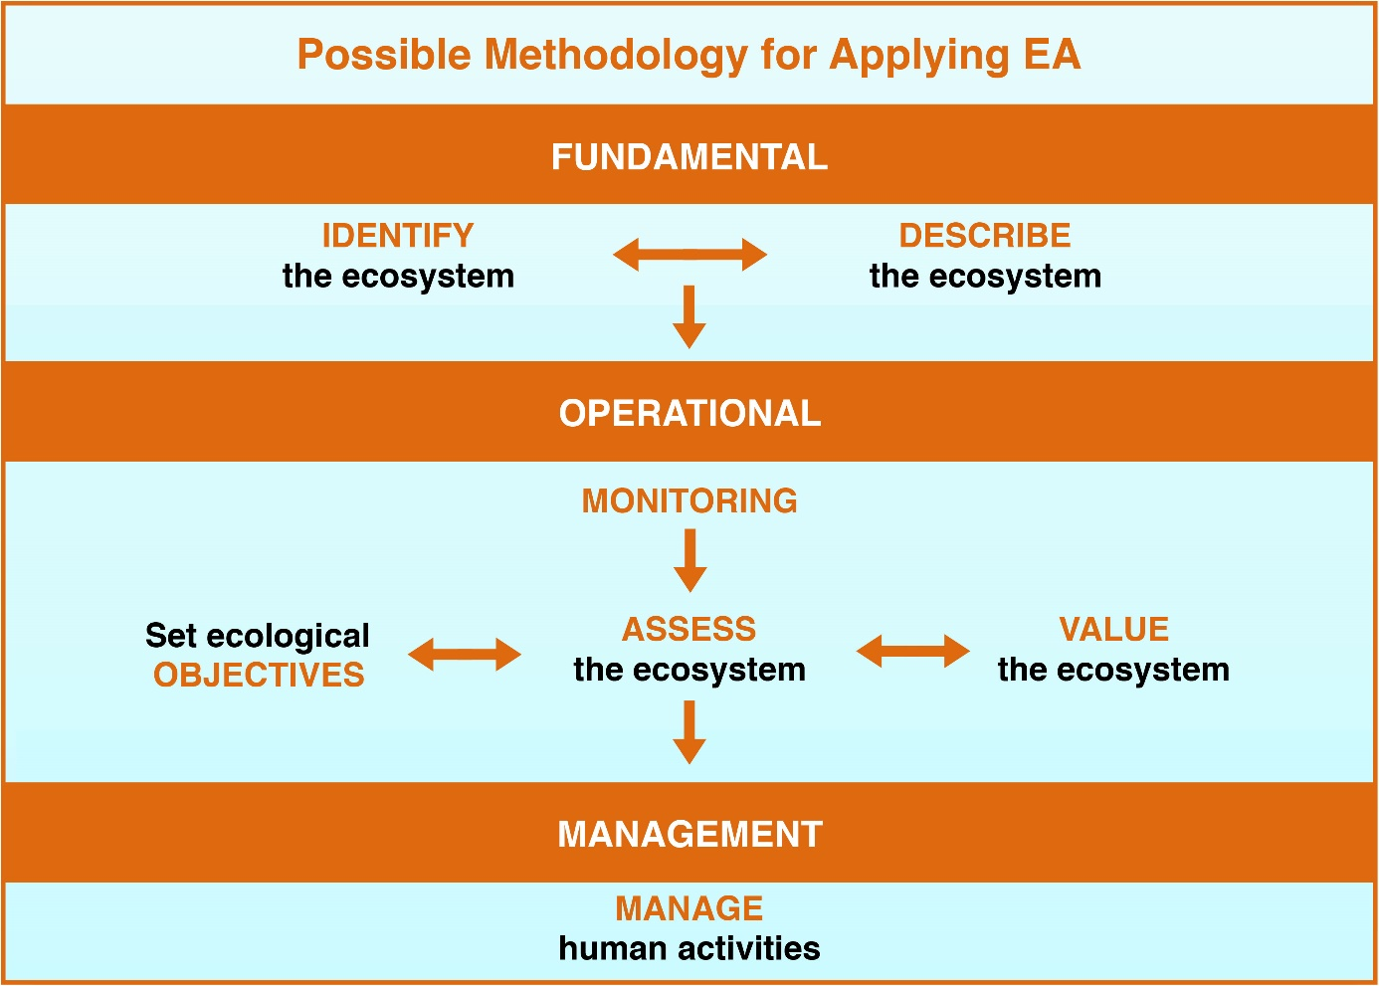

Sessions (DRAFT – all comments and suggestions welcome):
Meeting opening. Welcome by workshop leads and Introductions by all participants.

Session 1. Diversity of values
- Indigenous cultures (Storyteller from St. Lawrence Island)
- Local cultures (Storyteller from a fishery city/village)
- Industrialized cultures (Industry leader to be invited to talk about food-security vs nature conservation)
- Ethics and human rights (Speaker on UN Sustainable Development Goals)

Session 2. Diversity of methods of valuation
- Economic sciences
  - The Economics of Ecosystems and Biodiversity (TEEB) (speaker:… ask CAFF )
  - Non-market valuation (Dan Lew, NOAA AFSC)
- Social sciences
  - Kai Chan, UBC researcher;
  - Kirsten Leong, NOAA PIFSC
- Natural sciences
  - Integrated Ecosystem Assessments (Speaker: Kirstin Holsman, NOAA AFSC)
  - CAFF Biodiversity Assessment (speaker: Cathy Coon)
  - Valuing Marine Ecosystems (Melanie C. Austen, Plymouth Marine Laboratory UK)
- Ethics and human rights
  - Environmental ethics in the IPBES Sustainable Use Assessment (Jake Rice, Canada)
- Interdisciplinary and inter-cultural approaches
  - Bridging different worldviews (Robin Wall Kimmerer)

Session 3. Value and valuation in management
- Speaker: Alf Håkon Hoel (Norway)
- Practical examples of management approaches that incorporate Indigenous cultural values:
  - AEWC Conflict Avoidance Agreement
  - Shipping lanes development with Indigenous Communities
  - Co-management with nearby communities
  - Indigenous-lead MPAs and OECMs
  - North Pacific Fishery Management Council Bering Sea Fisheries Ecosystem Plan, ITK Task Force (Speakers: Sarah Wise NOAA AFSC, Diana Stram NPFMC)

Workshop products (DRAFT – all comments and suggestions welcome):
- Guidelines indicating how value and valuation can be used to manage human activities in the Arctic in order to maintain ecosystem integrity without compromising human rights.
- A collection of case studies that demonstrate how value and valuation shape human activity and that demonstrate how to integrate different values into EA.
- A PAME statement to be posted on the homepage that acknowledges the importance of cross-cultural valuation that honors ethics and human rights.

https://www.cbd.int/decision/cop/default.shtml?id=7148
EA and EBM are synonymous terms for the same management concept.
http://hdl.handle.net/11374/1927
http://hdl.handle.net/11374/2390

