The 6th EA Workshop on Ecosystem Approach Guidelines and Integrated Ecosystem Assessment, co-sponsored by the Joint Ecosystem Approach Expert Group (PAME, AMAP, CAFF, SDWG) and the ICES.

Accommodation – deadline to book 15 Dec. 2017

6th EA Workshop in Seattle

9-11 January 2018

Venue:
National Oceanic and Atmospheric Administration Western Regional Center
7600 Sand Point Way NE, Seattle, WA, USA

Registration and Logistics:
- Registration (deadline to register is 15 Dec.) here
- 6th EA Workshop website here

Accommodation and Program:
Block booking at Silver Cloud Hotel, University District (hotel website: silvercloud.com/university) at $179 US each night (plus lodging tax 15.6%).
How to Make Reservations Online
Please click on the GROUP link: NOAAARCT
- On the left-hand side of the screen please select the desired arrival and departure dates (within the contracted date range 1/8/2018 - 1/12/2018) and the number of guests).
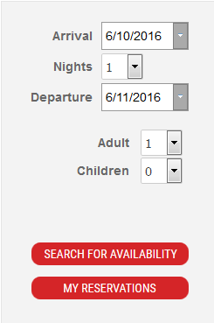
- Click on "Search for Availability"
- Then Click on "Reserve" for the room type you prefer. It will take you to a page where guests can enter all their information.
- Finally, click on "Make a Reservation" and your guests should receive a reservation confirmation email shortly thereafter.
How to make Reservations Via Phone: Call directly to +1 (206) 526-5200 or 1 (800) 205-6940 and ask for the "Arctic Council PAME Eco-System Approach Workshop" or "NOAAARCT" group and the guest services agent will be able to assist with the reservation.

