Guidelines for Implementing an Ecosystem Approach to Management of Arctic Marine Ecosystems
  - Arctic Council Joint PAME, CAFF, AMAP, SDWG Ecosystem Approach Expert Group

Table of Contents
1. Introduction 2
2. Framework for EA implementation 3
3. Guidelines for Implementing EA in the Arctic 5
General points 5
3.1 Identify the geographic extent of the ecosystem 6
3.2 Describe the biological and physical components and processes of the ecosystem including humans 8
3.3 Set ecological objectives that define sustainability of the ecosystem 8
3.4 Assess the current state of the ecosystem (Integrated Ecosystem Assessment) 9
3.5 Value the cultural, social and economic goods and services produced by the ecosystem 11
3.6 Manage human activities to sustain the ecosystem 12
4. Acknowledgements 13
Annex 1: List of acronyms 13

1. Introduction
The concept of the Ecosystem Approach to management (EA) has been around for at least 30 years and has been extensively discussed, elaborated and developed within national and international fora. The EA was adopted as an overarching principle and approach by Arctic Council Ministers in 2004 as part of the Arctic Marine Strategic Plan (AMSP). In 2011, the Ministers established an expert group on Arctic ecosystem-based management, which reviewed the EA (or EBM) concept and provided a definition of EA along with principles and recommendations that were adopted as part of the Kiruna Declaration in 2013. In Iqaluit in 2015, and in Fairbanks in 2017, the Arctic Council Ministers recognized the need for EA and requested and encouraged the development of practical guidelines for EA implementation in the Arctic.
PAME established an EA expert group (EA-EG) in 2007 that was broadened in 2011 as a joint group with participation also of other Arctic Council working groups (AMAP, CAFF, and SDWG). The EA-EG has convened six EA workshops in 2011-2018, and a first international EA conference in August 2016 (in Fairbanks, Alaska). The workshops addressed key aspects of implementing EA in the Arctic: setting geographical boundaries, defining a framework, assessing data issues, reviewing case studies, and setting ecological objectives. The objective of the 6th, most recent workshop was to scope and start work on development of guidelines for EA in the Arctic. The guidelines presented here are the culmination of the discussions at all these workshops, and the participation of the scientists, managers and community leaders who attended is greatly appreciated by the Joint EA-EG. These first guidelines are developed to assist scientists, policy-makers, managers and communities in implementing an ecosystem approach for Arctic marine ecosystems.
EA in the Arctic is a potentially powerful force for coordination (e.g., management of fishing fleet diversity) and cooperation (e.g., co-management of subsistence resources such as caribou and bowhead whales). It addresses the interplay between resource extractions, resource managers, conservation agencies, and subsistence users. The EA is about us human beings and our relationships with the external environment, the ecosystem, of which humans are an integral part. The overarching goal is to manage human activities and behavior in order to achieve or maintain sustainable use and the long-term integrity of ecosystems.
The ecosystem approach includes management and conservation approaches, such as protected areas, and single-species conservation programmes, as well as other approaches carried out under existing national policy and legislative frameworks. This allows us to deal with complex situations.
Definition
Arctic Council Ministers agreed in 2013 (Kiruna Declaration) to the following definition for EA (or EBM, which are synonymous terms):
Comprehensive, integrated management of human activities based on best available scientific and traditional knowledge about the ecosystem and its dynamics, in order to identify and take action on influences that are critical to the health of ecosystems, thereby achieving sustainable use of ecosystem goods and services and maintenance of ecosystem integrity.
This definition has four parts: 1) it is explicitly clear that it is about management of human activities; 2) it is based on the best knowledge available about the ecosystem; 3) the purpose is to do the right management decisions; and 4) the goal is to have sustainable use while maintaining the integrity of the ecosystem.

2. Framework for EA implementation
Under the Arctic Council, a framework for implementation of the EA to management of human activities in Arctic marine and coastal environments has been developed. The EA framework consists of six related elements:
- Identify the geographic extent of the ecosystem;
- Describe the biological and physical components and processes of the ecosystem including humans,
- Set ecological objectives that define sustainability of the ecosystem,
- Assess the current state of the ecosystem (Integrated Ecosystem Assessment),
- Value the cultural, social and economic goods produced by the ecosystem,
- Manage human activities to sustain the ecosystem.

While they are numbered, the elements do not necessarily need to be sequential although they are eventually linked in an iterative and adaptive operational management cycle (Fig. 1).

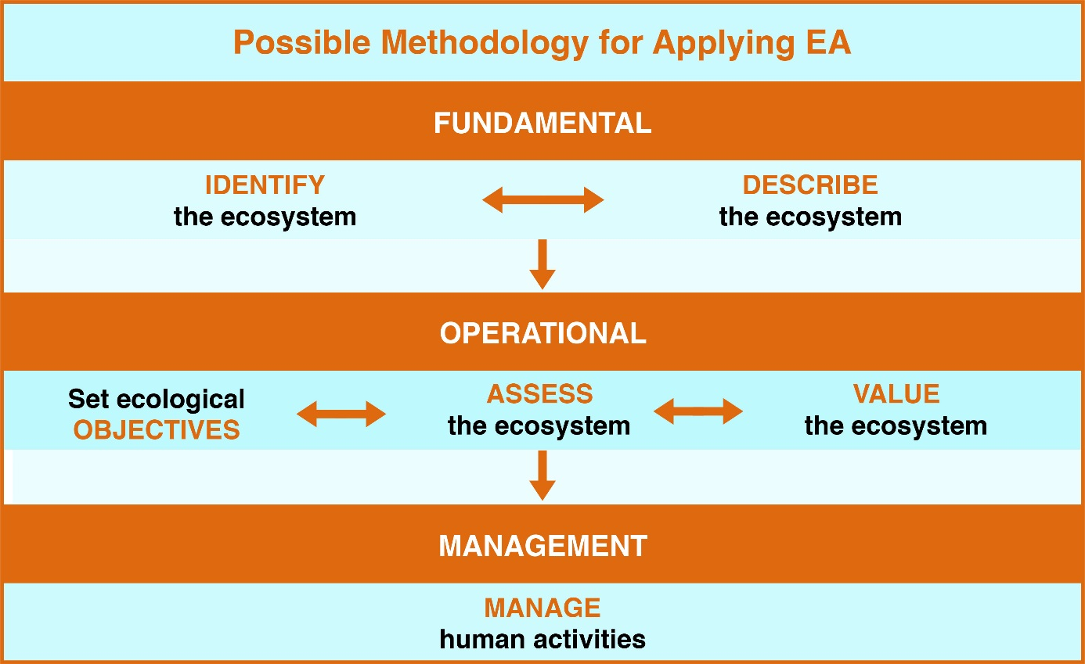
Figure 1. Joint Ecosystem Approach Expert Group (EA-EG) framework for implementing the EA to management of marine ecosystems in the Arctic

There is no single way to implement the ecosystem approach, as it depends on local, provincial, national, regional or global conditions. Nevertheless, the common denominators described in these guidelines can provide a framework for delivering the objectives of the AC and its member countries.

There is a dual meaning of “management” in the context of EA. It can be understood in a narrow sense as the sixth element of the EA framework, or in a wider sense as the whole EA framework with all six elements.
The relationship between the 6-elements of EA and the definition of EA is illustrated in Figure 2. The EA is very much a foundation and mechanism for sustainable development, which is reflected in the dual objective of having use without compromising the integrity of the ecosystem.
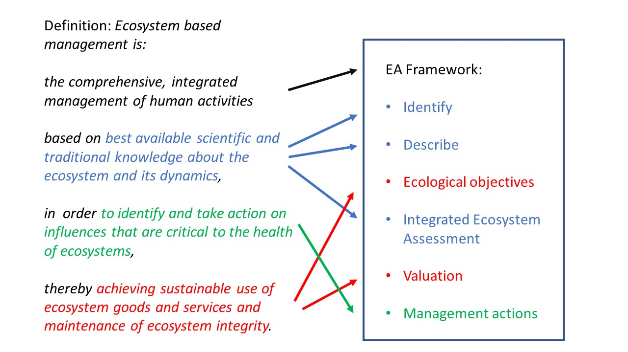
Figure 2. How the 6-element EA Framework (on the right) is related to the definition of Ecosystem Approach to management (or Ecosystem based management; on the left).

3. Guidelines for Implementing EA in the Arctic

General points
A strong theme in much of the discussion of guidelines for implementing EA is that Arctic peoples’ knowledge (indigenous, local, traditional) is essential to all aspects of EA from developing guidelines to implementing the approach. Indigenous knowledge provides a comprehensive perspective of the ecosystem (Ottawa Indigenous Knowledge principles). Another recurring theme is the importance of communication, participation and inclusivity. For EA to succeed in the Arctic it is crucial to include stakeholders in all stages of the process. Successful implementation of EA requires inclusive processes and co-production of knowledge in order to establish a foundation for EA. An inclusive process will also build interest, expand participation and create settings for those who live and operate in the Arctic to come together. Communicate and engage early and often is the message from stakeholders in local and indigenous communities.
Implementation of EA is a dynamic and ongoing process. Setting objectives, valuing ecosystem goods and services, conducting integrated assessments and managing human activities all benefit from the iterative process of monitor, evaluate and adapt.
This first set of EA Guidelines is crafted at the LME scale and covers the six main elements of EA broadly. Future Guidelines may address EA activities at smaller scales, as well as providing more detail about particular elements, such as defining ecological objectives, or valuing the ecosystem.
Following are the proposed set of guidelines to implement EA in the Arctic organized by element from the EA Framework.

3.1 Identify the geographic extent of the ecosystem
The 18 Large Marine Ecosystems (LMEs) in the Arctic (Fig. 3) are a useful and agreed-upon delineation of the geographic scale and boundaries for implementation of the Ecosystem Approach (Large Marine Ecosystems (LMEs) of the Arctic area - Revision of the Arctic LME map 15th of May 2013, 2nd edition). The LME boundaries define areas of coherent ecological and geophysical processes and thus LMEs represent an appropriate scale for assessing the structural and functional integrity of ecosystems, including the separate and cumulative impacts of human activities.
While LMEs are a useful scale for EA and management, integration across scales is an important consideration and should be done in an orderly fashion while retaining the focus on the integrity of the ecosystem. For example, ecosystem features important to Arctic communities occur at scales smaller than the LME, such as whaling and fishing areas. Pan-Arctic oceanographic processes and fluxes of water and organisms across LME boundaries (e.g. seasonal migrations of birds and mammals) mean that scales larger than the LME also should be taken into consideration.
Many of the Arctic LMEs are cross-boundary, including waters under the national jurisdiction of two or more Arctic states. Some of them also contain areas beyond national jurisdiction, e.g. in the Bering Sea, the Norwegian Sea, and most notably in the Central Arctic Ocean which includes a large area of High Seas (see the 2017 EA status report). The transboundary nature of LMEs, as well as interactions between adjacent LMEs (e.g. migrations of birds and mammals), require management cooperation between Arctic states and organizations with jurisdiction and management competence for a given LME.

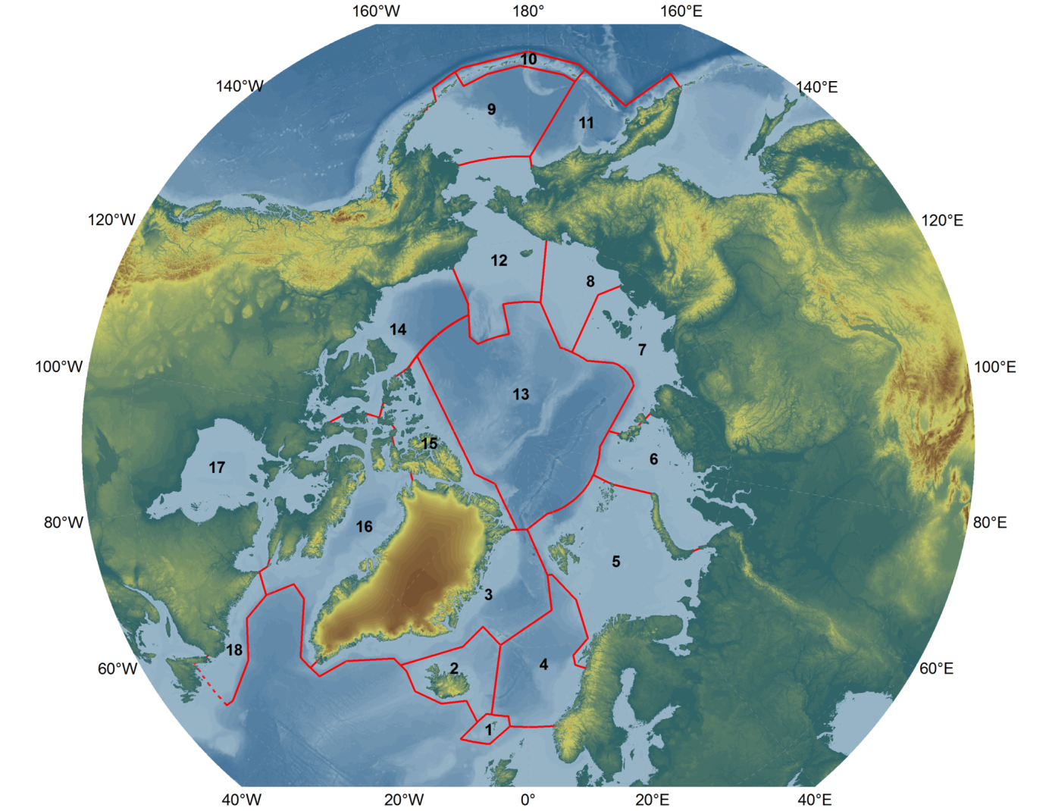
Figure 3. The 18 Large Marine Ecosystems: 1 – Faroe Plateau, 2 – Iceland Shelf and Sea, 3 – Greenland Sea, 4 – Norwegian Sea, 5 – Barents Sea, 6 – Kara Sea, 7 – Laptev Sea, 8 – East Siberian Sea, 9 – East Bering Sea, 10- Aleutian Islands, 11 – West Bering Sea, 12 – Northern Bering-Chukchi Seas, 13 – Central Arctic, 14 – Beaufort Sea, 15 – Canadian High Arctic-North Greenland, 16 – Canadian Eastern Arctic-West Greenland, 17 – Hudson Bay Complex, 18 – Labrador-Newfoundland.

3.2 Describe the biological and physical components and processes of the ecosystem including humans
Knowing what is critical to the health of an ecosystem and how to evaluate the integrity of the ecosystem rest on a fundament of ecosystem understanding. How well do we know how a given LME is constructed, and how does it work? The focus here should be on the key characteristics of the ecosystem (both in general and specific terms), which is the epitome of how we understand the particular ecosystem with its underwater landscape, ocean currents, and drifting, resident, and migratory biota ranging from viruses and bacteria to marine mammals. How are all these parts connected into a functional unit (which is how an ecosystem is defined in the UN Convention on Biodiversity)?
A description of the ecosystem can be achieved or supported through construction of conceptual models. This description of the ecosystem should include human activities along with the natural (non-human) components and processes of the system. It is recommended that development of these conceptual models be done in close collaboration with stakeholders, using Traditional and Local Knowledge equally with physical, biological and social science knowledge. The description phase of EA is also a good time to identify current or future threats and pressures to all components of the system. Prioritizing threats and pressures can stimulate interest and participation by stakeholders in EA; and is another opportunity for building partnerships.
There is a spatial component to the description of the ecosystem. Hot-spots of productivity, high biodiversity areas and other ecologically-significant areas should be identified. This includes descriptions of migratory patterns and habitats used by fish, birds, and mammals during life cycles and their annual migrations. In addition, a description of where these areas overlap with human activities (e.g., shipping, subsistence use) should be included. There is also a temporal component. Ideally, this should be a dynamic description that can be responsive to pressures, activities and scenarios of future ecosystem states. In addition, it is important to adopt procedures for regular updates of information on ecosystem components and pressures. When building the conceptual model, it will be useful to imagine plausible futures of the social-ecological system.
Many of the areas in the Arctic are data deficient when it comes to describing the ecosystem. This causes a problem when using models that require an abundance of data and is also an issue in identifying hot spots of productivity, biodiversity, etc. For data deficient areas the method used to assess the information should consider the quality and quantity of data available. This will also result in the identification of data gaps which is an important deliverable in and of itself.

3.3 Set ecological objectives that define sustainability of the ecosystem
As for the EA in general, it is important to adopt a collaborative and participatory approach when developing objectives. Setting ecological objectives is in essence striking a balance between exploitive use and conservation to achieve sustainability and is ultimately a societal choice. The objectives of nations and managers should be balanced with the objectives of local communities, and in this way the top-down approach will be balanced with the bottom-up approach. Developing objectives will entail identifying key concerns (e.g., drivers of change; governance gaps; fluctuation in, or thresholds of ecosystem services) and measurable variables in order to take action when needed.
A full range of ecological objectives would include (but not be limited to): harvested living resources, endangered species, and habitat and water quality. The ecological objectives should reflect ecological features on one hand, and be related to the impacts of human activities on the other. To be operational, ecological objectives may have to be linked to, or translated into, management objectives. An example from fisheries management is the objective to keep exploited fish populations above minimum stock levels, which are then translated into a system of fish quotas that are the operational management objectives. There may also be important social and cultural objectives linked to ecological objectives (e.g., conservation of ringed seals for umiaq (skin-boat) building to enable whale hunting). Ecological objectives will have a spatial component in ecosystems where sustainability entails insuring future functioning of vulnerable places, hotspots of productivity, Vulnerable Marine Ecosystems (VMEs), etc.
The issue of scale integration comes into play with regard to setting ecological objectives. Thus, objectives for local habitats, such as spawning or nursery areas for fish, or breeding colonies for seabirds, serve objectives to maintain healthy populations and ensure their functional roles in the wider ecosystem at a larger scale. Setting ecological objectives from a holistic perspective at the LME scale is a way to monitor that local management decisions e.g. at community level do not impair the functional integrity of the ecosystem.

3.4 Assess the current state of the ecosystem (Integrated Ecosystem Assessment)
Assessment of ecosystem status is a core element of the EA which sets it apart from previous sector-based management approaches. The focus is on the state of the ecosystem which needs to be assessed with due regard to its dynamic nature. Integrated Ecosystem Assessment (IEA) is an assessment of the status and trends in all relevant ecosystem components and thereby of the overall state of the ecosystem as such. It includes assessments of the impacts by various human activities such as fishing, pollution, coastal development, etc., as well as the overall or cumulative impacts by those activities. Integrated assessments include also socioeconomic factors and conditions, e.g. as driving forces for use and impacts, and as consequences back on society from altered provision of ecosystem goods and services.
Marine ecosystems are inherently dynamic and ever changing. Physical forcing, expressed by variability in ocean climate (currents, water masses etc.), has large influences on marine populations of fish and other organisms and on ecological processes. These processes include trophic interactions (predator-prey relationships and food-web dynamics). There is therefore an intricate relationship between physical forcing and biological interactions in marine ecosystems with simultaneous and linked bottom-up and top-down regulations. The strengths of these regulations may fluctuate, reflecting time delays by mechanisms such as strong year-classes of fish caused by climatic conditions in one period, being manifested as ecological interactions some years later when the fish grow up.
The large natural variability of marine ecosystems poses a challenge when it comes to assessing the impact of human activities, both individually and cumulatively. The impacts or effects e.g. from fishing or pollution, come in addition to the natural fluctuations in ecosystem components and may be difficult to distinguish from the natural variations. Assessments need therefore to be careful and detailed in order to allow effects from human activities to be distinguished from the natural ups and downs of ecosystem components such as fish stocks. This is challenging but not impossible, but it requires the best use of the best available scientific and other knowledge.
An IEA builds on two main pillars: 1) updated information from monitoring of ecosystem components and human activities, and 2) ecosystem understanding, being cumulated from past and on-going research, as well as being a by-product from assessment activities themselves. Assessment and monitoring are twins and need to go hand-in-hand. IEA is not possible without monitoring; in fact, it must rest squarely and solidly on comprehensive monitoring to supply the necessary information to assess the changing state of an LME. Therefore, a coordinated monitoring and assessment program should be developed to ensure that relevant information is collected as needed for an IEA. Monitoring of an LME should include climate, physical oceanography, nutrients, contaminants, plankton, benthos, fish, birds, and mammals, as well as human activities e.g. in fisheries, shipping and other sectors. The state of monitoring varies among Arctic LMEs, but in most cases much information is being collected by a multitude of government agencies, communities, and industries. A key aspect is to make an inventory and bring together all relevant existing information from monitoring for use in IEAs for a given LME. Such an exercise may reveal gaps which may have to be filled, but also possible redundancies and scope for more cost-effective monitoring through coordination and cooperation.
Assessment is an important component of co-management and both Traditional and Local Knowledge (TLK) and science knowledge contribute. Examples of co-management include the Inuit-Inuvialuit Beluga Whaling Commission (IIBWC) and the Inuvialuit-Inupiat Polar Bear Commission (IIPBC). Similarly, in the North Slope Borough of Alaska US, communities drive the science and monitoring which provides a good opportunity to implement EA. IEA can also contribute substantially to federal management documents such as the US National Environmental Policy Act (NEPA) assessments and consultations. To maximize stakeholder engagement, the process of constructing an IEA should be open and inclusive.
There is a diversity of approaches to IEA, some aspects are shared or common and some are specific to a program or project. There is still much to be gained by “learning by doing”. The International Council for Exploration of the Sea (ICES) is doing this on an extensive scale through working groups for doing IEAs for regional ecosystems in the North Atlantic, including two Arctic LMEs (the Barents and Norwegian seas) as well as the central Arctic Ocean (jointly with PICES and PAME). An iterative process has been suggested (6th EA Workshop) where best practices could be identified from what we know at present, and then the best practices can be updated as we gain more experience. Scientific advisory organizations, such as ICES, could help address this issue and could provide practical examples.
Common elements:
- Use of trend analysis of multivariate datasets to describe and evaluate recent and ongoing changes in the ecosystem as a whole
- Conceptual models as organizing and communication tools
- Human dimension; socio-economic information and TLK
- LME scale
- Monitoring and evaluation (adaptive management)
Other elements:
- Risk Assessment, including ecological, economic, social and management risks
- Analysis of outcomes and trade-offs of alternative management scenarios (management strategy evaluations)
- Indicators with target levels
- Qualitative descriptors with associated criteria and indicators
- Sub-LME scale
- Gap analysis
The purpose of doing an IEA is to provide basis for advice for management decisions and actions (element no. 6 below). There is a need for an advisory mechanism that can translate the findings about the complexity of an ecosystem as revealed by an IEA into clear options for management measures. This applies to harvest of living resources by commercial fisheries and subsistence harvest, as well as to the conservation measures to protect species and habitats to ensure good ‘health’ and the overall integrity of the ecosystem. The advice to managers should be in relation to the agreed ecological objectives set for the specific ecosystem (LME).
The advisory mechanism should be institutionalized as part of the overall EA management system. It is important that the advice is trusted as representing the best available knowledge about the ecosystem and its dynamics. There will often be a tension regarding the balance between use through new industrial developments and conservation to maintain the integrity of the ecosystem – basically where is the upper limit of sustainable use. Deciding this is made complicated by the large natural variability, and the additional changes of Arctic ecosystems now experienced due to climate change. The responsibility for giving management advice based on IEA needs to be clearly identified, and the integrity of the advisory process needs to be protected from undue political and other influences.

3.5 Value the cultural, social and economic goods and services produced by the ecosystem
As with setting ecological objectives, it is important to include indigenous peoples and local communities in the process of valuation. For successful stakeholder buy-in, the valuation process needs to be transparent. One method that has proven to be effective is the development of conceptual models by the community to describe their needs from ecosystem resources (e.g. The Sitka Workshop, Marysia Szymkowiak pers. com). These can be Qualitative Network Models QNM or a set of ratings or ranks applied to the “goods”.
Given the rapid pace of current and anticipated future changes in the Arctic, the values should have a dynamic component. The valuation needs to account for changes in social, economic and political systems and to anticipate future changes in and uses of the ecosystem.
“Value” has a monetary implication but non-monetary values are important as well. Social, cultural and other non-monetary values are incorporated into some management approaches already and provide guidance for implementing EA in the Arctic. For example, maintaining the economic and social integrity of communities is an explicit value in the US National Standards of the Magnuson-Stevens Act which are the “principles that must be followed in any fishery management plan to ensure sustainable and responsible fishery management (https://www.fisheries.noaa.gov/national/laws-and-policies/national-standard-guidelines).” Food security is a value of particular importance to communities that rely on subsistence harvest of whales, other marine mammals, birds, and fish.
There are quantitative methods for assessing the non-market value of ecosystem goods and services. Some Arctic ecosystem goods and services, like seafood, are traded in explicit markets where signals about their economic value are conveyed by prices at which they are bought and sold. However, not all ecosystem goods and services are traded in explicit markets. For these non-market ecosystem goods and services, quantitative methods developed in the environmental economics literature can be utilized to measure values. These non-market valuation approaches fall into two main types that differ in the type of data used to infer values. Revealed preference methods use information on observed behavior to infer values, while stated preference methods use carefully worded survey questions that elicit information used to infer economic values. One consideration is whether one should attempt to conduct valuation of a resource that is irreplaceable or to changes that are irreversible, in this case the resource would not have zero value but infinite value. Perhaps some features or aspects of the ecosystem will be defined as non-negotiable (e.g., because it contributes to an essential part of human culture or way of life), such as subsistence needs.
The task of valuation of ecosystem services could be quite large, but perhaps we don’t need to evaluate everything. One strategy could be to identify key ecosystem goods and services that are likely to hold large values (monetary, societal or otherwise) and focus on those. One could also focus on key goods and services that affect management decisions.

3.6 Manage human activities to sustain the ecosystem
Management should be adaptive. The management decisions and measures need to be responsive and adaptive to the changing conditions in the ecosystem as well as in the human populations that depend on the ecosystem. Adaptive management involves the coordination between agencies, sectors, regulations and conventions. It entails evaluation of the progress of management with regular review, addressing the following types of questions: Is the management successful? Are objectives achieved?
Building on the theme of incorporating local and traditional objectives and values, management should be flexible in order to align with the opportunistic nature of human subsistence resource needs and use. Given a dynamic and warming Arctic, management should be designed to be responsive to changes in the natural non-human system. Responding to advise based on updated information on the changes that are taking place in the ecosystem as documented in IEAs, will allow adaptive adjustment of management decisions and actions, in line with the agreed ecological objectives. For example, time-limited area closures in fisheries management can be implemented in response to changes in the abundance and distribution of fish stocks with climate change. This is just one example, and other actions can be taken to allow flexibility in shifting access from one resource to another based on ecosystem changes. Educating the regulators on the importance of EA may assist with optimal ways to achieve adaptive management goals (i.e. briefing fishery management councils on need for time-limited area closures as it meets larger objectives).
To achieve successful management within the context of EA, it will be important to understand what the available management tools are and what the management entities can do. In addition, given the need for scale-integration and transboundary management, coordination and communication among regulatory groups should be encouraged. The different groups should work together to identify over-arching goals.
Communication is an important part of successful management. Managers should provide the public with information, and should also gather public feedback. The ultimate goal is to encourage a transparent and dynamic/iterative management process.
Prepared by:
Elizabeth Logerwell, Alaska Fisheries Science Center, National Marine Fisheries Service, NOAA, USA
Hein Rune Skjoldal, Institute of Marine Research, Norway

4. Acknowledgements
The authors gratefully acknowledge the contribution of the participants of the 6th EA workshop held 9-11 January 2018 in Seattle, USA (https://pame.is/images/03_Projects/EA/6th_Workshop/6th_EA_Workshop_Report.pdf). In addition, Leah Brown, Catherine Coon, Eva Degré, Anja Elisenberg, Jon L. Fuglestad, Marthe Margrethe Haugan, Marianne Kroglund, Hanne-Grete Nilsen, Rebecca Shuford, and Cecilie von Quillfedlt provided many helpful suggestions to earlier drafts of the Guidelines.

Annex 1: List of acronyms

AACA | Adaptation Actions for a Changing Arctic
AMAP | Arctic Monitoring and Assessment Programme
AOA | Arctic Ocean Acidification
CAFF | Conservation of Arctic Flora and Fauna
EA | Ecosystem Approach
EA-EG | Ecosystem Approach Expert Group
EBM | Ecosystem-Based Management
ICES | International Council for the Exploration of the Sea
ICG-COBAM | OSPAR Commission's Intersessional Correspondence Group on Coordinated Biodiversity Assessment and Monitoring
IEA | Integrated Ecosystem Assessment
IIBWC | Inuit-Inuvialuit Beluga Whaling Commission
IIPBC | Inuit-Inuvialuit Polar Bear Commission
IPCC | Intergovernmental Panel on Climate Change
LME | Large Marine Ecosystems
TLK | Traditional and Local Knowledge
UNFCC | United Nations Framework Convention on Climate Change
NOAA | National Oceanic and Atmospheric Administration
PAME | Protection of the Arctic Marine Environment
QNM | Qualitative Network Model
SAMBR | State of the Arctic Marine Biodiversity Report
SDG | Sustainable Development Goals
SDWG | Sustainable Development Working Group
SWIPA | Snow, Water, Ice, and Permafrost in the Arctic
VME | Valuable Marine Ecosystem
WGIBAR | Working Group on the Integrated Assessments of the Barents Sea
WGICA | Working Group on Integrated Ecosystem Assessment (IEA) for the Central Arctic Ocean
WGINOR | Working Group on the Integrated Assessments of the Norwegian Sea

https://pame.is/images/03_Projects/EA/EA_Docs_and_Workshop_Reports/Status_reports/Status_of_Implementation_of_the_Ecosystem_Approach_to_Management_in_the_Arctic.pdf
http://www.saamicouncil.net/fileadmin/user_upload/Documents/Eara_dokumeanttat/Ottawa_TK_Principles.pdf
Harvey, C.J., Reum, J.C.P., Poe, M.R., Williams, G.D., and Kim, S.J. 2016. Using Conceptual Models and Qualitative Network Models to Advance Integrative Assessments of Marine Ecosystems. Coast. Manag. 44(5): 486–503. Taylor & Francis. doi:10.1080/08920753.2016.1208881.
Champ, P.A., K. Boyle, and T.C. Brown (2017) A Primer on Nonmarket Valuation. Springer Netherlands. Freeman A.M., J.A. Herriges, and C.L. Kling (2014) The Measurement of Environmental and Resource Values: Theory and Methods. New York: Taylor & Francis.

